Question Two

Part A) Calculate the Big Oh performance for the Sequential Search on the array given below that has 15 elements? Given that sequential search of an array of 10 elements took on average 1 second. [2.5 mark points]
[ 99, 101, 8, -22, 3, 55, 42, -1, 0, 52, 33, -4, 66, 1, 52]
Part B) Calculate the Big Oh performance for the Binary Search on the sorted array given below that has 15 elements? Given that Binary search of an array of 10 elements took on average 1 second. [2.5 mark points]
[ -22, -4, -1, 0, 1, 3, 8, 22, 42, 52, 52, 55, 66, 99, 101]

Question Three

Write a complete program that creates two stacks with the following element:
s1 = {10, 3, 1, 5}
s2 = {7, 9, 2, 8, 12, 4}
Use the pop method to extract the top element from each stack and print the summation of these two elements. Finally, print the remaining elements from both stacks, indicate if empty or show what is left in the stack.
Sample Output:
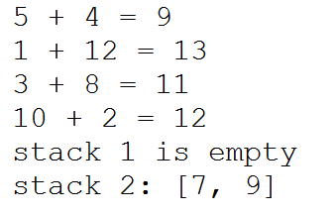

Question Four

Part (A) Draw a diagram of a linked list that contains the following city nodes: “Jeddah”, “Mecca” and “Dammam”. Include an instance variable (pointer) to indicate the beginning of the list. In addition, for each element, clearly show its fields, contents and the references. [2.5 mark points]
Part B) List three differences between Linked List structure and Array structure? Include the differences of: 1. How we add/remove elements in each. 2. Differences in structure itself 3. How each access its elements. [2.5 mark points]

NOTE: You can use MS Word or any diagraming tool to draw. Or simply “hand” drawing. Then, take picture snapshot and paste your diagram here.

Question Five

Using a LinkedList and ListIterator classes from the java library packages. Write a program that contains a list of courses’ codes. Your program should do the following functions in order.

- Add the following courses in the list: “CS141”, “CS140” and “IT409”.
- Remove the course “CS141” from the list and return it in “removed” variable.
- Add the course “IT448” after the course “CS140”.
- Prints all the courses in the list using ListIterator object.

