Assignment Question: Managerial Accounting(30%)
Budgets & Budgetory Controls
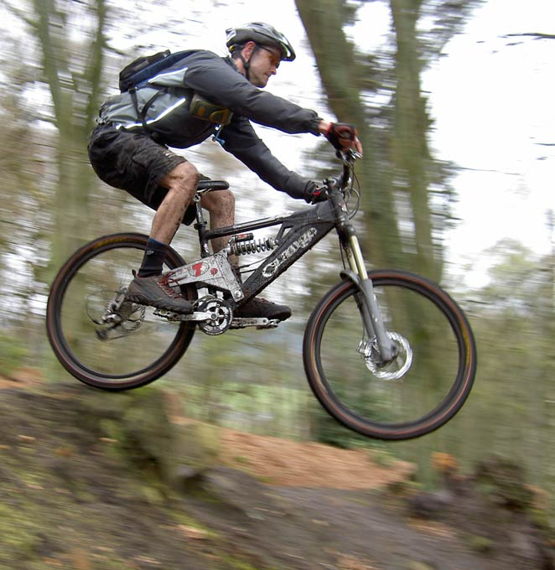
You are the accountant for Sepang Bikes, a manufacturer of sturdy mountain bikes for intermediate level bikers. The entity’s managers are forecasting an increase in the sales because of the success of their current advertising campaign. They asked you to create a master budget for the upcoming year, given the forecasted sales increase.
To gather information needed for the budget, you first access relevant data about revenues, inventories and production costs from last period’s accounting records. Next, you obtain information from every department and meet with top management to identify changes in sales volumes and prices, production processes, manufacturing costs and support department costs. The following are information you have gathered:
- The managers forecasted that 100,000 bikes would be sold at a price of RM800 each.

- According to the prior accounting records, beginning finished goods inventory consists of 2,500 bikes at a cost per unit of RM454.75, or RM1,136,875 in total. Given the anticipated increase in sales volume, the managers want to increase finished goods inventory to 3,500 units.

- Direct materials beginning inventory consists of:
Wheels and tyres RM 20,000
Components 70,000
Frames 50,000
Total 140,000

- The cost per unit of direct materials is expected to be:
Wheels and tyres RM 20
Components 70
Frames 50

- The managers want ending inventories to be:
Wheels and tyres RM 25,000
Components 87,500
Frames 62,500
Total 175,000

- The quantity and cost of direct labour per unit is expected to be:
Direct labour Hours Cost per hour
Assembly 1.5 RM25
Testing 0.15 RM15

- For overheads, you use information that you collected from last year’s operations and update it with current prices. The cost per unit of variable manufacturing overhead is expected to be as follows:

Variable overhead (cost per unit):
Supplies RM20.00
Indirect labour RM37.50
Maintenance RM10.00
Miscellaneous RM 7.50
Total RM75.00

- You expect a total of RM20,200,000 to be spent on fixed manufacturing overhead costs as follows: Depreciation: RM4,040,000; Property taxes: RM1,010,000; Insurance: RM1,414,000; Plant supervision: RM5,050,000; Fringe benefits: RM7,070,000; Miscellaneous: RM1,616,000. Overheads are absorbed by budgeted volume of production.

- You also estimate other operating costs for all the support departments. All support costs for Sepang Bikes happen to be fixed as follows: Administration: RM16,478,215; Marketing: RM9,886,929; Distribution: RM4,943,465; Customer service: RM1,647,821.

- Income taxes are expected to be at the rate of 30%.

Required:
(a) Describe and discuss ONE (1) strategic tool / technique / process that has elevated and changed the role of management accounting in facing the challenging business environment over the recent decades. (10 marks)
(b) As the accountant at Sepang Bikes, develop a master budget for the review of the entity’s controller, so that it can then be presented at a meeting with the CEO and the various department heads. Create individual /functional budgets in the following order: (20 marks)
- Sales revenue budget
- Production budget
- Direct materials usage and purchases budget
- Direct labour budget
- Manufacturing overhead budget
- Ending inventories budget
- Cost of goods sold budget
- Support department budget
- Budgeted statement of profit or loss

