Homework questions
#1
Pollitt Potato Packers has a flexible budget for manufacturing overhead that is based on direct labour hours. The following overhead costs appear on the flexible budget at the 200,000-hour level of activity:
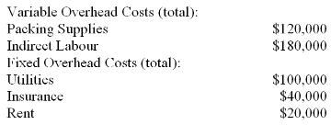
At an activity level of 180,000 direct labour hours, what amount would the flexible budget estimate for indirect labour cost?
$108,000.
$144,000.
$162,000.
$180,000.
What amount would the flexible budget estimate for total variable overhead cost per direct labour hour?
$0.60.
$0.90.
$1.50.
$1.80.
At an activity level of 180,000 direct labour hours, what amount would the flexible budget estimate for total budgeted fixed costs?
$100,000.
$144,000.
$150,000.
$160,000.
At an activity level of 160,000 direct labour hours, what amount would the flexible budget estimate for the utilities?
$80,000.
$100,000.
$120,000.
$160,000.

#2
Mongelli Family Inn is a bed and breakfast establishment in a converted 100-year-old mansion. The Inn's guests appreciate its gourmet breakfasts and individually decorated rooms. The Inn's overhead budget for the most recent month appears below:
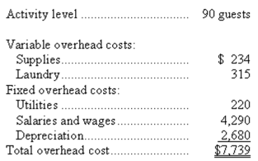
The Inn's variable overhead costs are driven by the number of guests.
Assuming that the activity levels of 90 guests and 99 guests are within the same relevant range and rounding to the nearest dollar, what would be the total budgeted overhead cost for a month if the activity level is 99 guests?
$7,794.
$61,541.
$8,513.
$7,739.

#3
Capelli Hospital bases its budgets on patient-visits. The hospital's static budget for August appears below:
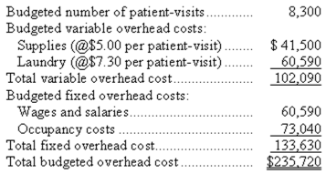
What should be the total variable overhead cost at an activity level of 9,300 patient-visits per month?
$114,390.
$149,730.
$102,090.
$133,630.

What should be the total fixed overhead cost at an activity level of 9,600 patient-visits per month?
$133,630.
$154,560.
$235,720.
$272,640.

What should be the total overhead cost at an activity level of 9,400 patient-visits per month?
$235,720
$249,250
$266,960
$250,640

#4
Alaska Company expressed the total expenses (Y) component of its master budget for February with the cost formula Y = $100,000 + $40*X, where X represents the expected number of units of its only product to be manufactured and sold. The budgeted average selling price per unit was $65 for budgeted sales volume 5,000 units. Reported actual results for February were as follows:
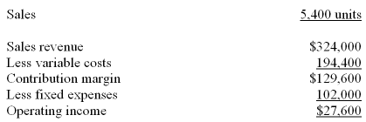
What was the master budget operating income for February?
$23,000.
$25,000.
$35,000.
$33,000
What was the flexible operating income for February?
$23,000.
$25,000.
$35,000.
$33,000.

