Network Design Proposal Template
Network Design Proposal

Prepared for:
University of Maryland University College

Prepared by:
Student Name

II. Network Addresses Design (in its entirety)

A. Subnetting

Subnetting is a process of breaking a large network into small networks known as subnets. Subnetting happens when we extend the default boundary of the subnet mask. Basically we borrow host bits to create networks (i.e., subnets).

We have been assigned the network address 199.1.2.0. Based on the chart below, we know this is a Class C address. This is determined by observing the first octet of the IP address, which is 199. This octet falls in between 192 and 223.

Class | Octet Decimal Range
A | 1 - 126
B | 128 - 191
C | 192 - 223

Each class has a predefined default subnet mask that tells us the octets, which are already part of the network portion, as well as how many bits we have available to work with.

Class | Subnet Mask | Format
A | 255.0.0.0 | Network.Host.Host.Host
B | 255.255.0.0 | Network.Network.Host.Host
C | 255.255.255.0 | Network.Network.Network.Host

CIDR (Classless Inter Domain Routing)

CIDR is a slash notation of the subnet mask. CIDR tells us the number of on bits in a network address.

- Class A has default subnet mask 255.0.0.0. that means first octet of the subnet mask has all on bits. In slash notation it would be written as /8, means address has 8 bits on.

- Class B has default subnet mask 255.255.0.0. that means first two octets of the subnet mask have all on bits. In slash notation it would be written as /16, means address has 16 bits on.

- Class C has default subnet mask 255.255.255.0. that means first three octets of the subnet mask have all on bits. In slash notation it would be written as /24, means address has 24 bits on.

Scenario

The building will house four computer labs that will be used for instruction. In the building diagrams above, the labs are labeled Classroom #2 and Classroom #4 on the first floor and Classroom #1 and Classroom #5 on the second floor; each computer lab will have a closet. Each lab will have 25 computers: 23 student computers, 1 instructor computer, and 1 server in the closet for instructional use.
In addition, there will be a Student Computer Lab that will provide computer access to students to do their homework. There will be 25 computers in this lab and a server in the closet. To allow students access to library resources, the library will also have 20 computers for the general public to use and 5 computers for library staff.
There needs to be separation between students, staff, and public access networks. The open Wi-Fi also needs to be separate from the other three groupings.
Finally, there are various offices in the building. Each of these offices will have one computer for staff use, with the exception of the admissions office, which will have five computers. There will be two server rooms, one on the first floor and one on the second floor.

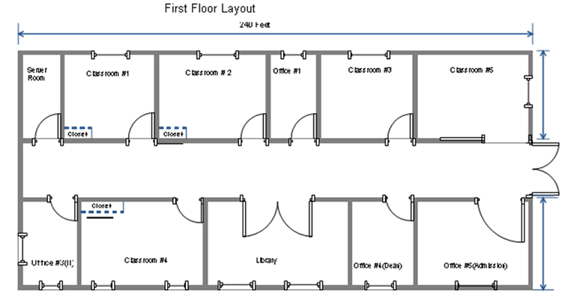
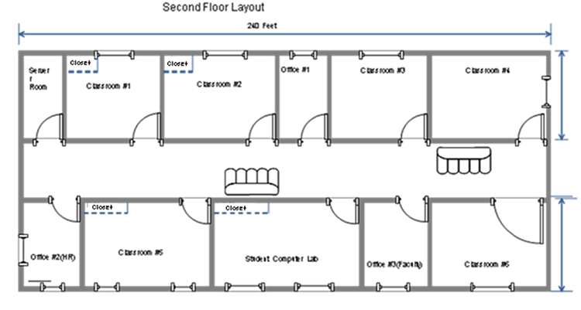

Methodology

Given the aforementioned scenario, we are going to use the 192.168.0.0/24 network and create a total of 8 subnets, with 25 hosts on each subnet. The chart below describes structures the scenario to include each subnet and required hosts.

Subnet Description | Required Hosts
Students in Classroom 1 Computer Lab | 23 Computers
Students in Classroom 2 Computer Lab | 23 Computers
Students in Classroom 3 Computer Lab | 23 Computers
Students in Classroom 4 Computer Lab | 23 Computers
Students in Student Computer Lab | 24 Computers
Public Access network | 20 Computers
Equipment | xx Network Peripherals (servers access points) Computers
Staff Office / Admissions Network | xx Computers

(Using the How to Subnet a Network Video provided in CMIT 265 LEO - Content - UMUC Network Design Proposal, complete the following chart.)

Subnet | Network Address | Host Address Range | Broadcast Address
Subnet Mask: 255.255.255._____
Classroom 1 | 192.168.0.0 | 192.168.0.1 – 192.168.0.30 | 192.168.0.31
Classroom 2 | 192.168.0.__ | 192.168.0.__ - 192.168.0.__ | 192.168.0.__
Classroom 3 | 192.168.0.__ | 192.168.0.__ - 192.168.0.__ | 192.168.0.__
Classroom 4 | 192.168.0.96 | 192.168.0.97 – 192.168.0.126 | 192.168.0.127
Student Computer Lab | 192.168.0.128 | 192.168.0.129 – 192.168.0.158 | 192.168.0.127
Equipment | 192.168.0.__ | 192.168.0.__ - 192.168.0.__ | 192.168.0.__
Library Lab (Public Access) | 192.168.0.__ | 192.168.0.__ - 192.168.0.__ | 192.168.0.__
Staff Network | 192.168.0.__ | 192.168.0.__ - 192.168.0.__ | 192.168.0.__

