Lab 5
Configuring Print and Document Services
This lab contains the following exercises and activities:
Exercise 5.1  Exercise 5.2  Exercise 5.3  Lab Challenge | Installing a Printer  Deploying Printers Using Active Directory  Scheduling Printer Access  Creating a Printer Pool
BEFORE YOU BEGIN
The lab environment consists of computers connected to a local area network, along with a server that functions as the domain controller for a domain called adatum.com. The computers required for this lab are listed in Table 5-1.
Table 5-1
Computers Required for Lab 5
Computer | Operating System | Computer Name
Domain controller | Windows Server 2012 R2 | SERVERA
Member server | Windows Server 2012 R2 | SERVERB

In addition to the computers, you also require the software listed in Table 5-2 to complete Lab 5.
Table 5-2
Software Required for Lab 5
Software | Location
Lab 5 student worksheet | Lab05_worksheet.docx (provided by instructor)

Working with Lab Worksheets
Each lab in this manual requires that you answer questions, create screen shots, and perform other activities that you will document in a worksheet named for the lab, such as Lab05_worksheet.docx. It is recommended that you use a USB flash drive to store your worksheets, so you can submit them to your instructor for review. As you perform the exercises in each lab, open the appropriate worksheet file, fill in the required information, and save the file to your flash drive.
After completing this lab, you will be able to:
- Use the Print Management console
- Install a printer
- Deploy printers to workstations
- Control access to printers
Estimated lab time: 75 – 100 minutes
Exercise 5.1 | Installing a Printer
Overview | In this exercise, you install the Print and Document Services role and use the Print Management console included in Windows Server 2012 R2.
Mindset | The Print Management console enables administrators to deploy and manage printers all over the network.
Completion time | 10-20 minutes

1. On the SERVERB computer, in Server Manager, click Manage > Add Roles and Features. The Add Roles and Features Wizard appears, displaying the Before you begin page.
2. Click Next. The Select installation type page appears.
3. Click Next. The Select destination server page appears.
4. Click Next. Select the Print and Document Services check box. The Add features that are required for Print and Document Services dialog box appears.
5. Click Add Features. Then click Next. The Select features page appears.
6. Click Next. The Print and Document Services page appears.
7. Click Next. The Select role services page appears.
8. Click Next to accept the default selection. The Confirm installation selections page appears.
9. Click Install. The wizard installs the role.
10. Click Close. The wizard closes.
11. In Server Manager, click Tools > Print Management. The Print Management console appears (see Figure 5-1).
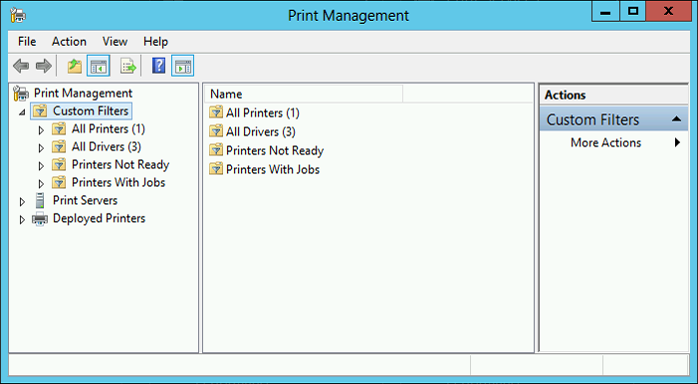

Figure 5-1
Print Management console

12. Expand the Print Servers node, and then right-click the SERVERB (local) node representing the server. From the context menu, select Add Printer. The Network Printer Installation Wizard appears.
13. Select the Add a new printer sing an existing port option, and leave the LPT1: (Printer Port) value selected. Then click Next. The Printer Driver page appears.
14. Leave the Install a new driver option selected, and click Next. The Printer Installation page appears.
15. In the Manufacturer list, select Generic.
16. In the Printers list, select MS Publisher Color Printer, and click Next. The Printer Name and Sharing Settings page appears.
17. In the Printer Name text box, type MSColor.
18. Leave the Share this printer check box selected and, in the Share Name text box, type MSColor. Then click Next. The Printer Found page appears.
Question1 | Why is the wizard able to install the printer when an actual print device is not connected to the computer?

19. Click Next. The Completing the Network Printer Installation Wizard page appears.
20. After the printer is installed, click Finish.
21. Repeat the process to install a second printer, using the following settings:
- Port: LPT2
- Manufacturer: Generic
- Printer: MS Publisher Imagesetter
- Printer Name: MSMono
- Share Name: MSMono
22. Expand the SERVERB (local) node, and select the Printers node.
23. Press Alt+Prt Scr to take a screen shot of the Print Management console showing the contents of the Printers node. Press Ctrl+V to paste the image on the page provided in the Lab 5 worksheet file
End of exercise. You can leave the windows open for the next exercise.

Exercise 5.2 | Deploying Printers Using Active Directory
Overview | In this exercise, you use two methods to deploy the printers you created in Windows Server 2012 R2.
Mindset | To simplify network printer deployments, you can publish printer connections to Active Directory Domain Services using Group Policy.
Completion time | 10–20 minutes

1. On the SERVERB computer, in the Print Management console, right-click the MSColor printer and, from the context menu, select List in Directory.
2. Right-click the MSMono printer and, from the context menu, select Deploy with Group Policy. The Deploy with Group Policy dialog box appears (see Figure 5-2).
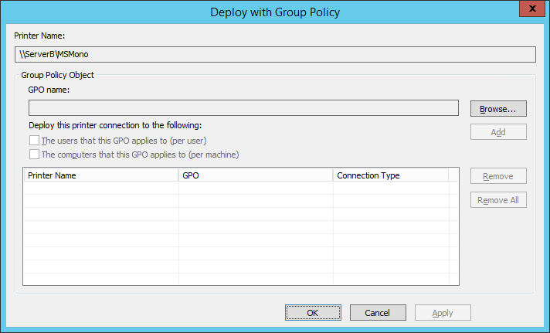
Figure 5-2
The Deploy with Group Policy dialog box

3. Click Browse. The Browse for a Group Policy Object dialog box appears.
4. Select Default Domain Policy, and click OK. Default Domain Policy appears in the GPO Name field.
5. Select the check box for The computers that this GPO applies to (per machine), and click Add. The printer appears in the deployment list.
6. Click OK. A Print Management message box appears, indicating that the printer deployment has succeeded.
7. Click OK twice to close the message box and the Deploy with Group Policy dialog box.
8. Unlock the screen (if needed), and then, on the SERVERA computer, click the Windows PowerShell button on the taskbar. An Administrator: Windows PowerShell window appears.
9. At the Windows PowerShell prompt, type control /name Microsoft.DevicesAndPrinters and press Enter. The Devices and Printers window appears. (Note: It might be necessary to wait several minutes and click Refresh before the new printer appears.)
Question2 | Apart from Microsoft XPS Document Writer, which appears by default, which of the SERVERB printers appear in the Devices and Printers window on SERVERA?
Question 3 | Explain why the SERVERB server’s MSColor printer does not appear in the Devices and Printers window on SERVERA.

10. Press Alt+Prt Scr to take a screen shot of the Devices and Printers window. Press Ctrl+V to paste the image on the page provided in the Lab 5 worksheet file.
11. On the SERVERA computer, in Server Manager, click Tools > Active Directory Users and Computers. The Active Directory Users and Computers window appears.
12. Right-click the adatum.com domain and, from the context menu, select Find. The Find Users, Contacts, And Groups dialog box appears.
13. In the Find drop-down list, select Printers. The title of the dialog box changes to Find Printers.
14. Click Find Now.
Question4 | What printers appear in the Search Results box?

15. Right-click the MSColor printer and, from the context menu, select Connect.
16. Switch to the Devices and Printers window.
Question 5 | What changed in the Devices and Printers window?

17. Press Alt+Prt Scr to take a screen shot of the Devices and Printers window, showing the latest change. Press Ctrl+V to paste the image on the page provided in the Lab 5 worksheet file.
18. Close the Devices and Printers window and the Find Printers window.
End of exercise. You can leave any windows open for the next exercise.

Exercise 5.3 | Scheduling Printer Access
Overview | In this exercise, you configure a printer you installed previously to limit its access to specific individuals and times.
Mindset | Consumables for the color printer you installed in Exercise 5.1 are expensive, so you want to prevent users from running personal jobs or printing after hours. However, you want selected users to be able to access the printer at all times. You also want to prioritize those users’ print jobs, printing them before other users’ jobs.
Completion time | 10–20 minutes

1. On SERVERB, in the Print Management console, add a second printer for the MS Publisher Color Printer print device you installed in Exercise 5.1. Use the following settings:
- Port: LPT1
- Printer Driver: MS Publisher Color Printer
- Manufacturer: Generic
- Printer: MS Publisher Color Printer
- Printer Name: MSColor-PM
- Share Name: MSColor-PM
2. Select the Printers node in the console, right-click the first MSColor printer you created, and, in the context menu, select Properties. The MSColor Properties sheet appears.
3. Click the Advanced tab (see Figure 5-3).
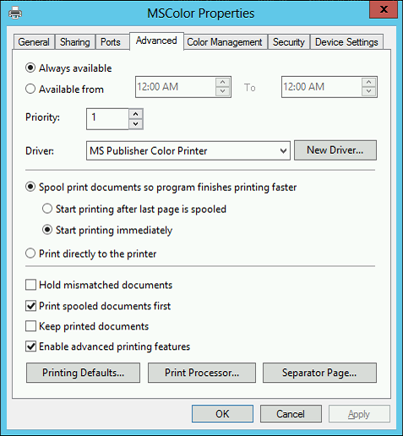

Figure 5-3
The Advanced tab of a printer’s Properties sheet

4. Select the Available from option and, in the two spin boxes, select the hours 9:00 AM and 5:00 PM.
Question6 | Which of the problems described in the Exercise 5.3 overview will this setting prevent? How is it prevented?

Question 7 | In some instances, a user deliberately or accidently interrupts a print job, stalling the queue until the partial job is removed. Which of the parameters on the Advanced page of a printer’s Properties sheet can prevent these interruptions from occurring?

Question 8 | When users send print jobs requiring a paper size that is not available, the entire print queue halts until someone inserts the correct paper for that job. Which of the parameters on the Advanced page of a printer’s Properties sheet can prevent the queue from being halted?

5. Click Apply, and then click the Security tab.
6. Click Add. The Select Users, Computers, Service Accounts, or Groups dialog box appears.
7. Type Domain Users and click OK. The Domain Users group appears in the Group or user names list, and receives the Allow Print permission.
8. Select the Everyone special identity and click Remove.
9. Click OK to close the MSColor Properties sheet.
10. Open the MSColor-PM Properties sheet, and click the Advanced tab.
11. Leave the Always available option selected, and change the value in the Priority spin box to 99.
Question9 | Which of the problems described in the Exercise 5.3 overview is prevented by modifying the Priority value? How is it prevented?

12. Click Apply, and then click the Security tab.
13. Add the Domain Admins group to the Group or User Names list, and grant the Allow Print permission to it.
14. Remove the Everyone special identity from the Group or User Names list.
Question 10 | How do these permission modifications achieve the goals stated in the exercise overview?

15. Press Alt+Prt Scr to take a screen shot of the Security tab in the MSColor-PM Properties sheet. Press Ctrl+V to paste the image on the page provided in the Lab 5 worksheet file.
16. Click OK to close the MSColor-PM Properties sheet.
End of exercise. Close any open windows before you begin the next exercise.

Lab Challenge | Creating a Printer Pool
Overview | To process a large quantity of print jobs with a single printer, you can create a printer pool, which distributes the print jobs among multiple print devices.
Completion time | 20 minutes

To support the Legal department at Contoso, Ltd., your supervisor purchased five identical HP LaserJet 4250 printers to be used as a printer pool. Unlike the printers you installed previously in this lab, which connected to the server using LPT ports, these five printers have Hewlett Packard JetDirect network interface adapters that have already been assigned the following IP addresses:
- 10.0.0.220
- 10.0.0.221
- 10.0.0.222
- 10.0.0.223
- 10.0.0.224
To complete this challenge, add a printer on your server, and share it using the name HPLJ4250 Pool. Then, configure the printer to function as a printer pool using the IP addresses cited previously. Write the procedure you use to create and configure the printer pool, and then take a screen shot of the Ports tab in the HPLJ4250 Pool Properties sheet. Paste the image in the Lab 5 worksheet file.

End of lab. You can log off or start a different lab. If you want to restart this lab, you’ll need to click the End Lab button in order for the lab to be reset.

