Lab 1
Installing Servers
This lab contains the following exercises and activities:
Exercise 1.1  Exercise 1.2  Lab Challenge | Performing a Clean Installation  Installing Windows Server Migration Tools (WSMT)  Accessing a WSMT Distribution Point
BEFORE YOU BEGIN
The lab environment consists of computers connected to a local area network. The computers required for this lab are listed in Table 1-1.

Table 1-1
Computers Required for Lab 1
Computer | Operating System | Computer Name
New server | Bare metal | SERVERA
Server for migration | Windows Server 2008 R2 | SERVERC

In addition to the computers, you also require the software listed in Table 1-2 to complete Lab 1.

Table 1-2
Software Required for Lab 1
Software | Location
Installation disk for Windows Server 2012 R2 | Mounted on SERVERA
Lab 1 student worksheet | Lab01_worksheet.docx (provided by instructor)

Working with Lab Worksheets
Each lab in this manual requires that you answer questions, create screen shots, and perform other activities that you will document in a worksheet named for the lab, such as Lab 01 worksheet.docx. It is recommended that you use a USB flash drive to store your worksheets, so you can submit them to your instructor for review. As you perform the exercises in each lab, open the appropriate worksheet file, fill in the required information, and save the file to your flash drive.
After completing this lab, you will be able to:
- Perform a clean Windows Server 2012 R2 installation on a bare metal computer
- Install the Windows Server Migration Tools
Estimated lab time: 40 minutes
Exercise 1.1 | Performing a Clean Installation
Overview | In this exercise, you install Windows Server 2012 R2 on a new computer with no previously installed operating system.
Mindset | In many cases, organizations purchase servers without operating systems installed—sometimes called bare metal servers—either because they have an existing license agreement or because they intend to purchase the OS through another channel. In these cases, you perform what is known as a clean operating system installation, which is a procedure that creates a new server with its default operating system settings.
Completion time | 10 minutes

1. Select the SERVERA computer, on which the Windows Server 2012 R2 installation disk is mounted and loaded. The Windows Setup page appears.
2. Click Next to accept the default values for the Language to install, Time and currency format, and Keyboard or input method parameters. Another Windows Setup page appears.
3. Click the Install now button. The Select the operating system you want to install page appears.
4. Select Windows Server 2012 R2 Datacenter (Server with a GUI) and click Next. The License terms page appears.
5. Select I accept the license terms and click Next. The Which type of installation do you want? page appears.
6. Click Custom: Install Windows only (advanced). The Where do you want to install Windows? page appears (see Figure 1-1).
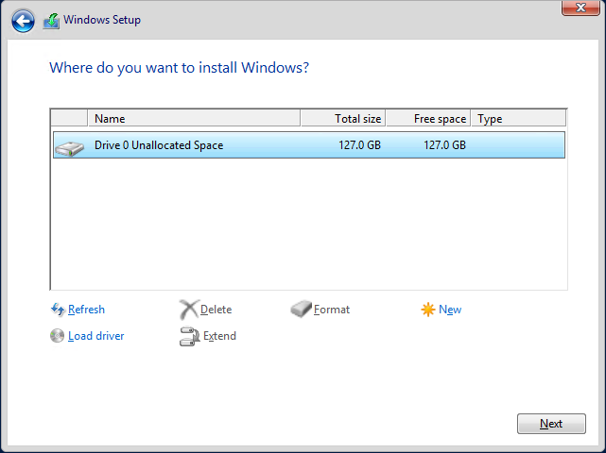

Figure 1-1
The Where do you want to install Windows page

7. Select Drive 0 Unallocated Space and click Next. The Installing Windows page appears as the system installs Windows Server 2012 R2.
Question1 | What should you do if the drive on which you want to install Windows Server 2012 R2 already has a partition on it containing an operating system and data you do not need?

Question 2 | What should you do if the Where do you want to install Windows? page appears, but it does not list any drives or partitions?
8. After several minutes and a system restart, the Settings page appears.
9. In the Password and Reenter password text boxes, type Pa$$w0rd and click Finish. The Windows security page appears, showing the time.
10. Click Ctrl+Alt+Del and log on using the Administrator account with the password Pa$$w0rd. The Server Manager console appears.
11. Click Local Server in left pane and then click the Computer Name link. The System Properties sheet appears.
12. Click Change. The Computer Name/Domain Changes dialog box appears.
13. In the Computer name text box, type SERVERA and click OK. A message box appears, telling you to restart the computer.
14. Click OK. Then click Close. Another message box appears.
15. Click Restart Now. The system restarts.
End of exercise. Close all windows before beginning the next exercise.

Exercise 1.2 | Installing Windows Server Migration Tools
Overview | In this exercise, you install the Windows Server Migration Tools, which enable you to migrate roles from an existing server to a new server running Windows Server 2012 R2.
Mindset | Compared to an in-place upgrade, a side-to-side migration is a more complex procedure, but usually results in a more stable server configuration. Windows Server 2012 R2 includes tools that facilitate the migration of certain roles, but before you can use them, you must deploy those tools on both the source and the destination server.
Completion time | 10 minutes

- Select the SERVERA computer, on which you installed Windows Server 2012 R2, previously in this lab. SERVERA will be the destination server in the migration.
- Click Ctrl+Alt+Del. The Windows login page appears, with the Administrator user account.
- In the Password text box, type Pa$$w0rd and press Enter. The Server Manager console loads.
- In Server Manager, click Manage > Add Roles and Features. The Add Roles and Features Wizard appears, displaying the Before you begin page.
- Click Next. The Select installation type page appears.
- Click Next to accept the default Role-based or feature-based installation type. The Select destination server page appears.
- Click Next to accept the default settings, which install the selected roles and features to the local server. The Select server roles page appears.
- Click Next to continue. The Select features page appears (see Figure 1-2).
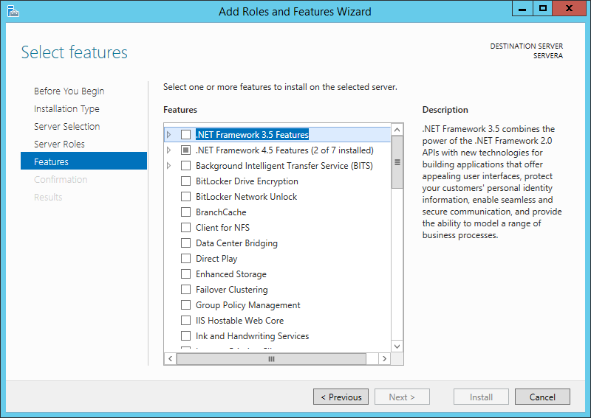

Figure 1-2
The Select features page of the Add Roles and Features Wizard

- Select the Windows Server Migration Tools check box and click Next. The Confirm installation selections page appears.
- Click Install. The wizard installs the Windows Server Migration Tools feature.
- When the installation is completed, click Close. The wizard closes.
- To install the Windows Server Migration Tools on SERVERC, the source server in the migration, you must create a distribution folder on SERVERA and populate it with the installation files for the tools. To create a distribution folder for the Windows Server Migration Tools on SERVERA, right-click the Start button and select Command Prompt (Admin). A Command Prompt window appears.

Question3 | Why can you not install the Server Migration Tools to the server running Windows Server 2008 R2 using the Add Roles and Features Wizard on your server running Windows Server 2012 R2?

- At the prompt, type cd \windows\system32\ServerMigrationTools and press Enter.
- At the prompt, type SmigDeploy.exe /package /architecture “amd64” /os WS08R2 /path “C:\users” and press Enter. The program creates the Windows Server Deployment Tools distribution folder in the specified location.
- Take a screen shot of the Command Prompt window by pressing Alt+Prt Scr and then paste it into your Lab 1 worksheet file in the page provided by pressing Ctrl+V.
- To share the distribution folder, in the Command Prompt window, type net share WSMT=C:\Users.
End of exercise. You can leave the windows open for the next exercise.

Lab Challenge | Accessing a WSMT Distribution Point
Overview | After completing Exercise 1.2, a user on SERVERC, the source server for the migration, can access the installation files for the Windows Server Migration Tools from the distribution point on the destination server, SERVERA.
Mindset | After creating a distribution point for the Windows Server Migration Tools on the server running Windows Server 2012 R2, the source SERVERC can access the distribution point over the network, or by copying the files on a portable storage device.
Completion time | 10 minutes

To complete the challenge, you must install the Windows Server Migration Tools on SERVERC by accessing the shared distribution folder on SERVERA and running the Smigdeploy.exe program with no parameters from an Administrative command prompt. Then, take a screen shot of the Command Prompt window by pressing Alt+Prt Scr and paste it into your Lab 1worksheet file in the page provided by pressing Ctrl+V.

Hint | The distribution folder is already shared on SERVERA, but before SERVERC can access the share, you must turn on File and Printer Sharing on SERVERA.

End of lab. You can log off or start a different lab. If you want to restart this lab, you’ll need to click the End Lab button in order for the lab to be reset.

