Lab 3
Configuring Local Storage
This lab contains the following exercises and activities:
Exercise 3.1  Exercise 3.2  Exercise 3.3  Lab Challenge | Initializing Disks  Creating Simple Volumes  Creating a Storage Pool  Removing Storage Components
BEFORE YOU BEGIN
The lab environment consists of computers connected to a local area network, along with a server that functions as the domain controller for a domain called adatum.com. The computers required for this lab are listed in Table 3-1.
Table 3-1
Computers Required for Lab 3
Computer | Operating System | Computer Name
Domain controller | Windows Server 2012 R2 | SERVERA
Member server | Windows Server 2012 R2 | SERVERB
Member server with three additional SCSI hard drives | Windows Server 2012 R2 | SERVERC
In addition to the computers, you also require the software listed in Table 3-2 to complete Lab 3.

Table 3-2
Software Required for Lab 3
Software | Location
Lab 3 student worksheet | Lab03_worksheet.docx (provided by instructor)

Working with Lab Worksheets
Each lab in this manual requires that you answer questions, create screen shots, and perform other activities that you will document in a worksheet named for the lab, such as Lab03_worksheet.docx. It is recommended that you use a USB flash drive to store your worksheets, so you can submit them to your instructor for review. As you perform the exercises in each lab, open the appropriate worksheet file, fill in the required information, and save the file to your flash drive.
After completing this lab, you will be able to:
- Initialize new disks
- Create storage spaces, disks, and volumes with Server Manager
- Create volumes with the Disk Management snap-in
Estimated lab time: 60 minutes
Exercise 3.1 | Initializing Disks
Overview | In this exercise, you use two different tools to bring three new disks online and initialize them in preparation for creating storage volumes.
Mindset | Adding disk drives is a common server hardware upgrade, requiring an administrator to prepare them for use.
Completion time | 15 minutes

1. Log on to the SERVERC computer, then, in Server Manager, click File and Storage Services. A File and Storage Services submenu appears (see Figure 3-1).

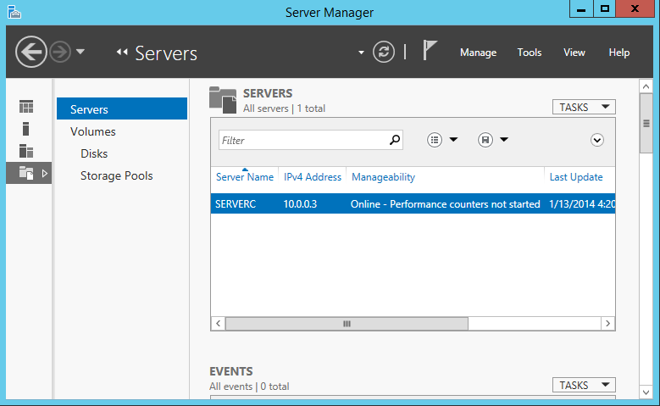
Figure 3-1
The File and Storage Services submenu in Server Manager

2. Click Disks. The Disks page appears, showing one online disk and three offline disks.
Question 1 | The three offline disks all use the SCSI bus type, whereas the online disk uses the ATA bus. Why can’t the three offline disks use the ATA bus as well?

3. Right-click the offline disk number 1 and, from the context menu, select Bring Online. A message box appears, warning you not to bring the disk online if it is already online and connected to another server.
4. Click Yes. The disk’s status changes to Online.
5. Right-click the same disk number 1 and, from the context menu, select Initialize. A message box appears, warning you that any data on the disk will be erased.
6. Click Yes. The disk is partitioned and ready to create volumes.
7. In Server Manager, click Tools > Computer Management. The Computer Management console appears.
8. In the left pane, click Disk Management. The Disk Management snap-in appears (see Figure 3-2).
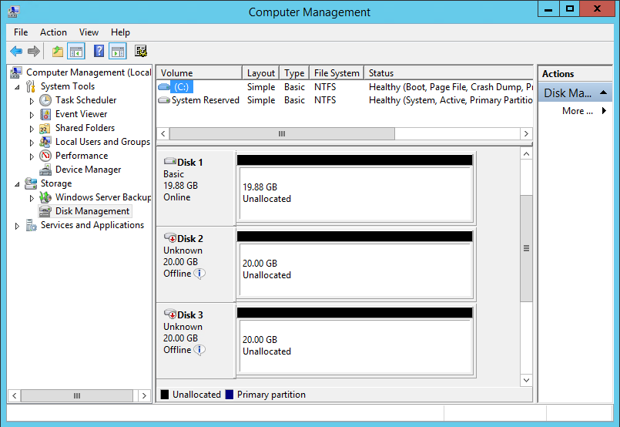

Figure 3-2
The Disk Management snap-in

9. Right-click the Disk 2 tile and, from the context menu, select Online.
10. Right-click the Disk 2 tile a second time and, from the context menu, select Initialize Disk. The Initialize Disk dialog box appears.
11. Select the GPT (GUID Partition Table) option and click OK. The Disk 2 status changes to Online.
12. Repeat steps 9 to 11 to initialize Disk 3.
End of exercise. You can leave the windows open for the next exercise.
Question2 | What advantage is there to using the Disk Management snap-in to initialize new disks, rather than Server Manager?

Exercise 3.2 | Creating Simple Volumes
Overview | In this exercise, you use two methods to create simple volumes, using Server Manager and the Disk Management snap-in.
Mindset | Server Manager and Disk Management both provide wizards for creating simple volumes, with similar capabilities.
Completion time | 15 minutes

1. On SERVERC, in Server Manager, in the File and Storage Services submenu, click Volumes. The Volumes home page appears.
2. Click Tasks > New Volume. The New Volume Wizard appears, displaying the Before you begin page.
3. Click Next. The Select the server and disk page appears.
4. Select Disk 1 and click Next. The Specify the size of the volume page appears.
5. In the Volume size text box, type 10 and click Next. The Assign to a drive letter or folder page appears.
6. Click Next. The Select file system settings page appears.
7. Click Next. The Confirm selections page appears.
8. Click Create. The Completion page appears.
9. Click Close. The new volume appears in the Volumes pane.
10. Switch to the Computer Management console. The new volume you just created appears in the Disk 1 pane of the Disk Management snap-in.
11. Right-click the unallocated space on Disk 2 and, from the context menu, select New Simple Volume. The New Simple Volume Wizard appears, displaying the Welcome page.
12. Click Next. The Specify Volume Size page appears.
13. In the Simple volume size in MB spin box, type 10000 and click Next. The Assign Drive Letter or Path page appears.
14. Click Next. The Format Partition page appears.
15. Click Next. The Completing the New Simple Volume Wizard page appears.
16. Click Finish. The wizard creates the volume, and it appears in the Disk 2 pane.

Question3 | What Windows PowerShell commands should you use to create a simple volume of the same size on disk 3 using the drive letter G:?

17. Create a 10 GB simple volume on disk 3 with the drive letter G: using Windows PowerShell.
18. Press Alt+Prt Scr to take a screen shot of the Disk Management snap-in, showing the three volumes you created, and then press Ctrl+V to paste the resulting image into the Lab 3 worksheet file in the page provided.
End of exercise. Close Computer Management and any formatting prompt windows, if needed, before you begin the next exercise.

Exercise 3.3 | Creating a Storage Pool
Overview | In this exercise, you use the Server Manager console to create a storage pool, which consists of space from multiple physical disks.
Mindset | Storage pools are a new feature in Windows Server 2012 R2, which enable you to create a flexible storage subsystem with various types of fault tolerance.
Completion time | 15 minutes

1. On SERVERC, in Server Manager, on the File and Storage Services submenu, click Storage Pools. The Storage Pools home page appears (see Figure 3-3).
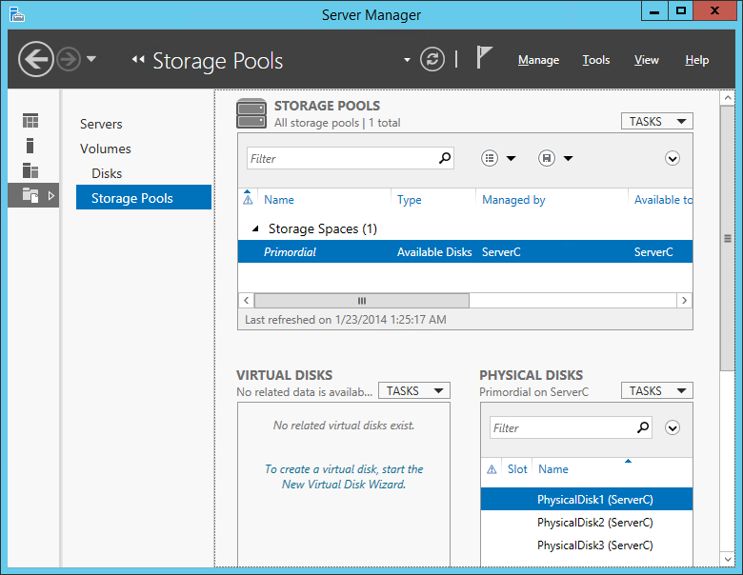

Figure 3-3
The Storage Pools home page

2. In the Storage Pools tile, click Tasks > New Storage Pool. The New Storage Pool Wizard appears, displaying the Before you begin page.
3. Click Next. The Specify a storage pool name and subsystem page appears.
4. In the Name text box, type Pool1 and click Next. The Select physical disks for the storage pool page appears.
5. Select the check boxes for PhysicalDisk1 and PhysicalDisk2 in the list and click Next. The Confirm selections page appears.
6. Click Create. The wizard creates the storage pool.
7. Click Close. The new pool appears in the Storage Pools tile.
8. Select Pool1.
9. In the Virtual Disks tile, click Tasks > New Virtual Disk. The New Virtual Disk Wizard appears, displaying the Before you begin page.
10. Click Next. The Select the storage pool page appears.
11. Click Next. The Specify the virtual disk name page appears.
12. In the name text box, type Data1 and click Next. The Select the storage layout page appears.
13. In the layout list, select Parity and click Next. A warning appears, stating that the storage pool does not contain a sufficient number of physical disks to support the Parity layout.

Question4 | Why can’t the wizard create a virtual disk using the Parity layout when there are only two physical disks in the storage pool?

14. In the layout list, select Mirror and click Next. The Specify the provisioning type page appears.
15. Leave the default Fixed option selected and click Next. The Specify the size of the virtual disk page appears.
16. Select the Maximum size option and click Next. The Confirm selections page appears.
17. Click Create. The wizard creates the virtual disk and the View results page appears. Clear the Create a volume when this wizard closes checkbox.
18. Click Close. The virtual disk appears on the Storage Pools page.
19. Press Alt+Prt Scr to take a screen shot of the Storage Pools page, showing the storage pool and the virtual disk you created, and then press Ctrl+V to paste the resulting image into the Lab 3 worksheet file in the page provided.
20. In the Virtual Disks tile, right-click the Data1 disk you just created and, from the context menu, select New Volume. The New Volume Wizard appears.
21. Using the wizard, create a volume on Disk 4 (Data1) using all of the available space, the NTFS file system, and the drive letter J:.
End of exercise. Close any open windows before you begin the next exercise.

Question5 | At this point in the lab, what would happen to any data stored on the E:, F:, G:, and J: drives if Disk 2 on the server was to fail?

Lab Challenge | Removing Storage Components
Overview | In addition to the graphical tools provided with Windows Server 2012 R2, you can also manipulate the storage subsystem using Windows PowerShell commands.
Completion time | 15 minutes
To complete this challenge, list the Windows PowerShell commands needed to delete all of the storage components you created during this lab on the SCSI disks of SERVERC. Then, restart SERVERC and take a screen shot of the Storage Pools page, showing the removal of the storage pool and the virtual disk you created. Press Ctrl+V to paste the resulting image into the Lab 3 worksheet file in the page provided.

End of lab. You can log off or start a different lab. If you want to restart this lab, you’ll need to click the End Lab button in order for the lab to be reset.

