- What was the purpose of TigerVNC?
________________________________________________________________________________
________________________________________________________________________________
________________________________________________________________________________
- What was the purpose of Kali Linux?
________________________________________________________________________________
________________________________________________________________________________
________________________________________________________________________________
- What did the following command do when typed in Kali Linux’s terminal window?
nmap 192.168.0.0/24 > hosts.txt
________________________________________________________________________________
________________________________________________________________________________
________________________________________________________________________________
- What did the following command do when typed in Kali Linux’s terminal window?
nmap –O –sS 192.168.0.0/24 > hosts.txt
________________________________________________________________________________
________________________________________________________________________________
________________________________________________________________________________
- What was the difference between nmap and zenmap?
________________________________________________________________________________
________________________________________________________________________________
________________________________________________________________________________
General Questions about Network Footprinting
Guidelines
- Answer each of the following questions using knowledge gained from the iLab, readings from the textbook, and individual research on the Web. Answer all questions in full graduate-level sentences and paragraphs.
- What is accomplished by network footprinting?
________________________________________________________________________________
________________________________________________________________________________
________________________________________________________________________________
- What are the countermeasures a network security architect can set in motion to diminish the threat from network footprinting?
________________________________________________________________________________
________________________________________________________________________________
________________________________________________________________________________
- What is the difference between network footprinting and network reconnaissance?
________________________________________________________________________________
________________________________________________________________________________
________________________________________________________________________________
- In the context of network security, explain what is meant by after reconnaissance comes penetration.
________________________________________________________________________________
________________________________________________________________________________
________________________________________________________________________________
- What is a denial of service (DOS) attack?
________________________________________________________________________________
________________________________________________________________________________
________________________________________________________________________________

Conclusion
Guidelines
Minimum of two paragraphs that describe the following:
- What you accomplished in the assignment or iLab
- What you learned from performing it
- How it relates to course material
- How you feel it will benefit you in your academic and professional career
________________________________________________________________________________
________________________________________________________________________________
________________________________________________________________________________
________________________________________________________________________________
________________________________________________________________________________
________________________________________________________________________________
________________________________________________________________________________
________________________________________________________________________________
________________________________________________________________________________
________________________________________________________________________________
________________________________________________________________________________
________________________________________________________________________________

Figure for question 3 after opening it up on leafpad

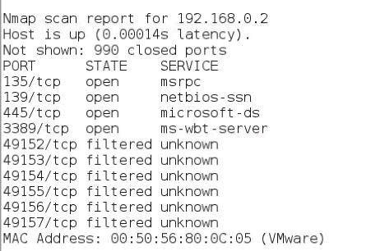

Figure for question 4 after opening it up on leafpad

References

Guidelines
- Include all references used to complete this iLab. This must be in APA format.

