
AMITY INSTITUTE OF TELECOM TECHNOLOGY & MANAGEMENT

AN INTERNSHIP EXPERIENCE REPORT ON

HETEROGENEOUS NETWORKS

By

INTERNSHIP WITH
SABS KPO Solutions Pvt. Ltd.

UNDER THE GUIDANCE OF
MR. AJAY RANJAN MISHRA
Managing Director

DURING MAY - JULY 2013

CREDIT UNITS: 9 CREDITS

REMARKS BY FACULTY-IN-CHARGE

DECLARATION

I, Nandini Deb, student of M.Tech. (TSE) hereby declare that the internship experience report on “Heterogeneous Networks” which is submitted by me to Amity Institute of Telecom Technology and Management, Amity University, Noida, Uttar Pradesh, in partial fulfillment of requirement for the award of the degree of Master in Technology in Telecommunication Systems Engineering, has not been previously formed the basis for the award of degree, diploma or other similar title or recognition.

Nandini Deb

ACKNOWLEDGEMENT

I would like to take this opportunity to thank the following individuals, institution and organization without whom this Internship Report could not have been successfully completed.
My industry mentor, Mr. Ajay Ranjan Mishra, for his wise counsel and unparalleled encouragement, without which it would not have been possible for me to gain complete knowledge of the topics essential to this project.
My faculty-in-charge, Mrs. A Devi Priya, for her continuous support and motivation to complete my work on time. A debt of gratitude to Mr. O. P. Aurora, AITTM’s IIC head, for arranging this internship.
I am deeply obliged to the Head of the Department, Prof. R. K. Kapur, my program leader Mr. Jitendra Singh Jadon and my class teacher Dr. Arun Kumar for sparing their precious time in providing guidance to me for the moble rendition of the ideas in my mind into this report.
My heartfelt gratitude to all of them for their support and direction in writing this essential piece of work.

Nandini Deb (A1637012017)
Noida, India

Table of Contents

- Introduction | 7
- Analysis of the Company | 9
- Internship Experience  - Introduction  - HetNet Architecture  - Technologies used in HetNet  - Topologies of HetNet  - Approach to HetNet Implementation  - Key HetNet Technologies  - Precise Hotspot Identification  - Integrated Micro Base Stations  - Macro-Micro Base Station Coordination  - Flexible Base Station Coordination  - Self-Organizing Network Features  - MIMO Technology  - Network Elements of HetNet  - 2G/2.5G  - 3G/3.5G  - 4G LTE  - Femtocell  - IMS Core  - Design Challenges  - Interference Issue  - Backhauling Issue  - Handover Issue  - Self-Organization Issue  - Security Issue  - Model Design of Secure Heterogeneous Networks  - Conclusion & Future Scope | 10  11  14  14  26  27  29  29  29  30  30  30  32  33  33  36  38  40  41  46  46  54  57  60  60  80  88
- Reference | 89

INTRODUCTION

An internship is a kind of on-the-job training for white-collar and professional careers. Internships for professional careers are quite similar to apprenticeships for vocational and trade jobs. Internship is typically done by college or university students and post-graduate scholars, and also by high-school students and middle school students. Internships may be paid or unpaid, and are usually understood to be temporary positions.
Generally, an internship brings in an exchange of services for experience between the student and the organization he/she is interning with. Internship can also be used by the students to determine if they have interest in a particular career, create a network of contacts, or gain university credits. Some interns find permanent, paid employment with the company with which they interned. This can be a significant benefit to the employer as experienced interns often need little or no training when they start regular employment.
My internship experience with SABS KPO Solutions Pvt. Ltd. started off when the company’s Managing Director Mr. Ajay Ranjan Mishra came to interview some of the PG students in college. When three of us were selected for internship with the company, we were very excited as we were getting a chance to work with such renowned personality. My internship started on 6th May, 2013 and ended on 3rd July, 2013. As an intern at the organization, I was responsible for assisting Ajay sir in his research work. I have been fortunate that he took time out of his busy schedule to assist and guide me in every possible way. My responsibility was not only to assist him in his research work but also to help effectively manage the work output of it.
During my internship with SABS, I have developed the following skills:
- Became an effective communicator with good interpersonal skills;
- Developed specific job competencies like how to proceed with a research project;
- Explored possible career opportunities;
- Learnt how to broaden the horizon of my knowledge;
- Gained sufficient industry exposure;
- Developed work ethics and timeliness.
It was a great experience to work for SABS and under Ajay sir who has helped me to acquire these skills. It has helped me to have a better understanding of my strengths and weaknesses and also helped me to figure out where I stand in the corporate world.

ANALYSIS OF THE COMPANY

SABS is a Global Knowledge Process Outsourcing, Consultancy & Training Solutions Development Company. Having consultants and partners that are sitting in various locations and continents across the world, we are best placed to understand your challenges and not only support you in your business growth but also in finding you solutions of the problems that are hindering the growth.
Innovation is in our genes; our mission is to enable organizations to unleash their potential and translate ideas into results of commercial value by offering practical, result oriented solutions with out-of-box thinking that is time-bound.
The company was started in June 2011 by group of well-respected consultants based across the world. The company is led by Ms. Shilpy Mishra who is Chief Executive Officer. Before starting the venture, she was Heading Marketing for well-respected brands in pharmaceutical industry such as Zydus, Astra Zeneca, Morepen etc. Other directors include Mr Sandeep Agarwal and Mr Rajesh Goyal. The Advisory board includes world famous consultants from across the globe. The board is chaired by Ajay Ranjan Mishra.
In last year, SABS made strides in Global Industry and some of its clients include VEK 21 (Education, Russia), Joy Global (Mining, China), Melbourne University (Knowledge Processing, Australia) etc.
SABS is based in New Delhi, India.

INTERNSHIP EXPERIENCE

HETEROGENEOUS NETWORKS
HetNet-
The mobile network of tomorrow

Abstract:
Heterogeneous Network is the future of mobile networking. It is considered to be the next big thing after 4G LTE. Though it is not commercially deployed yet, industry is preparing itself for future HetNet deployment. In this report, I have discussed in details the Network elements, architecture and design issues of HetNet. Lastly I have focused on the Security problem of HetNet design and I have mentioned various loopholes in present system which needs to be worked upon. Lastly, I have proposed an algorithm on security which I will work in upcoming future.

Chapter 1.

INTRODUCTION

As usage of data hungry smartphones are increasing in today’s fast-paced world, uploading pictures, watching live television and streaming videos, using cloud-based services- all of such types of applications are striving for higher and higher demands on the mobile networks. Simultaneously, the numbers of devices getting connected to a single network are also increasing at a rapid rate. It can be said that this trend of rise in smartphone and data device penetration and new data hungry applications is bringing in the demand for mobile broadband (MBB) to grow exponentially, which in turn requires significant rise in network capacity, which can be acquired by enhancing the present existing technology. Here comes the requirement of HetNet.
A HetNet is a network (wireless) which uses multiple types of access nodes in a wireless network. It can be described as a network with complex interoperation between large Macrocells and smaller cells including Microcells (<5 W), Picocells (<1 W) and Femtocells (200 mW), and in some cases Wi-fi network elements combined together to give a mosaic of coverage with good hand off capability between the network elements.
HetNets bring a mix of radio technologies and cell types which work together seamlessly to deliver a consistent, high quality mobile broadband experience. It is believed by mobile industry experts that HetNet will turn today’s big-tower cellular systems into dense, multi-layered and tremendously high capacity networks.
HetNets have 3 major components:
- An umbrella or “Macro” Network to provide an omnipresent coverage of Mobile Broadband.
- A crowded network of small cells which can provide huge quantities of Bandwidth in high density traffic areas.
- The Brilliance of a network that binds together all those networks- to control it all.
Hetnet is not a distinct network by itself- it is a gradual evolution of cellular topology. The term “heterogeneous” implies that various types of networks like wi-fi, home and public femtocells, picocells and microcells will be implemented in different levels of network hierarchy but all of them will eventually come together to form a larger network as a whole [3]. Keeping in mind the scary statistics of mobile demand for data, especially in the Hotspot regions, operators are increasing the number of base stations in those regions and improving Spectral efficiency using technologies like dual carrier (DC), Multiple-Input-Multiple-Output (MIMO) and Long-term-evolution (LTE). However, Base station deployment is not the ultimate solution to meet this rising demand as it either hits the saturation point after it reaches its capacity limit or become unreasonable in some urban areas, hence to fill the vacancies, other technologies like Wi-Fi and Micro Base stations are being used, hence making a HetNet Architecture, which is evolving not by design, but by need of the moment.
Present day, technologies like 3G/4G and Wi-Fi work side by side, but they do not work together. When one enters into an authorized hotspot area his device will log in, while the cellular connection runs parallel and separately along with the newly established connection. As one moves away from the access point (AP), the Wi-Fi connection turns weaker and gradually reaches a point when device gets disconnected from the Wi-Fi connection and turns its way back to the cellular grid [6]. This is not an ideal or seamless experience.
HetNet is aiming towards removing this difficulty. It is bringing in new traffic steering technologies which will make two separate networks act as one, choosing the best connection at a given time. For example, if a user suddenly enters an overloaded and congested hotspot, the new network knows to keep the user connected to the 3G cell instead of pushing him onto an almost useless Wi-Fi connection. As the traffic levels vary on these networks, the user’s device network is shifted between them in real time mode. This will be a major component of HetNets which will use various Radio technologies to make multi-layered, high-capacity networks. According to Petri Hautakangas, Head of technology, Nokia Siemens North America, it is just the 1st step. He says that Networks and devices will eventually be able to balance traffic between networks, as well as ship data simultaneously across multiple Radio connections.
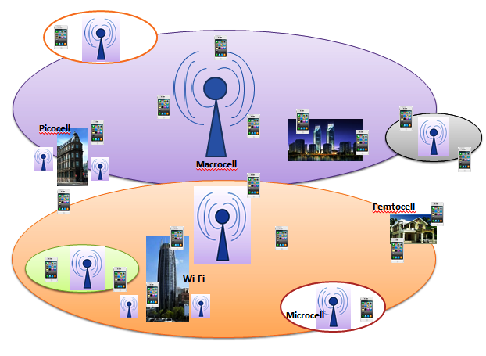
Figure 1. LTE Advanced Heterogeneous Network

Chapter 2.

HETNET ARCHITECTURE

  - Technologies used in HetNet - Brief Overview:
    - Cellular Technologies
In a cellular radio system, a land area to be supplied with radio service is divided into 27regular shaped cells, which can be hexagonal, square, circular or some other regular shapes, although hexagonal cells are conventional. Each of these cells is assigned multiple frequencies (f₁ – f₆) which have corresponding radio base stations. The group of frequencies can be reused in other cells, provided that the same frequencies are not reused in adjacent neighboring cells as that would cause co-channel interference. Generally, the cells are arranged in a honeycomb pattern to provide local, regional or national coverage.
Cellular networks are formed with three main components: Base stations (BSs), Mobile telephone switching offices (MTSO) and mobile devices. A radio transceiver and controller is put on each base station to provide radio communication to the mobile units located in its cell. The MTSOs are interconnected by copper, fiber optic or microwave technology and acts as a Central Office (CO) exchange allowing users to connect to local as well as long distance public telephone systems. MTSOs continuously check the communication signal quality and it can transfer a call to another base station which can give better signal to the mobile device.
A simple view of the cellular mobile-radio network consists of the following:
- A network of radio base stations forming the base station subsystem.
- The core circuit switched network for handling voice calls and text
- A packet switched network for handling mobile data
- The public switched telephone network to connect subscribers to the wider telephony network
The mobile communication devices consist of hand held phones, car phones, notebook computers, personal digital assistants, pen-based computers, palm-top computers, and portable data collection devices. When these mobile units communicate to the network, they must register with the system by subscribing to a carrier service [7]. Most carrier services have arrangements with other providers allowing users to roam. Roaming occurs when the mobile unit is outside the coverage of their cellular service provider and an alternative cellular provider places the call.
Cellular technology extends the bounds of a corporation's existing telecommunications infrastructure by connecting mobile units to the public network operated by the local exchange or long distance carriers. The cellular users have special features and functions specific to cellular customers but they can also use the features and functions of the public phone systems. This allows cellular technology to be flexible enough to take advantage of features and functions of almost any public or private network.
Radio channels effectively use the transmission medium through the use of the following multiplexing & access schemes: frequency division multiple accesses (FDMA), time division multiple access (TDMA), code division multiple access (CDMA), and space division multiple access (SDMA).
Four Generations of Cellular Telephony:
First Generation (1G) cell phones belong to the first generation of wireless telephone technology which was only used for Analog voice conversation. Antecedent to 1G technology is the mobile radio Telephone, or 0G. 1G was followed by 2G. Four main advantages of 2G networks over 0G and 1G were: The Radio signals on 2G networks are digital; Security: the phone conversations were digitally encrypted; Better Spectrum Utilization with greater penetration density and 2G brought in data services for mobile, introducing SMS text messages, picture messages and multimedia messages (MMS). 2G has been superseded by newer and better technologies like 2.5G, 2.75G. 3G, 4G and 5G. However, 2G networks are still used in many parts of the world [9].
While 2G can be used for the purpose of slow internet access, most Internet traffic has now moved to 3G wherever it is available. Application of 3G includes wireless voice telephony, mobile internet access, Video calls and Mobile TV. Recent 3G releases 3.5G and 3.75G also provide high Mbps mobile broadband access to smartphones and MODEMs in laptops. Below are given the standards that are branded as 3G:
- Universal Mobile Telecommunications System (UMTS)
The UMTS system, standardized by 3rd Generation Partnership Project (3GPP) first evolved in 2001. UMTS includes W-CDMA using paired or unpaired 5 MHz wide channels in bandwidth (agreed globally) around 2 GHz, although further bandwidth has been allocated on a regional basis by ITU. The radio access specifications provide for Frequency Division Duplex (FDD) and Time Division Duplex (TDD) variants, and several chip rates are provided for in the TDD option, allowing UTRA technology to operate in a wide range of bands and co-exist with other radio access technologies. These are detailed in 3GPP Technical Specifications 25.101 (FDD) and 25.102 (TDD), and allow for the eventual re-use of bands currently assigned to 2G services. High Speed Packet Access (HSPA) was introduced in Releases 5 (Downlink) and 6 (Uplink) giving substantially greater bit rates and improving packet-switched applications [10]. Unlike EDGE (IMT Single-Carrier, based on GSM) and CDMA2000 (IMT Multi-Carrier), UMTS requires new base stations and new frequency allocations.
UMTS functions on various spectrum bands of 450, 700, 850, 900, 1700, 1800, 1900, 2100 and 2600 MHz bands. It is known that signals travel farther at low frequencies; hence UMTS networks at 850 and 900 MHz fits well for covering sparsely populated rural areas [11]. UMTS operators has an advantage of using a common core network that supports various Radio access networks like GSM, EDGE, WCDMA, HSPA. Hence this network is called the UMTS multi-radio network, giving mobile operators maximum flexibility to provide various services across their coverage areas.
The latest UMTS release, HSPA+, can give peak data rates up to 56 Mbps in the downlink and 22 Mbps in the uplink.
- CDMA2000 System
This system has been standardized by 3GPP2 and used mainly in North America and South Korea, sharing infrastructure with IS-95 2G standards. Cell phones of today are typically IS-95 and CDMA2000 Hybrids [12]. CDMA2000 includes CDMA2000 1x and CDMA2000 High Rate Packet Data (EVDO), evolving from the IS-95 CDMA system.
4G is the successor of 3G standards. A 4G system is capable of running applications like mobile ultra-broadband internet access to smartphones, laptops with USB wireless modems, high definition mobile TV, IP telephony, gaming services, Video Conferencing, 3D television and Cloud Computing.
In present scenario, two 4G systems are being commercially deployed:
- Mobile WiMax Standard
It was first deployed in South Korea in 2006. WiMax (Worldwide Interoperability for Microwave Access) is a wireless communications standard designed to provide 30-4- Mbps data rates with 1 Gbps for fixed stations. WiMax is sometimes referred to as “Wi-Fi on steroids” as it is similar to Wi-Fi, but it can work at much greater distances. It can be used for a number of applications including Cellular backhaul, Broadband connections, Hotspots, providing data, telecommunications (VoIP) and IPTV services.
- Long Term Evolution(LTE) Standard
It was first deployed in Oslo, Norway and Stockholm, Sweden in 2009. It is based on GSM/EDGE and UMTS/HSPA technologies, increasing the speed and capacity by using a completely different radio interface with core network improvements.
As opposed to earlier generations, a 4G system does not support traditional circuit-switched telephony service, but all-Internet Protocol (IP) based communication such as IP telephony. The spread spectrum radio technology used in 3G systems is abandoned in all 4G candidate systems and replaced by OFDMA multi-carrier transmission and other frequency-domain equalization (FDE) schemes, making it possible to transfer very high bit rates despite extensive multi-path radio propagation (echoes). The peak bit rate is further improved by smart antenna arrays for multiple-input multiple-output (MIMO) communications.

Generation | 1G | 2G | 3G | 4G
Decade of Evolution | 1980s | 1990s | 2000s | 2010s
Coverage | Outdoor | Indoor/Outdoor | Global Roaming | Global Roaming
Data speed | 9.6-28 Kbps | Up to 100 Kbps | Up to 2 Mbps | Up to 100 Mbps
Current status | Obsolete | Deployed | Deploying | LTE technology expected to beat Mobile WiMax
Connection mode | Circuit | Circuit | “Always on”-packet | “Always on”- packet
Applications | Business Voice | Consumer Voice | Voice and some data | Data including voice

Table 1. Chart showing the transformation from 1G to 4G.
    - WI-FI
Wi-Fi is the name of a popular wireless networking technology that uses radio waves to provide wireless high-speed Internet and network connections. A common misconception is that the term Wi-Fi is short for "wireless fidelity," however this is not the case. Wi-Fi is simply a trademarked term meaning IEEE 802.11x. The Wi-Fi Alliance, the organization that owns the Wi-Fi (registered trademark) term specifically defines Wi-Fi as any "wireless local area network (WLAN) products that are based on the Institute of Electrical and Electronics Engineers' (IEEE) 802.11 standards."
Initially, Wi-Fi was used in place of only the 2.4GHz 802.11b standard; however the Wi-Fi Alliance has expanded the generic use of the Wi-Fi term to include any type of network or WLAN product based on any of the 802.11 standards, including 802.11b, 802.11a, dual-band, and so on, in an attempt to stop confusion about wireless LAN interoperability.

How Wi-Fi Works
Wi-Fi works with no physical wired connection between sender and receiver by using radio frequency (RF) technology, a frequency within the electromagnetic spectrum associated with radio wave propagation. When an RF current is supplied to an antenna, an electromagnetic field is created that then is able to propagate through space. The cornerstone of any wireless network is an access point (AP). The primary job of an access point is to broadcast a wireless signal that computers can detect and "tune" into. In order to connect to an access point and join a wireless network, computers and devices must be equipped with wireless network adapters [14].

Wi-Fi Support
Wi-Fi is supported by many applications and devices including video game consoles, home networks, PDAs, mobile phones, major operating systems, and other types of consumer electronics. Any products that are tested and approved as "Wi-Fi Certified" (a registered trademark) by the Wi-Fi Alliance are certified as interoperable with each other, even if they are from different manufacturers. For example, a user with a Wi-Fi Certified product can use any brand of access point with any other brand of client hardware that also is also "Wi-Fi Certified". Products that pass this certification are required to carry an identifying seal on their packaging that states "Wi-Fi Certified" and indicates the radio frequency band used (2.5GHz for 802.11b, 802.11g, or 802.11n, and 5GHz for 802.11a).
    - Macrocells and Smallcells
    - Macrocells
Macro cell is the conventional operator involved Base station with a dedicated backhaul, providing public access and wide area coverage up to a few kilometers.
A macro cell provides the largest area of coverage within a mobile network. The antennas for macro cells can be mounted on ground-based masts, rooftops or other existing structures. They must be positioned at a height that is not obstructed by terrain or buildings. Macro cells provide radio coverage over varying distances depending on the frequency used, the number of calls made and the physical terrain. Macro cell base stations have a typical power output in tens of watts.
    - Smallcells
Small cells are low-powered radio access nodes that operate in licensed and unlicensed spectrum that have a range of 10 meters to 1 or 2 kilometers, compared to a mobile macro cell which might have a range of a few tens of kilometers. With mobile operators struggling to support the growth in mobile data traffic, many are using Mobile data offloading as a more efficient use of radio spectrum. Small cells are a vital element to 3G data off-loading, and many mobile network operators see small cells as vital to managing LTE Advanced spectrum more efficiently compared to using just macro cells. ARCchart estimates that by 2017 a total of 5 million small cells will ship annually.
Small cells encompass femto cells, pico cells, and microcells. Small-cell networks can also be realized by means of distributed radio technology consisting of centralized baseband units and remote radio heads. Beam forming technology (focusing a radio signal on a very specific area) can be utilized to further enhance or focus small cell coverage. A common factor in all these approaches to small cells is that they are centrally managed by mobile network operators.
Small cells provide a small radio footprint, which can range from 10 meters within urban and in-building locations to 2 km for a rural location. Picocells and microcells can also have a range of a few hundred meters to a few kilometers, but they differ from femtocells in that they do not always have self-organizing and self-management capabilities.

Compatible technology
Small cells are available for a wide range of air interfaces including GSM, CDMA2000, TD-SCDMA, W-CDMA, LTE and WiMax. In 3GPP terminology, a Home Node B (HNB) is a 3G femtocell. A Home eNode B (HeNB) is an LTE femtocell. Wi-Fi is a small cell but does not operate in licensed spectrum therefore cannot be managed as effectively as small cells utilizing licensed spectrum. The detail and best practice associated with the deployment of small cells varies according to use case and radio technology employed
Small cells can be used to provide in-building and outdoor wireless service. Mobile operators use small cells to extend their service coverage and/or increase network capacity. With small cells, mobile operators can offload traffic as much as 80% during peak times. ABI Research estimates that by 2015, 48% of mobile data traffic will be offloaded from the macro network. No individual technology will dominate offloading.
ABI Research also believes that small cells also help service providers discover new revenue opportunities through their location and presence information, argues ABI Research. If a registered user enters a femtozone, the network is notified of their location. The service provider, with the user's permission, could share this location information to update user's social media status, for instance. Opening up small-cell APIs to the wider mobile ecosystem could enable a long-tail effect.
Rural coverage is also a key market that has developed as mobile operators have started to install public access metrocells in remote and rural areas that either have only 2G coverage or no coverage at all. The cost advantages of small cells compared with macro cells make it economically feasible to provide coverage of much smaller communities - from a few tens to a few hundreds. The Small Cell Forum has published a white paper outlining the technology and business case aspects.
- Microcells
A microcell is a cell in a mobile phone network served by a low power cellular base station (tower), covering a limited area such as a mall, a hotel, or a transportation hub. A microcell is usually larger than a Pico cell, though the distinction is not always clear. A microcell uses power control to limit the radius of its coverage area. Typically the range of a microcell is less than two kilometers wide, whereas standard base stations may have ranges of up to 35 kilometers (22 mi). Like picocells, microcells are usually used to add network capacity in areas with very dense phone usage, such as train stations. Microcells are often deployed temporarily during sporting events and other occasions in which extra capacity is known to be needed at a specific location in advance.
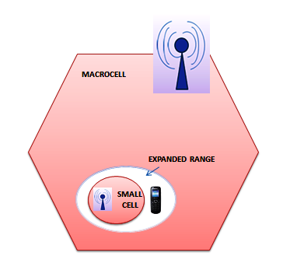
Figure 2. Macrocell and Smallcell

- Picocells
Picocells are operator involved low power small cellular base stations where there is no much of macrocell capacity reach. A picocell covers a small area, such as in-building (offices, shopping malls, train stations, stock exchanges, etc.), or more recently in-aircraft. In cellular networks, picocells are typically used to extend coverage to indoor areas where outdoor signals do not reach well, or to add network capacity in areas with very dense phone usage, such as train stations. Picocells provide coverage and capacity in areas difficult or expensive to reach using the more traditional Macrocell approach.
In cellular wireless networks, such as GSM, the picocell base station is typically a low cost, small (typically the size of a ream of A4 paper), reasonably simple unit that connects to a Base Station Controller (BSC). Multiple picocell 'heads' connect to each BSC: the BSC performs radio resource management and hand-over functions, and aggregates data to be passed to the Mobile Switching Centre (MSC) and/or the Gateway GPRS Support Node (GGSN).
Connectivity between the picocell heads and the BSC typically consists of in-building wiring. Although originally deployed systems (1990s) used PDH links such as E1/T1 links, more recent systems use Ethernet cabling. Aircraft use satellite links. More recent work has developed the concept towards a head unit containing not only a picocell, but also many of the functions of the BSC and some of the MSC. This form of picocell is sometimes called an access point base station or 'enterprise femtocell'. In this case, the unit contains all the capability required to connect directly to the Internet, without the need for the BSC/MSC infrastructure. This is potentially a more cost effective approach.
Picocells offer many of the benefits of "small cells" (similar to femtocells) in that they improve data throughput for mobile users and increase capacity in the mobile network. In particular, the integration of picocells with macrocells through a Heterogeneous Network can be useful in seamless handoffs and increased mobile data capacity. Picocells are available for most cellular technologies including GSM, CDMA, UMTS and LTE from manufacturers including IP access, ZTE, Huawei and Airwalk. Typically the range of a microcell is less than two kilometers wide, a picocell is 200 meters or less, and a femtocell is on the order of 10 meters, although AT&T calls its product, with a range of 40 feet (12 m), a "microcell".
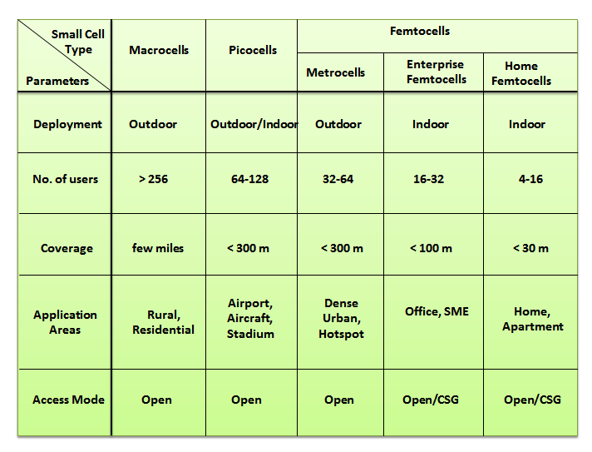
Table 2. Summary of HetNet small cell devices
- Femtocells
In telecommunications, femtocells are small, low-power user deployed cellular base stations, typically designed for use in a home or small business. Femtocells consume lesser power and have lower cost offloading data traffic using DSL or fiber optic lines connected across. A broader term which is more widespread in the industry is small cell, with femtocell as a subset. It connects to the service provider’s network via broadband (such as DSL or cable); current designs typically support two to four active mobile phones in a residential setting, and eight to 16 active mobile phones in enterprise settings. A femtocell allows service providers to extend service coverage indoors or at the cell edge, especially where access would otherwise be limited or unavailable. Although much attention is focused on WCDMA, the concept is applicable to all standards, including GSM, CDMA2000, TD-SCDMA, WiMAX and LTE solutions.
For a mobile operator, the attractions of a femtocell are improvements to both coverage and capacity, especially indoors. Consumers benefit from improved coverage and potentially better voice quality and battery life. Depending on the carrier they may also be offered more attractive tariffs, e.g., discounted calls from home. Femtocells are an alternative way to deliver the benefits of fixed-mobile convergence (FMC). The distinction is that most FMC architectures require a new (dual-mode) handset which works with existing unlicensed spectrum home/enterprise wireless access points, while a femtocell-based deployment will work with existing handsets but requires installation of a new access point that uses licensed spectrum.
Many operators have launched femtocell service, including Vodafone, SFR, AT&T, Sprint Nextel, Verizon and Mobile TeleSystems. In 3GPP terminology, a Home Node B (HNB) is a 3G femtocell. A Home eNode B (HeNB) is an LTE femtocell.
Relays are access points deployed by operator which routes traffic from macro BS to end users and vice-versa, improving reception in poor coverage areas and dead spots on the existing networks.
Remote Radio Heads (RRH) is lower weight units with higher power which are placed outside the conventional BSs and connected through a fiber optic cable resulting in a distributed BS.
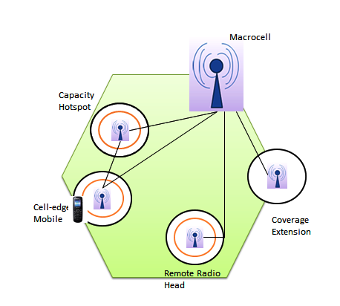
Figure 3. Cell site showing various functional units.

  - TOPOLOGIES OF HETNET
Development today is occurring from single technology network to multi-cellular technology, evolving further to multi-technology networks. These developments form the base of topologies of HetNet which can be categorized as below:
        - Multiple frequencies of same cellular technology e.g. HSPA working together.
To support the topology, spectrum reframing is done in the networks between cellular technologies.

        - Multiple Cellular technologies like HSPA and LTE working together.
The topology demands evolution of network infrastructure to address the difference in RF and packet core technology between different cellular technologies like HSPA and LTE.
        - Different technologies like cellular (HSPA, LTE) and Wi-Fi working together.
This topology requires common elements in the packet core to bring continuity of IP address and user experience across access of multiple technologies which should be recognized, authenticated and served seamlessly by both cellular and other accesses like Wi-Fi.
        - Active technologies like Cellular interacting seamlessly with passive DAS type technologies.
This topology involves mechanisms by which active technologies are extended to passive technologies to broaden their reach. It may bring in some discontinuity in user experience depending on the degree of integration or meshing of networks with one another.
  - APPROACH TO HETNET IMPLEMENTATION
A Het-Net may be implemented in any of these three approaches:
          - Device Driven
Operator has no control in ensuring network consistency in this approach. Device intelligence and priority acts as the driving factor for selection and reselection of networks. This approach is generally transparent to the user.

          - End User Driven
This case occurs when different networks in the HetNet lacks parity. That is when end user makes a conscious decision to move between networks and select-reselect them.
    - Core Network Driven
The various wireless accesses may be served by a common core that provides the IP address, hence offering seamless offload between different wireless access technologies. In this case, network is responsible for monitoring and triggering the device to move between component networks of the HetNet.

Chapter 3.

KEY HETNET TECHNOLOGIES

  - PRECISE HOTSPOT IDENTIFICATION
A hotspot is a region which offers access to internet over a wireless Local Area Network (WLAN) using a Router which is connected to an Internet Service provider (ISP) over a link. Hotspots typically use Wi-Fi technology [5].
Before distributing a HetNet, mobile operators should be able to locate Hotspots with high traffic. For wide-ranging hotspots, operators can add carriers or split sectors on Macro BSs [4]. For small range hotspots, operators can deploy Micro BSs.
Micro BSs can efficiently offload Macro BSs traffic only when they are put on Hotspots. Operators can obtain Network traffic Maps by gathering information like traffic geo-information, related locations and grid maps of live user equipment (UE) on the network.
The recommended precision of a generated traffic map is a 50*50 meter grid, which allows the operator to identify hotspots and where to deploy the micro BSs.

  - INTEGRATED MICRO BASE STATIONS
As site acquisition is becoming expensive day by day, micro base station deployment is gaining popularity as they can be deployed onto small areas like poles or walls. To achieve this, it requires a simple and clean installation process. The following factors should be kept in consideration while designing such base stations:
- Power supply;
- Transmission support;
- Surge protection;
- Less Robust form factor (Spherical or Rectangular);
- Weight should not exceed 8 kg so that a single person can install it single-handedly.

  - MACRO-MICRO BASE STATION COORDINATION
One of the major benefits of HetNet is that Micro base stations can use the same frequencies as Macro base stations. However, proper coordination is needed to reduce interference between them. This can be achieved by flexibly allocating carriers among Micro base stations to maximize capacity when number of traffic hotspots increases and more micro BSs are deployed at a time.

  - FLEXIBLE BASE STATION BACKHAUL
As most micro base stations are grafted hence flexibility in backhaul is needed. Both fixed and wireless backhaul is required for the last mile solutions of these micro BSs. As wireless backhaul, in spite of being flexible, is less reliable, hence fixed base stations serves to be the better option. Fibre is the primary medium for fixed BS backhaul via Point to point (P2P) or Passive Optical network (PON) with optical network units (ONU) deployed either indoors or outdoors. For wireless backhaul deployment, there are many options like 60 GHz microwave, LTE TDD, E-band microwave or wi-fi each having its own advantages over other.

  - SELF ORGANIZING NETWORK (SON) FEATURES
According to expert estimation, five years from now, Micro base station deployment will exceed the number of Macro BSs to meet mobile broadband network requirements. Here comes the necessity of SON as it enables easy deployment and maintenance hence reducing operational and maintenance costs over long term period.
A self-organizing Micro BS can automatically detect the surrounding radio environment conditions and automatically plan and configure the radio parameters like frequency and transmission power. A traditional Base station is incapable of carrying out this functionality.
The Self-Optimizing Network (SON) framework was originally developed as an essential component of LTE, but soon it extended to handle 2G and 3G networks [25]. Objective of SON s to improve user experience and control the OPEX associated with management of increasingly large and multifaceted networks. Through SON framework, a network is capable of detecting changes to the network itself, its environment and to determine and implement a proper course of action for network performance optimization.
The SON functionality will be spread across various network components:
- Inside macro cells and small cells;
- Within RAN vendors Element Management System (EMS) or Network Management System (NMS);
- Externally in a separate OSS system.
The initial SON use cases focused on the following areas of the Radio Network:
- Planning;
- Deployment;
- Optimization;
- Maintenance.
As the LTEs and HetNets matured, SON continued to evolve and its framework extended into areas like Backhaul Configuration and Energy Management. SON has been standardized by 3GPP and is divided into 3 categories:
- Self-optimization;
- Self-configuration;
- Self-healing.
Release 8 includes features like eNB self-configuration, Automatic Neighbor Relation (ANR) and PCI Selection. Release 9 and 10 brings in functions to support expanding networks and features such as Mobility Robustness Optimization (MRO) and Mobility Load Balancing (MLB). Release 11 introduces features like ANR and MRO to support inter-RAT use cases and Release 12 brings in multi-vendor eNB self-configuration.

  - MIMO TECHNOLOGY
Multiple-input-Multiple-Output (MIMO) is a major technology for Radio networks as it has two major benefits of high spectral efficiency and single site capacity. It will soon be commercially deployed in near future as soon as the supporting terminals become commercially available. MIMO and higher order MIMO (HO-MIMO) have the capability of multiplexing more than four channels hence enabling multi-channel transmission and reception for base stations with dual-polarized antennas.

Chapter 4.

NETWORK ELEMENTS OF HETNET

Heterogeneous Networks basically contains a variety of types of Base stations (BSs), Radio Access Networks (RANs), Transmission solutions and Power levels. This combination of such a variety of technologies provides the best option of choice but brings with it some operational problems which occur due to the wide variation of technologies and approaches. In spite of these difficulties, mobile operators are giving effort to adopt the HetNet approach to meet the two major goals of capacity and coverage to fulfill the exponentially rising demands of mobile networks.
To meet the challenges of increasing demand for improved performance and lower cost, operators are required to use a wide range of technologies to secure optimum operation of their networks in all kinds of possible scenarios. The motive is not only to provide coverage but the right form of coverage which can be achieved by the use of macro cells and small cells. This in turn requires the deployment of various types of Base stations and also implementing Heterogeneous format for the backhaul.
- HSPA Network
- LTE Network
- UMTS Network
- Wi-Fi network
- Macro cell Network
- Small cell Network
4.1 2G/2.5G:
- BTS (Base Transceiver Station) – A BTS is a piece of equipment which allows wireless communication between the User Equipment (UE) and a network. BTS is also known as Radio Base station (RBS), node B (in 3G networks) or simply base station (BS).

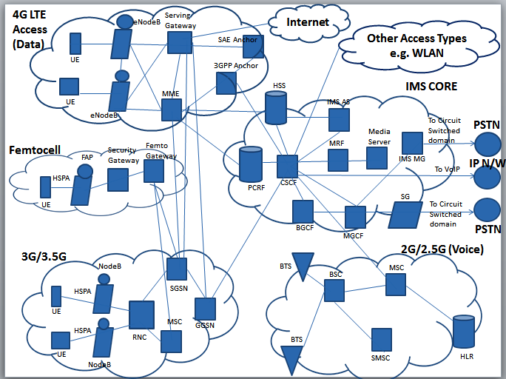
Figure 4. Hetnet Network Elements
- BSC (Base Station Controller) - A base station controller or base station subsystem (BSS) is the portion of a cellular telephone network which handles traffic and signaling between User Equipment (UE) and the network switching subsystem. The major functions of BSS are:
- Transcoding of speech channels;
- Allocation of Radio channels to UEs;
- Paging;
- Transmission and Reception over the air interface.
- MSC (Mobile Switching Center): The Mobile switching center (MSC) is the primary service delivery node for GSM/CDMA, responsible for routing voice calls, text messages (SMS) and other services like conference calls, circuit switched data, etc. Functions of MSC are:
- Set up and release end-to-end connection;
- Handling mobility and hand-over requirements during a call;
- Charging and real-time prepaid account monitoring.
- SMSC (Short Message Service Center): A short message service center (SMSC) is a network element in the mobile telephone network. Their purposes are to store, forward, convert and deliver SMS messages.
Basic Trajectories of SMS are:
- From Mobile to another Mobile , this trajectory is referred as MO-MT (Mobile Originated - Mobile Terminated)
- From Mobile to a content provider (also called as Large Account / ESME) , this trajectory is referred as MO-AT (Mobile Originated - Application Terminated)
- From Application to a Mobile, this trajectory is referred as AO-MT (Application Originated - Mobile Terminated).
- HLR (Home Location Register): The HLR is a central database which stores the details of each and every mobile phone subscriber that is authorized to use the GSM core network. HLRs contain the details of every SIM card issued by the mobile phone operator. Each SIM card s identified with a unique identifier called the IMSI which is the primary key to each HLR record. The HLR stores a user data as long as a subscriber remains with the mobile phone operator. HLR directly receives and processes MAP transactions and messages from elements in the GSM network, like the Location update messages it receives as mobile phones roam around. HLR also stores other data against an IMSI record which are given below:
- GSM services which the subscriber has requested or being provided.
- GPRS settings to allow the subscriber to access data (packet) services.
- Current location of the subscriber (VLR and SGSN)
- Calls divert settings applicable to each associated MSISDN.

4.2 3G/3.5G:
- NodeB: NodeB in UMTS technology is equivalent to Base Transceiver Station (BTS) in GSM technology. It is the hardware which is connected to the Mobile phone network and it is this device which communicates directly with the Mobile handsets. Each NodeB contains the Radio Frequency Transmitter and Receiver used to communicate directly with the User equipment (UE), which move freely around it.
NodeB has minimum functionality as it is controlled by an RNC. It has 2 major differences with a GSM base station which are:
- Frequency use: NodeB uses WCDMA/TD-SCDMA as the air interface technology as compared to TDMA used in GSM.
- Power requirements: Previously WCDMA used to operate at higher frequencies than GSM (at 2100 MHz against 900 MHz for GSM, hence cell radius was considerably smaller for WCDMA than for GSM cells. Now WCDMA has networks which operate in 850-900 MHz band. The coverage of WCDMA is found better than GSM network.

- RNC (Radio Network Controller): RNC acts as the governing element in UMTS Radio Access network (UTRAN). Its responsibility is to control NodeBs which are connected to it. It carries out the following functionalities:
- It carries out management functions like Radio Resource management and some of the Mobility management functions.
- It is where the encryption is done before user data is sent to and from Mobile Equipment.
- It connects to SGSN and Circuit switched network through Media gateway.

- MSC (Mobile Switching Centre Server): MSC or MSS is a 3G core network element that controls the network switching subsystem elements. MSC server and Media Gateway makes it possible to cross-connect the circuit-switched calls switched by using IP, ATM AAL@ as well as TDM.

- SGSN (Serving GPRS Support Node): A serving GPRS support node (SGSN) is responsible for the delivery of data packets from and to the mobile stations within its geographical service area. Its tasks include packet routing and transfer, mobility management (attach/detach and location management), logical link management, and authentication and charging functions. The location register of the SGSN stores location information (e.g., current cell, current VLR) and user profiles (e.g., IMSI, address used in the packet data network) of all GPRS users registered with it. SGSN exhibit the following functions:
- Detunnel GTP packets from the GGSN (downlink);
- Tunnel IP packets toward the GGSN (uplink);
- Carry out mobility management as Standby mode mobile moves from one Routing Area to another Routing Area;
- Billing user data.
In 4G technology, SGSN functionality is carried out by the MME.
- GGSN (Gateway GPRS Support Node): GGSN is a main component of the GPRS Network. It is responsible for internetworking between the GPRS network and external packet switched networks like X.25 and Internet networks. If seen from an external network’s point of view, GGSN is a Router to a sub-network as GGSN hides the infrastructure of GPRS from the external network. It carries out the following functionalities:
- When GGSN receives a data addressed to a specific user in its network, it checks whether the user is active or not. If it finds the user to be active, GGSN forwards the data to the corresponding SGSN that is serving that mobile user. If the user is found inactive, the data received is discarded.
- GGSN acts as the anchor point which enables mobility of the user terminal in the GPRS or UMTS networks. Its role in GPRS is equivalent to the Home Agent in Mobile IP.
- It performs routing necessary to tunnel the Protocol Data Units (PDUs) to SGSN that services a particular Mobile Station (MS).
- It converts GPRS packets coming from SGSN into their corresponding Packet data protocol (PDP) format, like X.25 or IP, and forwards them to the corresponding Packet Data Network.
- PDP addresses of incoming data packets are converted into GSM address of its destination user.
In 4G technology, GGSN functionality is carried out by the SAE gateway.

4.3 4G LTE:
- eNodeB: E-UTRAN Node B, also known as Evolved Node B, (abbreviated as eNodeB or eNB) is the element in E-UTRA of LTE that is the evolution of the element Node B in UTRA of UMTS. It is the hardware that is connected to the mobile phone network that communicates directly with mobile handsets (UEs), like a base transceiver station (BTS) in GSM networks.
Traditionally, a Node B has minimum functionality, and is controlled by an RNC (Radio Network Controller). However, with an eNB, there is no separate controller element. This simplifies the architecture and allows lower response times. eNB uses the E-UTRA protocols OFDMA (downlink) and SC-FDMA (uplink) on its LTE-Uu interface. By contrast, NodeB uses the UTRA protocols WCDMA or TD-SCDMA on its Uu interface.

- SGW (Serving Gateway): The SGW routes and forwards user data packets, while also acting as the mobility anchor for the user plane during inter-eNodeB handovers and as the anchor for mobility between LTE and other 3GPP technologies (terminating S4 interface and relaying the traffic between 2G/3G systems and PGW). For idle state UEs, the SGW terminates the downlink data path and triggers paging when downlink data arrives for the UE. It manages and stores UE contexts, e.g. parameters of the IP bearer service, network internal routing information. It also performs replication of the user traffic in case of lawful interception.

- MME (Mobile Management Entity): The MME is the key control-node for the LTE access-network. It is responsible for idle mode UE (User Equipment) tracking and paging procedure including retransmissions. It is involved in the bearer activation/deactivation process and is also responsible for choosing the SGW for a UE at the initial attach and at time of intra-LTE handover involving Core Network (CN) node relocation. It is responsible for authenticating the user (by interacting with the HSS). The Non Access Stratum (NAS) signaling terminates at the MME and it is also responsible for generation and allocation of temporary identities to UEs. It checks the authorization of the UE to camp on the service provider’s Public Land Mobile Network (PLMN) and enforces UE roaming restrictions. The MME is the termination point in the network for ciphering/integrity protection for NAS signaling and handles the security key management. Lawful interception of signaling is also supported by the MME. The MME also provides the control plane function for mobility between LTE and 2G/3G access networks with the S3 interface terminating at the MME from the SGSN. The MME also terminates the S6a interface towards the home HSS for roaming UEs.
- SAE (System Architecture Evolution) Anchor: System Architecture Evolution (aka SAE) is the core network architecture of 3GPP's LTE wireless communication standard.
SAE is the evolution of the GPRS Core Network, with some differences:
- simplified architecture
- all-IP Network (AIPN)
- support for higher throughput and lower latency radio access networks (RANs)
- support for, and mobility between, multiple heterogeneous access networks, including E-UTRA (LTE and LTE Advanced air interface), 3GPP legacy systems (for example GERAN or UTRAN, air interfaces of GPRS and UMTS respectively), but also non-3GPP systems (for example WiMAX or cdma2000)
- 3GPP Anchor: It act as the anchor for mobility between 3GPP and non-3GPP technologies such as WiMax and 3GPP2 (CDMA 1X and EvDO).

4.4 Femtocell:
- FAP (Femtocell Access Point): Femtocell Access Point is the primary node in a femtocell network that resides in the user premises (e.g., home or office). The FAP implements the functions of the base station and base station controller and connects to the operator network over a secure tunnel via the Internet.
A FAP can be introduced into a home in multiple ways. A standalone FAP can be directly connected to the home router. In some applications, the FAP may also include a built-in router, which is useful in prioritizing FAP voice traffic over other Internet traffic in the home network [16]. More advanced FAP’s include an Analog Terminal Adapter (ATA) to connect a fixed-line phone. In some cases, FAP’s are full-blown residential gateways with built-in Wi-Fi and a broadband modem (xDSL, cable).
- Security Gateway: The security gateway is a network node that secures the Internet connection between femtocell users and the mobile operator core network. It uses standard Internet security protocols such as IPSec and IKEv2 to authenticate and authorize femtocells and provide encryption support for all signaling and user traffic.
The security gateway supports a large number of femtocells connecting to the operator’s network. While similar to traditional VPN gateways used in enterprises, femtocell security gateways are designed for use in carrier networks and meet carrier-grade requirements such as scalability, high availability, and network management [16].
- Femto Gateway: It is responsible for the Radio resourse control, the Overall load control and the handover control. The FGW interfaces with the FAP over the broadband access network. This is shown as reference point Fa in Figure 4-1. The femto gateway performs signaling protocol conversion and in some implementations bearer (voice, video…) channel conversions. The femto gateway also performs the function of a security gateway by protecting the mobile network operator (MNO) from attack attempts over the public broadband access at reference point Fa. The FGW interfaces with the different MNO network segments that have been defined as reference points [17]. Fb-cs is the reference point between the FGW and the MNO’s circuit-switch network for transporting real-time applications such as voice and video. The Fb-ps is the reference point between the FGW and the MNO’s packet-switch network for routing user data such as text messages and e-mail. The Fb-ims interface is used by the FGW to communicate to the core IMS network.

4.5 IMS Core:
The IP Multimedia Subsystem or IP Multimedia Core network Subsystem (IMS) is basically an architectural framework for delivering IP multimedia services. IMS uses Internet Engineering Task Force (IETF) protocols wherever possible in order to ease the Integration with the Internet. It has nt been built with an aim of standardizing applications, but to act as a platform of access of multimedia and voice applications from wireless and wired terminals.
Aimed at person-to-person communication, IMS is the only standardized way to deliver IP-based services as it has one common core and control for all types of networks. Hence it is capable of providing the users with attractive communication services over multi-devices across multi-access technologies [15].
- HSS (Home Subscriber server): HSS is also known as User Profile Server Function (UPSF). It is a master user database whose function is to support the IMS network entities that actually handle calls. HSS is similar to Home Location Register (HLR) and Authentication Centre (AuC) of GSM technology. It executes the following functionalities:
- It stores the subscriber profiles i.e. the subscription-related information;
- It performs the authentication and authorization of the user;
- It can give information about the location of the subscriber and the associated IP information.

- PCRF (Policy Charging and Rules Function): The PCRF interfaces with the main packet gateway and takes charging decisions on its behalf. The centralized device acts as a Policy Decision Point (PDP) for wireless operators and acts granular to individual users. PCRF is part of the PCC architecture, which also includes Policy Charging Enforcement Function (PCEF) and Proxy Call Session Control Function (P-CSCF).
- CSCF (Call Session Control Function): CSCF is the heart of the IMS architecture. It can play 3 different roles: Serving (S-CSCF), Interrogating (I-CSCF) and Proxy (P-CSCF). Its functions include:
- to process SIP signaling;
- to do session control for terminals and application using the IMS network;
- to monitor the SIP sessions;
- to communicate with the Policy architecture to support Media Authorization;
- To interact with the HSS.

- MRF (Media Resource Function): MRF provides media services in the Home network and manages and processes media streams like voice, video, text-to-speech and real-time transcoding of multimedia data. Each MRF in the network can be divided into two parts:
- A Media Resource Function Controller (MRFC) - a signaling plane node which acts as a SIP user agent to the S-CSCF;
- A Media Resource Function processor (MRFP) – a media plane node which carries out the transcoding and content adaptation functionalities.

- BGCF (Breakout Gateway Control Function): BGCF selects breakout operator and/or site for outbound sessions to GSTN, a circuit switched network. If breakout happens in the IMS Network, BGCF routes the session to either a Media Gateway Control Function (MGCF) that then allocates a Media Gateway or to a BGCF in other operator’s network.

- MGCF (Media Gateway Control Function): MGCF is PSTN gateway’s central node. IT carries out the following functionalities:
- It controls media resources used when traffic flows between networks using different media, e.g. between a TDM network and an IP-based network.
- It interacts with:
- Call and session control functions using SIP protocol;
- Control Plane of GSTN using ISUP;
- Media Gateway using H.248 protocol.

- IMS MG (Media Gateway): MGCF controls Media gateway using H.248. MG provides internetworking of media flows between different networks. It provides internetworking between different formats of media transport like IP/UDP/RTP and TDM, as well as media transcoding of voice and video, if required.

- SLF (Subscriber Location Function): SLF is needed to map user addresses when multiple Home Subscriber Servers (HSS) are used.

- AS (Application Servers): An AS can be either a software framework or the server side of a specific implementation instance. An AS acts as a component set which a software developer can access through an Application Program Interface (API). An AS can be found in the home network or in an external 3rd party network.
- SIP AS: it hosts and executes IMS specific services and interfaces with S-CSCF using SIP.
- IM-SSF (IP Multimedia Service Switching Function): it interfaces SIP to CAMEL Application Part (CAP) to communicate with Customized Applications for Mobile Networks Enhanced Logic (CAMEL) Application Servers.
- OSA Service Capability Server (OSA SCS): Interfaces SIP to OSA framework.

- NASS (Network Attachment Subsystem): From the user’s perspective, this module provides registration and initialization of user equipment so that the services in the service layer can be accessed by the subscriber. From a network point of view, NASS provides network-level identification and authentication. NASS executes the following functions:
- Manages IP address space in the access network;
- Provides authentication to service sessions;
- Provides Authorization of network access based on user profiles.

- WAG (WLAN Access Gateway): It performs a function similar to a firewall which limits IP connectivity of WLAN users. 3GPP network pushes the filter rules to the WAG.

- PDG (Packet Data Gateway): When tunneled IP service (WLAN 3GPP IP Access) is provided, PDG performs authentications and authorizations for tunnel requests. PDG also generates charging information related to subscriber data traffic for online and offline charging purposes [18].

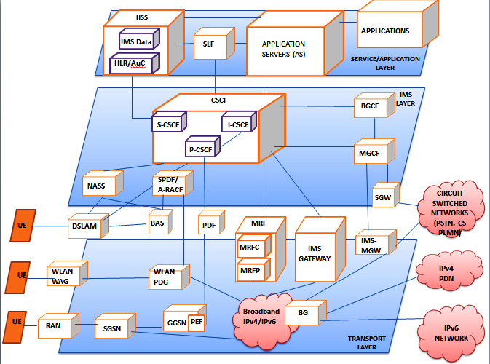
Figure 5. IP Multimedia Subsystem (IMS)

Chapter 5.

DESIGN CHALLENGES

The major key technical challenges attained during implementing HetNet are:
- Interference;
- Backhauling;
- Handover;
- Self-organization;
- Security.

  - INTERFERENCE ISSUE:
Interference is one of the most critical challenges which comes with the establishment of HetNet since the more the cells are created, the more the cell edge users are prone to inter-cell interference (ICI) from the neighboring cells. The main problem occurs due to the co-channel deployment. If small cells are deployed using same carrier as the macrocell, which is called co-channel deployment, the following interference issues occur:
- DL Interference: In the downlink (DL), a small cell (e.g. a femtocell) creates interference to a terminal assigned to a macro BS. This problem gets pronounced if that small cell serves a closed user group (CSG) abd the subscriber (i.e. the terminal) does not belong to that group. As a result, a terminal may be very close to a small cell but will not be allowed to connect to it.
- UL Interference: In the uplink (UL), a subscriber assigned to the macrocell creates interference to the small cell.
There are two types of interference problems in HetNet namely Cross-tier interference and Intra-tier interference. These problems are challenging due to other major design challenges of HetNet which are:
- As Femtocells are not directly connected to the core network, it experiences Backhaul signaling issue.
- As the network supports different cells, it faces problems like different bandwidth and delay constraints.
- Femtocells and Picocells have restricted access controls associated with them which may not allow users to handover to nearest cells leading to strong interference in both uplink and downlink.
- Self-organization requires continuous sensing and monitoring which is required to prevent interference.
Challenges in dealing with the Interference problem:
The challenges faced to handle the Interference problem in HetNet are given below:
- Unplanned Deployment:
- Closed Service Group (CSG) Access:
- Power Difference between nodes:
- Range expanded users:
As femtocells deployment is usually ad-hoc and cellular operators do not manually optimize Radio Frequency (RF) coverage of femtocells, RF interference issue may occur unless effective mitigation methods are used. By 3GPP terminology,
- A FEMTOCELL is denoted as a home NodeB (HNB);
- A MACROCELL is denoted as a macro NodeB (MNB);
- Femtocell users are called as home user equipment (HUE);
- Macro network user served by an MNB is called macro user equipment (MUE).

Interference between Macrocells and Femtocells:
Due to the issue of Closed Service group (CSG) access or restricted access requirement, femtocells can cause interference on both uplink (UL) and downlink (DL), e.g. a femtocell installed near a window or door of a house can cause DL interference to macrocell handsets outside the house. On the other hand, femtocell handsets can also cause UL interference to microcell handsets.
Inter-femto interference:
Femtocells can also be responsible for causing interference to each other due to the issue of unplanned deployment, e.g. in a multi-apartment building, femtocell installed near a wall separating two flats can interfere with femtocell of neighbor flats.
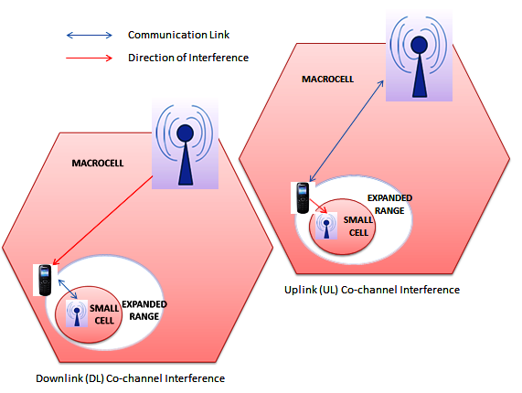
Figure 6. Uplink and Downlink Co-channel Interference
Cell-specific reference signals (CRS):
In order to efficiently receive data in downlink, the user equipments are expected to perform coherent demodulation as part of the LTE-A RAT specifications. Hence the UEs must have idea about the channel conditions for each sub frame. Therefore, reference symbols are transmitted in each sub-frame and inserted in OFDM time-frequency grid at known instances so that UEs can construct legitimate estimates of the downlink channel.
CRS-Interference Cancellation (CRS-IC): Despite the advantage of reuse 1 provided by the OFDM transmission scheme, operators are persisting to support the idea of co-channel-femto Hetnet deployment, where the small cell operate on the same spectrum as the macro layer. This is because of the advantages of cost effectiveness and higher capacity per available spectrum (higher spectral efficiency). Under such deployments, transmission of CRS in each sub-frame by all the BSs causes high interference on both data and control channels of UEs and can create problems in detecting the acquisition signal. This leads to the following problems:
- Degradation in the reliability of data/control channels lead to excessive retransmissions and declaration of Radio Link Failure (RLF) condition by the UEs.
- The network assisted deployment solutions like time shifting and muting of BSs do not solve the problem of interference due to CRS transmission and further limits the benefits of Range extension for femto cells. Hence overall SINR of the UEs degrades.
This leaded to the proposal of CRS-IC which is one of the simplest IC techniques to be implemented within UEs. As CRSs are transmitted on pre-determined intervals with a determined format, which the UEs can reliably estimate or get from neighbor cells, without the requirement of any strict coordination mechanisms between cells.
RF Propagation and System simulation Models:
Both basic interference models and system simulation models will be used to analyze the performance of HNBs. Basic interference model will show interference under simple scenarios while to study interference at system level, a dense urban model will be developed to capture femto-femto and micro-femto interactions.
Interference Mitigation Techniques:
There is a large imbalance of transmit power between macro cell and small cell (~20-30 dB) which is the potential cause of UL and DL interference. LTE physical layer provides many levers to mitigate interference. LTE is based on OFDM technology where a wide channel bandwidth is divided by orthogonal sub-carriers into multiple narrow frequency bands [20].
- Range Expansion Technique
- Inter-Cell Interference Coordination (ICIC)/ Enhanced ICIC (eICIC)
- Frequency Domain Partitioning/ Carrier Aggregation (CA)- For Macro Cells
- Time-Domain Multiplexing (TDM) – For Small Cells
Range Expansion Technique:
In Range Expansion technique, the coverage area of the small cell is expanded or enlarged so that it allows for more traffic. This leads to the following advantages:
- Resource optimization of the network;
- Increase of network throughput;
- Handover Reduction.
The disadvantage is that UEs handed over to small cell are likely to experience high interference from macrocell. Due to the power imbalance it results in interference. Below are given some improvements in LTE releases which dealt with interference problem:
- In LTE Release 8, the procedure called “Cell selection” is based on Signal strength received by downlink (DL) resulting in much smaller downlink coverage than uplink coverage because of the large power difference between UL and DL. The small cell range is expanded by doing selection offset or threshold handover to small cells.
Release 8 range expansions are limited to order of few dBs, around 3 to 4 dB gain.
- In LTE Release 10, the cell selection procedure depends on minimum path loss. Another improvement in this release is that various techniques have been introduced to manage Interference in expanded Range.

Inter-Cell Interference Coordination (ICIC)/ enhanced ICIC (eICIC):
ICIC is a broad technique which manages network interference by assigning resource blocks which reduces the chance of overlapping. ICIC techniques provide a feasible solution by applying restrictions to the RRM (radio resource management) block. These techniques improve favorable channel conditions across user subsets which are infected by interference, thus attain high spectral efficiency. This RRM can be achieved by fixed, adaptive or real-time coordination with the help of additional inter-cell signaling with accordingly variable signaling rate.
- LTE Release 8 supports only non-overlapping transmissions in frequency domain.
- LTE Release 8 and 9 ICIC works well in Homogeneous networks, they do not provide significant gain in hetnet architecture. This is because Range expansion is only limited to data channels and not to control channels where interference remains significant.
- LTE Release 10 brings in a number of new features in order to improve ICIC performance and for range expansion of small cell, which includes scheduling across multiple frequency carriers and time-domain multiplexing where macrocell and small cell function on same frequency. To support these newer developments, Release 10 has undergone up gradation of interface with additional messages.

  - Frequency Domain Partitioning:
This is also called Carrier Aggregation (CA). The idea is spectrum division into 2 parts: one to be used by the Macrocell and the other to be used by small cell. Either of the two uses its own part of the spectrum to transit its control channels in order to avoid interference.
The standard provides support for each cell layer to use wither part of the spectrum to communicate with the UE by using a fast cross-carrier scheduling process. To use this technique, the UE must support features of Release 10.
There are possibilities of two extreme cases of Carrier Aggregation implementation, which are:
- Lowest Complexity and Flexibility: Intra-band CA when both carriers are in same band and are either contiguous.
- Highest Complexity and Flexibility: Inter-band CA when two carriers are in completely different bands.
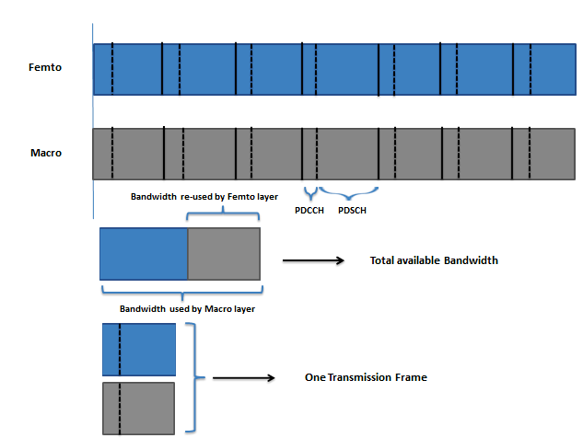
Figure 7. Frequency Domain Partitioning

  - Time Domain Partitioning:
While Frequency domain Partitioning techniques are focused on isolating interference by spectrum segmentation, Time-domain multiplexing techniques use the same frequency channel on all layers of hetnet while leveraging the time domain to manage interference between the layers.
TDM reduces interference by featuring a capability to suppress transmissions in certain sub-frames of aggressor base station which in turn allows the victim base station to schedule transmissions during these empty sub-frames. However suppressed transmission is not absolutely possible as some control signaling continues to be broadcast for the purpose of Backward Compatibility. Hence, this is referred to as ‘Almost Blank Sub-frame’ (ABS). This ABS will take its full form in LTE Release 11 when mobile handsets will be capable of suppressing interference using this technique to efficiently receive control signaling from the low-power victim Base station.
The victim BS must be able to identify the mobile units subjected to interference and accordingly schedule them during an ABS zone while the mobile units closer to the center of the cell can be scheduled on normal sub-frames. The UEs keep on sending channel measurement update reports to the Base station corresponding to the ABS patterns of that base station.
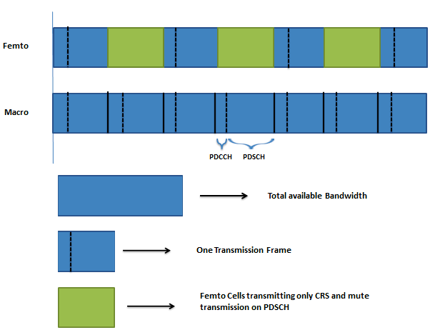

Figure 8.Time Domain Partitioning

To effectively implement interference management techniques in HetNet deployments, further enhancements to other aspects of LTE network is needed. In particular, the X2 interface which is the communication interface between base stations has been upgraded in LTE release 10 and future releases in order to accommodate message transmission and reception for dynamic coordination of Base station resources.

  - BACKHAULING ISSUE:
The telecom industry expects the future wireless networks to be heterogeneous rather than the present homogeneous honeycomb grids of Macrocells or Big cells in current scenario. Heterogeneous networks imply the complex multi-layered networks of overlapping Macrocells and smallcells, providing our bandwidth-hungry smartphones and tablets with huge amount of cheap bandwidth [21]. But there are many problems the industry has to solve before HetNet becomes a reality, with one of the biggest problem being to figure out how to link all the small cells back to the network.
The LTE and HSPA+ networks require fat backhaul pipes which have been managed by the mobile operators by installing fiber to their towers. Unfortunately, the fiber option is not suitable for the hetnet world. This is because the small cells will be installed and mounted on places like building walls and street light poles which brings with it the fact that cost of installing fiber is prohibitive.
Small cells are generally placed in locations that do not have backhaul facilities. This comes as a challenge in hetnet deployment. The two basic scenarios that can be used to provide backhaul for small cells, called as small cell access are:
- 3PP (Third Party Provider) Transport: Backhaul is provided by a leased facility from a 3rd party provider.
- Subtended Macro: The small cell is connected to its nearest macro site and uses the macro cell’s backhaul to connect to the core network.

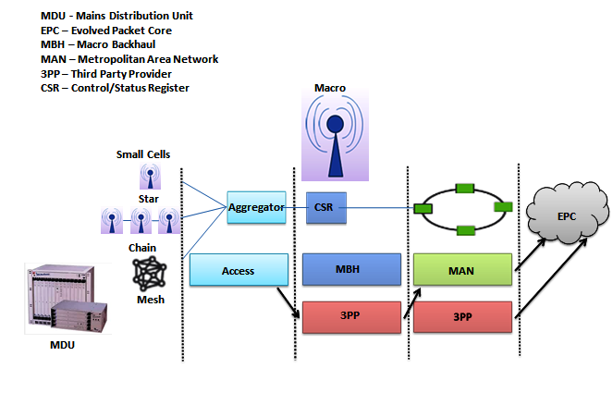
Figure 9. Backhauling in HetNet
The small cell access can be wired or wireless. Fixed Backhaul options include Fiber Optic cable, VDSL or CAT5 cable, while wireless backhaul options include Line of sight (LOS) or Non Line of Sight (NLOS), radio or mesh.
Small cell access backhaul has different requirements to that of macro Backhaul (MBH). IT needs the following required factors:
- Installation cost should be low;
- There should be very low or no Monthly recurring costs (MRC);
- For a range of 4 to 16 small cells, there should be an aggregation point.
Millimeter wave (mmW) technology:
Various wireless Radio vendors like Bridgewave and Siklu have come up with a solution to the Backhaul problem in HetNet, called the Millimeter waves. Extremely High Frequency (EHF) is a form of electromagnetic radiation and is the highest radio frequency band, which runs in the frequency range of 30 to 300 gigahertz (GHz). Radio waves in the EHF band have wavelengths from 10 to 1 mm, giving it the name Millimeter band or Millimeter wave, abbreviated as MMW or mmW.
MMW technically encompass a huge swath of spectrum (i.e. 30-300 GHz), but specifically for the wireless backhaul purpose in hetnet, the licensed spectrum in 70-95 GHz range is used for point-to-point high bandwidth radio links. Below are given two reasons why these frequencies are considered ideal for small cell backhaul:
- It is relatively easier to obtain licenses for big blocks of MMW spectrum, which would allow carriers to deploy large backhaul pipes (as required for HetNet) over size of 1 Gbps. A single small cell will not require that much capacity, hence daisy-chaining of a number of small cells may be done, each cell passing the load down the line. The final backhaul link in such daisy chains or meshes winds up handling a large number of cells with traffic before it dumps it onto a fiber network.
- MMW have characteristic of high frequency which is used effectively by small cell backhaul. It is known that the higher the frequency, the shorter distance a wave propagates, the only exception is when it gets a serious power boost. This is not a problem in the case of HetNet as HetNets will be composed of densely packed cells in urban environments, implying no MMW will have to travel far between hops.

Problem with MMW:
The 60 GHz airwaves are all unlicensed, which means that no single operator will have proprietary use of them in any given area. This indicates that there will be potential for interference between Radios in areas where multiple carriers are running multiple HetNets of small cells [21].

  - HANDOVER ISSUE:
Smooth handover between different systems should be taken as a basic requirement. Multiple authentications taken by various systems are annoyed. How to keep service continuity during handover across different systems is an issue.
Increased handovers due to small cell sizes introduce a potential source of increased Dropped Call Rate (DCR), even when handover success rate remains unchanged.

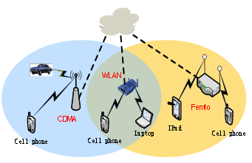
Figure 10. Handover

For User-equipments in connected state which are moving out of cell coverage, handovers are required to move their Radio link from one cell to another. It is preferred to retain an UE in the same layer (macro or small cell) as handover is performed, unless there is a requirement to move from one layer to the other. Same layer handovers use the normal coverage-based intra-frequency handover framework existing in Macrocell network.
In Handover procedures in 3GPP HetNet, the UE starts a handover procedure, based on signal and time thresholds defined and transmitted to it by its serving cell. These signal and time thresholds are the HO hysteresis, Time To Trigger (TTT) and Cell Individual Offset (Oc). Oc is a vector quantity sent to UE by the serving cell and it contains the offsets of the serving cell (Oc(s)) and neighbor cells (Oc(n)). All UEs in that cell must apply this parameter value to determine whether the measures RSRP satisfies the condition of the event named “Event A3”. This event implies that UE sends a measurement report (MR) which triggers the handover [1]. Oc values can either be positive or negative. The measured RSRPs are filtered and Oc values are added to them to determine the cell ID. The following relationship is used to determine the Cell ID.
Cell IDk = arg [max (RSRPi + Oc)]
The challenge is to configure the cells optimally with these parameters so that the HO success rate and DCR is kept close to their targets. This is tough to achieve in urban regions due to a problem called as the “traffic-light” problem [1]. In this problem, UEs stopping in intersections may handover to a nearby picocell for a few tens of seconds (duration of red signal in traffic light) and then handover again to the macro cell.
- Coverage-based (CB) Handover:
As an active mobile device moves out of coverage of its hosting cell (macro or small cell), it must be handed over to another cell for the purpose of service continuity. Most common handover is the small cell to macro handover. UEs that are connected to small cells may continue to perform handover to other small cells till they reach into a boundary small cell. This is when the UE needs to be handed over to a macrocell which provides coverage in the same area.
The reverse, i.e. macro to small cell handover is also possible but not always needed. As a UE that is connected to a macrocell moves, it can maintain its connection by performing handovers to other macrocells; it does not need to handover to small cell even if small cell coverage is available in that particular area. Below are given two situations when macro to small cell handover is desirable:
- Macro-coverage Gap: When macro layer has a coverage gap that is covered by a small cell, the UE connected to macro layer must be handed to small cell when it enters that region, or else there will be a break in the continuity.
- Cell-edge/Weak Macrocell Coverage: In areas like cell-edge region, where the small cell signal is comparatively stronger than the macrocell signal, the macro-connected UEs can be handed over to the small cell.

- Load-based (LB) Handover:
Macrocells support load-based handovers. In case of small cells, when a microcell gets overloaded, it gets relief by handing over some UEs to the macro layer. Small cells can be configured in such a manner so that if requirement occurs, they can perform LB handover to macrocells. This is to be noted that LB handover is applicable only for small cells in hotspot regions.
There are two possible types of handovers:
- Intra-frequency Handover:

This is needed when macro cell and small cell layer use the same frequency. In this handover, no new inter frequency measurements or reporting is required.

- Inter-frequency Handover:

This is needed when macro cell and small cell layer are on different frequencies. Inter-frequency measurements and reporting configuration is needed for target frequencies in this case.

  - SELF-ORGANIZATION ISSUE:
Self-organization is a process where the organization of a system spontaneously increases i.e., without this increase being controlled by the environment or an encompassing or otherwise external system.
Below is given a study by industry experts of the problems of self-organization when applied to infrastructure networks.

The design issues of implementing SON in Cellular macro network are:
- Tightly planned, automated operation.
- Single operator.
- Single vendor equipment per OAM domain.
The design issues of implementing SON in Cellular Heterogeneous Networks are:
- Soma parts are only coarsely planned, with highly automated operation.
- Multi-operator (shared infrastructure).
- Multi-vendor per domain.

The design issues of implementing SON in Ad-hoc/mesh network are:
- Uncoordinated deployment, autonomous operation.
- Only node operator.
- Open environment, standardized protocols between nodes.

  - SECURITY ISSUE:
It is of no doubt that small cells have several benefits as seen from the network performance point of view, but it has a disadvantage too if seen from the security point of view [22]. Security challenges in Heterogeneous Networks can be broadly divided into 2 parts:
- Physical Security;
- Network/ Information Security.

- Physical Security:
While Macrocells have strong physical security in the form of alarms, locked doors and rigid access control, Small cells due to their small form factor are generally deployed in open access public areas; hence they have a high chance to get tampered with and potentially compromised by unauthorized people. This poses serious security vulnerability due to the fact that small cells are connected to the core network of the serving operator. Hence small cell units can be stolen, vandalized, replaced etc. As a result, to prevent such misuse of the small cell units, strong authentication mechanisms are required.
- Information/Network Security:
Macrocells originally relied on secure TDM protocols while most small cells will be installed in IP mobile networking environment which has greater security vulnerabilities. The other problem is that as small cells support fewer numbers of users, they need to use the existing fixed access network for backhaul due to which its user traffic gets exposed to untrusted open Internet environment.
It is true that technologies like small cells and Wi-Fi comes with great benefits and they provide new opportunities for telecom operators, but they also bring with them new kinds of security risks which must be addressed. Small cells allow mobile operators to use existing spectrum more efficiently as well as access additional spectrum, hence promoting greater deployment flexibility, and all of it at a low cost. Small cells also reduce RAN build-out and investment in Backhaul, improved customer experience by providing increased access to network. Also, due to their small size, base station footprint gets reduced, hence less environmental impact in terms of power consumption and obstructive objects in the public domain.
This next generation of small cells can be broken into four main types:
- 3G/4G femtocells for closed user groups;
- Public access small cells;
- Mobile operator-deployed Wi-Fi access points;
- Public Wi-Fi WLAN access points.
The specific security issues vary across each small cell type, but the solution can be found in variations of the same 3GPP security architecture, leveraging a carrier-grade, highly-scalable security gateway.
Common Security Vulnerabilities across Small Cells
Small cells, including Wi-Fi WLAN merge into the IP-oriented mobile network where there are a lot of security vulnerabilities. As these small cell and Wi-Fi deployments rely on such untrusted IP networks, their security risks increase for both user and control plane channels. Below are given some examplis showing loopholes in HetNet architecture which makes it prone to security attacks:
- When small cells need backhaul facility they use the pre-existing fixed access networks for backhaul via DSL, as a result, the traffic of mobile users in that cell gets exposed to the untrusted open internet environment, instead of being managed by end-to-end trusted facilities of the Mobile operator.
- User traffic of femtocell is no more protected by 3GPP encryption; hence it becomes a potential victim of interception.
- In LTE, the 3GPP encryption terminates in eNodeB. There is no embedded or native encryption system in LTE between the eNodeB and core network, hence it is vulnerable to security attacks.
- Small cells are generally deployed in relatively open and accessible public places, like shopping malls and street light poles; hence they become easier target for unauthorized parties attack.
- Some public access small cells have radio-based backhaul that has a physical separate unit; as a result, it brings in additional vulnerability of possible interception of traffic in wired or wireless communication path between the two devices.
Hence security and data encryption becomes an important challenge in HetNet deployment.
Security Enablers for HetNet:
The following features bring in security to the HetNet architecture:
- Integration to the Operator Core Network:
The preferred way of securing end-to-end traffic from user equipment to the Core of operator is the parallel development of 3GPP approved I-WLAN standard of IEEE 802.11x authentication and IPsec tunneling from small cell to core. I-WLAN needs an IPsec tunnel from UE to core and has limited scalability to support a large number of devices, precisely, when it reaches to millions. Instead, 802.1x authenticates the UEs and encrypts the air interface using 802.11i which results in a more scalable solution as tunneling is required only for small cells. IPSec provides a uniform approach for both authentication and encryption across all its insecure cells.

- Use of Wireless Backhaul:
Wireless Backhaul plays an important role in HetNet security. Most of the microwave and other Radio-based Backhaul solutions support robust encryption.

Trusted Wi-Fi Access:
Wi-Fi operates in unlicensed spectrum which makes it more prone to interference as compared to the licensed 3GPP spectrum. Hence it has a poor relation to licensed cellular radio standards in mobile operator circles. Wi-Fi is typically used as a parallel access network to the mobile network.
Wi-Fi is very popular with subscribers. According to the ComScore data referring to the U.S. market in Q3 2011, customer smartphone usage is now split evenly between Wi-Fi and 3GPP access networks. Furthermore, the number of connections on AT&T’s Wi-Fi networks has increased from 20 million in 2008 to 745 million by the end of the third quarter in 2011. This trend is making mobile operators to think of how to use Wi-Fi for handling increasing data traffic volumes and complement their service offerings.
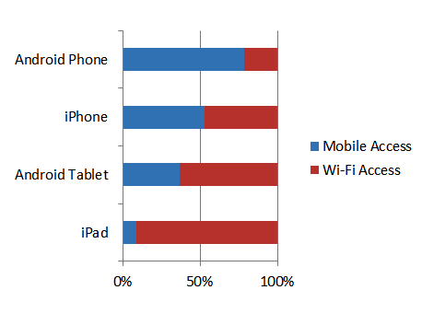
Figure 11. Connection Types of Devices and OS (Source: ComScore)
With its origins as a self-deployed home and enterprise access technology, security wasn’t a key consideration in the evolution of Wi-Fi. Wi-Fi has a unique set of security challenges that must be addressed. The resulting ease with which countless numbers of users have had sensitive, personal information copied and stolen is well known, but a lot of work is being done to render Wi-Fi networking more secure in terms of both the user-facing air interface and the network-facing transport or backhaul service.
3GPP Security Architecture:
3GPP Security Architecture has flexible model for all small cell types. Its unique security architecture for Wi-Fi and small cells offload is highly secure which has been proved by its successful support for 2 million femtocells in service today. The key feature of 3GPP’s femtocell architecture is that it provides the IPsec tunnel within the femtocell for the purpose of encryption and authentication of traffic as it exits the femtocell and is transported across the access network. That tunnel is then encrypted by a SEG (Security Gateway) in the operator’s core network.

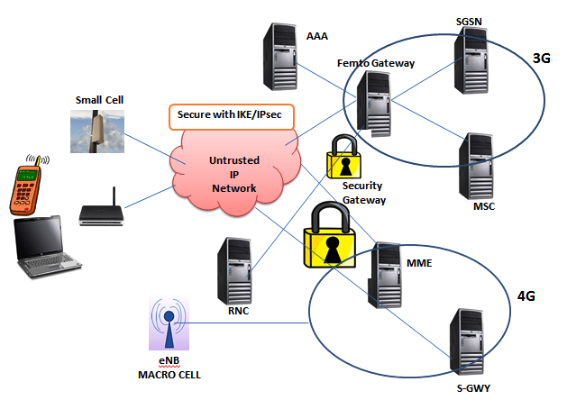
Figure 12. IPsec architecture

The same security gateway can be reused to terminate both public access small cell and femtocell traffic. The same security architecture is shared by the operator across both public domain and private domain small cells and also the same physical equipment, provided it is capable of sufficient scaling to support millions of subscriber. The upfront investment is lowered if operators reuse the same security infrastructure; hence providing carriers with significant CAPEX and OPEX savings.
SEGs (Security Gateways):
Mobile operators can support large number of concurrent, bi-directional IPsec tunnels with the help of SEGs on a stateful, high-availability system at the lowest possible cost per subscriber, at the same time meeting the unique security challenges for each type of small cell. Let us explain this with an example, a European mobile operator is internetworking with 3G and 4G service and implementing WLAN offloading and an Asian mobile operator is using Wi-Fi to offload data traffic. Both the operators are using LTE SEG to secure their networks, which serves as a common platform in 3GPP Architecture and provides turnkey tunnel terminating gateway and internetworking wireless LAN functionality; hence giving telecom operators great advantages in providing various applications of same platform for each type of small cell.
With the successful implementation of SEG, mobile operators now can offer a multitude of security services to their customers on a single blade, which includes Firewall, LTE Network domain security and an evolutionary path to supporting packet data gateway technologies.
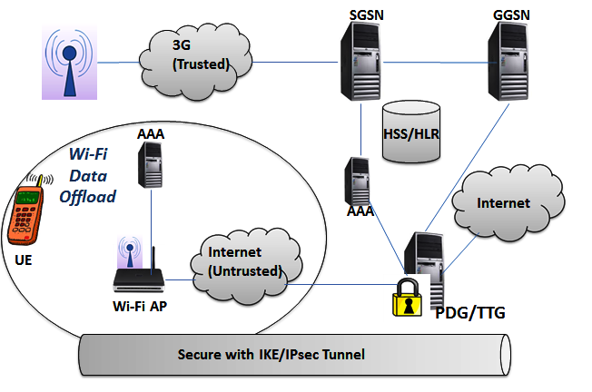
Figure 13. TTG / PDG Configuration for I-WLAN Untrusted Networks
Key Requirements for 3GPP Security Gateways
Mobile operators need highly-scalable and cost-effective security solutions to protect their networks and subscribers as small cells are rolled out in volume in the home, enterprise and wide area public access markets. Carrier-class solutions are preferable to enterprise products, enabling the operator to support potentially large numbers of concurrent, bi-directional IPSec tunnels on a stateful, high-availability system, at the lowest possible cost per subscriber.
Key factors required from a 3GPP SEG to ensure rollout of small cells is accompanied by robust security are:
- carrier-grade availability and redundancy;
- full alignment with 3GPP standards;
- ease of integration into the existing network;
- high scalability and performance ;
- reuse of the security solution across multiple types of small cells, LTE and macrocells; and
- Highly secure hardware and software architecture.
When an operator buys a 3GPP SEG, it must consider the factors: location, performance and reuse of the software throughout its network. As SEG is integrated or co-located with primary elements in network infrastructure such as Radio Network Controller (RNC); hence PDG or GGSN is recommended for deployment.
Because 3GPP-based public access small cells share many of the same vulnerabilities as closed user group femtocells, reusing the femtocell security architecture is a viable solution. For Wi-Fi small cells, 3GPP’s I-WLAN standard specifies the use of an IPsec tunnel in the end user device as a means of securing what it defines as untrusted Wi-Fi traffic coming into the 3G core. Moreover, when encryption is terminated in the 3G public-access small cell, the operator needs to encrypt it again across the backhaul to secure it effectively.
A variety of Network access technologies like WCDMA, TD-SCDMA, cdma2000 for Wireless WAN, WiMAX for wireless MAN and Wi-Fi for WLAN technology, specialized security mechanisms are required as at the same point of time, a variety of network access technologies work together. Before going into the HetNet security architecture, a brief overview of security aspects of these individual technologies will be discussed below:
Security Standards for Wireless Local Area Network (WLAN)
WLAN has come a long way with its wide range of applications and it has become a mature international standard. WLAN includes IEEE 802.11, IEEE 802.11i, WPA and WAPI (used in China). Authentication and data encryption were achieved by IEEE 802.11 through WEP (Wired Equivalent Privacy). IEEE 802.11i came up in June 2004 to increase the WLAN security further and to ensure that wireless security technologies between different manufacturers are compatible with each other. 802.11i defines a robust security network (RSN) of key management protocol based on the 802.11x standard. WPA standard came as a transition which uses 802.11 and TKIP to implement facilities like WLAN access control, data encryption and key management. WAPI is the standard for wireless network technology in China. It uses Elliptic Curve Cryptography to obtain device authentication, link authentication, access control and encryption of user information. WAPI is believed to change the current scenario where a variety of security mechanisms co-exist and are incompatible for WLAN.
It can be concluded that international standards are mainly covering the areas of user and network authentication, access control, key exchanging and data encryption. However, user security in HetNet environment has not been considered which in includes end-to-end security framework in cross-domain environment.
Security Standards for Wireless Metropolitan Area Network (WMAN)
The main WMAN security standards are 802.16 D3, 802.16E and WiBro (used in South Korea). 802.16 D3 has come up with a secure sub-layer on MAC layer to guarantee security. It consists of two protocols: Data Encryption Encapsulation Protocol and Key Management Protocol (PKM). The former protocol defines encryption suite supported by IEEE 802.16 protocol including data encryption and integrity verification algorithm and also the rules of how to apply these algorithms to MAC PDU load. PKM, the latter protocol defines secure distribution way of Key data from Base station (BS) to user device and synchronization of key data and restrictions to access network services. 802.16e is the improved version of 802.16d standard which supports mobile and vehicular services between 2-11 GHz bands and also supports handoff between station and sector. 802.16e has PKM in two versions: PKMv1 and PKMv2. PKMv2 support enhanced services like broadcast and multicast service, BS and MSS mutual authentication, etc. WiBro has been declared by South Korea’s Ministry of Information and Communication to be fully compliant with 802.16e.
Security Standards for Wireless Wide Area Network (WWAN)
Major communication specifications of 3G systems with comprehensive security mechanisms are TD-SCDMA, WCDA and cdma2000. These security features are defined along with the advantages of 2G system and new features of 3G system. Main security mechanisms of 3G system are 3GPP and 3GPP2. These have the following services:
- WAP security;
- Filtering techniques for spam short messages;
- Location service security;
- Presence service security;
- Payment service security;
- DRM standard to stop reproduction without proper authorization;
- Identity authentication function secured by password, smart card and entity identification mechanisms;
- Security protection and access control for data service through policy of access control;

These services lack two features which are needed with rising applications of Mobile IP. They are:
- Authentication systems to support user roaming;
- Authentication systems across administrative domains.

HetNet Access Authentication Mechanisms:
Implementation of integrated network is a large and complex task which requires the support of various key technologies, and Security is one of the major keys for successful implementation of hetnet. The first step to security is the access authentication process. The challenge lies in the fact that different access technologies have different ways to secure access authentication. The aim is to design a universal access authentication mechanism for the integration network which is capable of providing seamless secure roaming and services to be enjoyed by mobile users in the wireless networks. Below we will discuss three combinations of integrated network:
- 3G-WiMax internetworking;
- UMTS-WLAN internetworking;
- CDMA2000-WLAN internetworking.

- 3G-WiMax Authentication Mechanism:
Integration architecture of 3G system and WiMax can be divided into two types of architecture: Loose Coupling and Tight Coupling Architecture. The internetworking is based on below mentioned features:
- 3G system based Network Authentication;
- Common Billing and Accounting;
- Customer Care;
- WiMAX access to 3G system’s
-Packet-switched based services with service consistency and seamless continuity;
-Circuit-switched based services.
Common Billing, customer care, authentication and accounting belongs to the loose coupling mode and the rest belongs to the tight coupling mode. Common Billing and customer care can be accomplished by the AAA located in the appended network between two systems. For authentication and accounting of WiMAX as the complementary network of 3G system, Home Location Register (HLR) and AAA of 3G system is used. Traffic export of WiMAX can either be directly connected to MAN or by the packet domain gateway of 3G system. For Packet-switched based services, WiMAX can directly access all services of 3G, while in circuit-switched based services, WiMAX network is controlled by 3G and its VoIP service can handover to 3G. For the purpose of seamless service continuity, Radio resources of WiMAX and 3G can be centrally scheduled.

- UMTS-WLAN Authentication Mechanism:
There are several approaches to UMTS-WLAN interconnection. Below are discussed some of the architectures:
- Internetworking Architecture based on Mobile IP: This architecture considers 3G and WLAN as two types of peer networks connected through internet. Mobile IP (MIP) is achieved through the set of Home-agent (HA) and Foreign-agent (FA) in the network. GGSN (GPRS Gateway Support Node) in home network of 3G is set as HA while SGSN (Serving GPRS Support Node) in foreign network of 3G is set as FA. In WLAN network, HA is located in DNS (Domain Name Server) and FA is located in DHCP (Dynamic Host Configuration Protocol) server.
- Internetworking Architecture based on Inter-connection Gateway: This architecture also considers 3G and WLAN as peer networks while an interconnection gateway is added. In 3G system, mobile nodes perform mobility management according to 3G network’s session management and GPRS mobility management, while in WLAN system, Hotspots execute the mobility management function. Mobility management of dual-mode user can exchange signal through gateway.
- Loose Coupling Architecture: This architecture logically separates the 3G and WLAN service domains. Mobile IP takes care of Location management, authentication, authorization and accounting in Handoff process between WLAN and 3G, as a result WLAN has to undergo the fewest changes.
- Tight Coupling Architecture: This architecture considers WLAN as one of the access networks of 3G Core Network; hence satisfying the internetworking requirements for WLAN access to packet domain traffic of 3G, like for access control and accounting based on 3GPP system and for unified accounting, customer services and service continuity.
- Semi-tight Coupling Architecture: UMTS and WLAN works concurrently in this architecture, but authentication messages with user identifier is carried over UMTS access network and core network to WLAN. Signaling which can’t be carried over UMTs is carried over WLAN.

Framework Model:
It is of no doubt that wireless communication networks bring a great convenience to us, but is also true that they face a series of security issues like security between network entities, seamless connection among security protocols and updated security requirements of various new services. Hence it is necessary to construct a flexible security model which can avoid attacks and have key security technologies and methods. It should also be kept in mind that if a security system fails, the remaining security systems should be able to provide the same level of security protection to the network.
On studying security standards of various access subnets like wireless LAN, wireless MAN, wireless WAN, it is found that to build a perfect security standard framework for wireless broadband system, it must refer to the seven layer Open Systems Interconnection (OSI) protocol system model. The security mechanisms will be studied by dividing them in three layers: access layer, network layer and application layer. The security mechanisms will also be classified according to the strength of attacker’s ability.
The security protocol standards can be broadly classified into three levels: general level, weak cipher level and strong cipher level on the basis of security of cipher cell.
- General Level Protocol standard: It focuses on function realizing, security is considered low level security or even not, such as WEP, PEAP.
- Weak Cipher level standard: This standard fully considers security when established standard. It makes a compromise between interests and security for commercial reasons, such as WPA1. It uses the RC4 stream cipher system. Weak standard indicates there are some weakness in its cipher security, or a standard which becomes insecure because of enhanced attack methods.
- Strong Cipher level standard: It is a standard which has proved its security by appropriate model and which also meets the latest safety requirements, such as IKEv2. It is also a standard which has not proved its security under appropriate model, but till now there has been no effective attack to such standard, such as WPA2.
Based on existing wireless LAN (WEP, IEEE 802.11i, WPA and WAPI), wireless MAN (802.16 D3, 802.16E and Korea WiBro) and wireless WAN (3GPP and 3GPP2) standards, security architecture includes six safety technologies:
- Heterogeneous Network Access Security technology;
- Password Security technology;
- Access Control security technology;
- Wireless Intrusion and Detection technology;
- Mobile Terminal security technology;
- Mobile Commerce security technology.

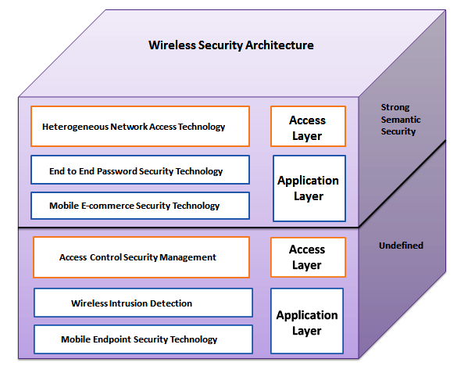
Figure 14. Wireless Broadband Network Security Architecture
- Heterogeneous Network Access Security Technology:
HetNet has multi-trust domains, resources, users, sharing servers and authentication service providers who belong to different secure institutions [23]. HetNets are expected to provide the UEs freedom of roaming among diverse set of wireless networks. Since different wireless networks have different security standards and requirements, the mobile terminals should hold a variety of schemes which are secure. There should be a standard which has a mechanism for
- Trusted domain-crossing (including Roaming) Authentication and Key agreement;
- Effective harmonization of cross-domain information resource or access service in security;
- Validation by UE to decide whether the provider is legitimate or not;
- Validation by service provider to decide whether the user is legitimate or not;
- Capacity of preventing attacks like fake attack due to key leaking, unknown session key sharing attack, forward security and so on.
- Password Security Technology:
Public key mechanism is always better than private key mechanism in enhanced protocol security, but in increases the amount of computation, network burden and times protocol information transmission. In current scenario, cross-domain password authentication and key exchange protocol are largely based on Symmetric Key cryptography. But this mechanism fails to prevent new types of attacks like PCI and KCI.
Hence it is desired to find a certifiable secure cross-domain protocol which has the following desired features:
- Low transmission time;
- Tradeoff security and Efficiency in a wide range of application environments;
- Broad application market;
- Resist off-line Dictionary attack;
- Resist on-line dictionary attack;
- Satisfy forward security;
- Resist Server destroy attack;
- Resist Denning Sacco attack.
- Mobile Terminal Secure Technology
As number of 3G users are increasing, more and more personal information are being stored in terminal user equipment. This information can be highly confidential hence mobile terminal security requirement is very important. Security technology is embedded in UEs by product and service providers to ensure secure cross-platform computing, communication and interoperability. These security solutions are generally embedded in the operating system (OS) of the device. The OS level security brings in two major problems:
- Generally OS are very complex; hence it becomes problematic to obtain a stable security system simply relying on an OS alone;
- Implementing security in OS also prolongs the process of developing and debugging.
Some other security problems which current intelligent Mobile UEs of 2G and 2.5G networks are facing are:
- Lack of abundant security defending software;
- Low Firewall usage rate;
- Lack of user’s security awareness.
There should be a model of Mobile Terminal Secure Technology which contains the following features:
- Access Security- Identity Authentication using Password, Smart Card and Entity Authentication mechanism;
- Data Security-Ensuring safety by setting Access control policy, Hierarchical storage and Isolation, Data Integrity detection measures;
- Protection of Terminal Security-Protecting safety of various types of Hardware and Software systems (OS Security), Content and Data Security, Avoidance of illegally juggling information, unauthorized access and malicious access caused by viruses, Trojans and malicious codes.
- Access Control Technology
Access control is to allow or stop ability to access and extension by some approaches and techniques and it limits the visiting to confidential protected resources, and prevents destructions caused by illegal user’s malicious invasion or legal user’s careless operation. Access control faces brand new challenges due to the continuous changes and developments in computation environment; hence it is required to devise a model with the following features:
- Good support to Heterogeneous environments;
- High system scalability;
- Thin granularity;
- Good dynamic Access control;
- Low cost;
- Authorization management;
- Domain-crossing Authentication.
- Wireless Intrusion Detection Technology
Unlike wired network, it is not possible for wireless network to directly employ the Intrusion Detection system (IDS) due to the following reasons:
- IDS largely depend on monitoring and analysis of entire network in real-time mode, while wireless networks can only provide partial data for intrusion detection.
- Wireless networks fail to adopt the communication protocols designed for wired IDS as the link of mobile network is slow, bandwidth is limited and the mobile nodes rely on battery for power-supply.
- There is no defined specific boundary between normal and in normal operation due to continuously changing high-speed mobile network topology.
- Nodes sending wrong messages may be the captured nodes or nodes temporarily losing synchronization due to fast moving.
At present, there are two reputed IDS: Distributed IDS based on Mobile Agent and Ad Hoc Network Distributed IDS.
- Distributed IDS based on Mobile Agent: Its core is mobile agent module. Based on various functions of number-limited mobile agents in Ad Hoc network, mobile agents are distributed to several nodes, and execute various intrusion detection based on the test results. This model works fine as the number of mobile agents are significantly reduced resulting in lower network overhead than other IDS.
- Ad Hoc Network IDS: This system requires participation of all nodes in the network to detect intrusion and make response. Each node is given an IDS agent and they make a statistical abnormality-based detection. When a node makes an exceptional report, the IDS agents in different regions co-operate to launch global intrusion detection and make response. If an intrusion node is detected, CAMA agent will broadcast security information to entire network through its base station. CAMA agent finds out malicious node in the network and kicks it out from the network.
- Mobile E-commerce Secure Technology
The growing demand of e-commerce indicates the requirement of a standardized secure technology in the mobile e-commerce application process. The secure technology helps protecting important information of merchants and customers in the mobile commerce, and maintains credibility and property of the business system. The crucial technologies of mobile e-commerce which requires evolution and proper standardization are discussed below:
- End-to-end secure strategies: It indicates that transmission of data from source node to destination node should be absolutely safe.
- Employ WPKI technology: End-to-end secure data transmission, secure authentication of users, reliable transaction and implementation of non-replication ability can be achieved by deploying Wireless Public Key Infrastructure (WPKI) technology. WPKI uses public key cryptography and opening standard technology to build credible security architecture which can facilitate safe transactions and secure communications authentication in public access networks.
- Identity Authentication: In mobile e-commerce transaction process, it is important to maintain accuracy of user’s access and authorization which can be guaranteed by strengthening the management of user’s identity authentication.
- Mobile Payment: As mobile payments often happen in an open environment of mobile internet, dealing parties may not trust each other. Hence fairness in transaction is desired which can be achieved by two parties each dealing goals or not when the transaction is over. Mobile payment must also consider protecting the anonymity of user’s privacy.

Chapter 6.

MODEL DESIGN OF SECURE HETEROGENEOUS NETWORKS
Security issue is one of the most critical concerns over any communication technology when it comes to the application level. Wireless access technologies like cellular networks, WLANs and wireless mesh networks are widely popular for the purpose of internet access [24]. Their popularity among users foresees the coming prosperity of ubiquitous Internet access over the Heterogeneous wireless networks. In such a scenario, solutions for secured internet access become an urgent requirement for Wireless Internet Service Providers (WISPs).
Form factor and installation of small cells in open public areas expose them to security threats (both physical and network security). For security risk mitigation in small cells, from theft to network hacking attacks, some security measures need to be taken [1]. Both IPsec and Hotspot 2.0 (for Wi-Fi) are important mechanisms for securing end-to-end traffic from the mobile device (UE) to the core network. IPsec is used for securing network infrastructure at the edge (femtocells, picocells and carrier-grade Wi-Fi), and Hotspot 2.0 secures the air interface of devices.
Below are given some features that the Industry experts suggest to be included in the security system of Heterogeneous Networks:
- Small cells need to be authenticated to the IMS core network using pre-shared credentials like certificates.
- Small cells are required to be tamper-proof i.e., Alarm generation facility should be there in case of unauthorized access. Any kind of moving or displacing the device should also generate alarm.
- The traffic between small cells and IMS core network should be carried via a secure tunnel (the IPsec approach) when traversing untrusted medium like Internet.
- IPsec is used as a unified approach to all the insecure cells. This includes encryption and authentication from small cells to IMS core.
- Wi-Fi access should be limited to WPA2 security i.e., all users should be authenticated to an AAA server. This will be facilitated by Hotspot 2.0.
- The traffic between UEs and small cells should be protected by Air Link Encryption like AES 128 bit.
While mobile operators are positively thinking about the opportunities that small cells and Wi-Fi represent, they also need to be strategic and hard-headed about addressing the risks and security exposures that small cells will bring to their network assets and user experience of their customers [26]. If seen from a mobile operator’s perspective, small cells can be broken down into 3 primary types:
      - 3GPP-compliant 2G, 3G or 4G femto cells for CSGs in residential and enterprise areas, managed separately from Macro network.
      - 3GPP-compliant public-access small cells to be used by all subscribers, integrated with the macro network; and
      - Mobile operator-deployed Wi-Fi access points.
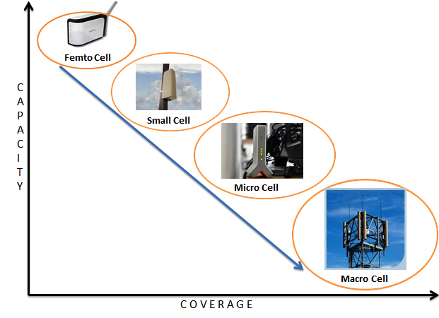
Figure 15. Capacity vs. Coverage showing the positions of Macrocell, Microcell, Small Cell and Picocell in terms of these two parameters.
Below will be discussed how Mobile Network Evolution has created Security Risks:
            - In 1990’s to 2000’s, the phase of development was 2G and 3G. Mobile Operators owned the Infrastructure [27]. Hence it was a trusted network as
- Circuit-switched and Packet-switched networks were owned/ operated by the providers; hence there were no security concerns.
- The key operators did not share RAN or Backhaul with each other.
            - In current scenario, the phase is of 4G Evolution. We are moving towards an all-IP network. It brings with it increasing risk factors as given below:
- Wi-Fi Offload to reduce RAN builds out.
- Replacement of TDM and ATM with IP/ Ethernet throughout the network.
- Heightened risk of flattened LTE and EPC architecture.
      - If we see the future trend, i.e. 2012 onwards, we are moving towards Capacity Build and increased Network Sharing i.e. heterogeneous Networks. It will be an untrusted network due to the following reasons:
- Increased sharing of eNodeB facilities
- Increased usage of Small Cell sites
- Increased usage of X2-u communications
The major security concerns and challenges in small cell market are listed below:
- Repudiation – Incorrect Billing and Lawful Intercept information.
- Attacks on the network – more attacks against operator infrastructure and subscribers.
- Attacks on Packet Services – Packet services getting prone to attacks and frauds.
- Privacy – Subscriber communications getting exposed.
- Reputation – Successful attacks will put an impact on operators’ and users’ reputations.
- Small cell volume will increase due to IP connectivity needs.
- Unlike macrocells which have strong physical security, small cells can be easily compromised.
- Small cells in many instances will use existing broadband networks for Core access (untrusted connection).
- There is no native or embedded encryption in LTE between eNB and Core.
- 3G public access small cells can bypass the RNC which the operator will need to encrypt.
- The serving gateways (S-GW,) responsible for connecting to and keeping active connections to now tens of thousands of eNode Bs/small cells, will struggle with maintaining throughput when processing high volumes of small encrypted packets from signaling traffic.
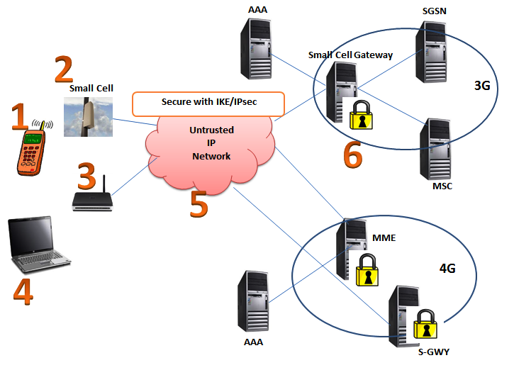
Figure 16. Small Cells 3GPP 33.320; IPsec Security for Small, Femto and Picocells with numbers showing loophole areas prone to security threats as given below.
            - Mobile device compromise of Small cell credentials from the User Equipment
            - Physical attacks on small cell for purpose of data access, cloning and false configurations.
            - Configuration attacks on a small cell like outdated Software versions loaded, Access control alterations.
            - User data and Identity privacy attacks
            - Protocol attacks on a sall cell like man-in-the middle or DOS attack.
            - Attacks on the Core network via fakes Small cell.
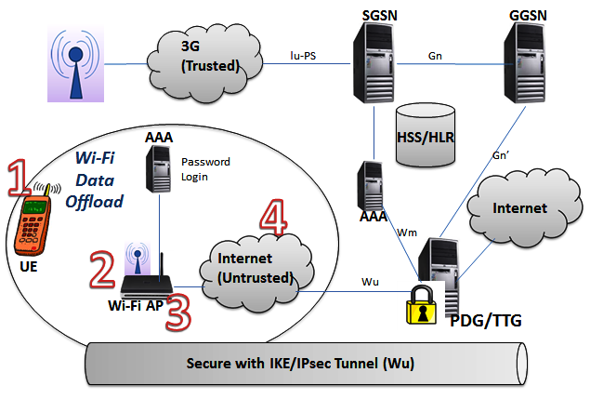
Figure 17. IWLAN 3GPP 33.234; Threats numbered in Mobile Offload Tunnel Terminating Gateway (TTG). The threats which may occur at various points in the Hotspot (WLAN provider or Partition are given below.
  - Attacks on Mobile Device like IP address spoofing, DOS, floods, etc.
  - Attacks on Air Interface: WEP cracking, TKIP hijacks/cracks, session hijacks.
  - Access Point Attacks: physical and logical threats like physical replacement of Aps, replace AP software with rogue software;
  - Transport: Impersonate AP’s, snoop subscriber packets and network control packets, alter control and subscriber communications.
In this project, I will find out the issues and develop solutions to security problems in mobility and communication for seamless Internet access in Heterogeneous wireless networks. The goal would be to develop algorithms to build techniques to defend potential security threats while maintaining the Quality of Service (QoS). Below is given the methodology steps which are intended to be followed:
- At first, protocol with high security and efficiency should be made for handoff across various wireless networks which can belong to different administrative domains.
- Secondly, it will be aimed to provide systematic solutions to improve security level of multi-hop communication in wireless mesh networks.
- Thirdly, mechanisms will be designed to mitigate security flaws during information exchange when applications migrate among diversified network infrastructures and various portable devices.
Scheduling security is an important issue in application design as these applications are widely used almost anywhere in a network. If we look at the current scenario, we observe that security requirements have not been considered in existing scheduling schemes of multimedia applications running on real time heterogeneous networks.
Algorithm Steps:
- Users request for applications via a server.
- Server decides whether to allow a user to access the demanded application or not. The decision is based on the following steps:
- The user authenticity to access the application is tested.
- If it passes the test, the application data is fetched and put in the scheduler queue or else the request is discarded.
- Each time a new application data arrives after passing the authenticity test (step i), it is put in the scheduler queue based on earliest deadline first (EDF) rule.
- All data are tested to achieve the highest schedulability.
- If application data cannot be accommodated, it is dropped to the Rejection queue. Otherwise, it gets transferred to the accepted queue.
- When a new data is allocated to accepted queue, the security checker is activated.
Security checking is done in 3 steps:
- First checking occurs within the RAN from which the application originates. The security checking is done by the existing infrastructure of that RAN technology.
- Second checking is done by the Authentication Module at the IMS core. If the data passes the test at the AM in IMS, it reaches the RAN of the user from which the request had come.
- On entering the RAN of user, it goes through the final checking of the security procedure of that network and on passing the clearance test, it finally reaches the user who had requested for the data.

Chapter 7.
CONCLUSION & FUTURE SCOPE

This internship report mainly consists of an exhaustive report on heterogeneous networks. I have given the detailed version of background, architecture, network elements and design issues of heterogeneous networks. Firstly, I have discussed the background and history of Heterogeneous Networks where I have given details of why HetNet deployment is required and how the situation has arised where we have to move from homogeneous networks to heterogeneous networks. I have then discussed about the Ket HetNet technologies like precise Hotspot identification, Integrated Micro BS, SON features, MIMO technology, etc. I have then moved towards the network elements of HetNet where I have discussed 2G. 3G, 4G, Smallcells and IMS core architecture. I have then focused on the design challenges of HetNet where I have pointed out the major design issues like Interference, Backhauling, handover, SON, Security which needs to be taken care of during HetNet deployment.
The last chapter specifically focuses on a single design issue of HetNet-the security issue. I have pointed out the specific loophole areas where the security is lacking in presently designed Heterogeneous Network. I have also proposed an algorithm for schedulability and step-wise security checking of HetNet.
The future scope of the work is that the pseudocode and real coding will be formulated and implemented in real time HetNet.

REFERENCES
- 4G Americas- Developing and Integrating a High Performance HET-NET, October 2012
- http://www.huawei.com/ilink/en/solutions/broader-smarter/morematerial-b/HW_204152
- http://downloads.lightreading.com/huaweisl/HetNets_The_Future_Makeup_of_Mobile_Networks.pdf
- http://www.huawei.com/cc/static/HW-259753.pdf
- http://gigaom.com/2013/05/22/ericsson-nokia-siemens-lay-the-groundwork-for-hetnet-with-new-wi-fi-technology/
- http://scis.nova.edu/~raciti/cellular.html
- http://bpastudio.csudh.edu/fac/lpress/471/hout/3G.htm
- http://en.wikipedia.org/wiki/2G
- http://www.3gpp.org/Technologies/Keywords-Acronyms/article/umts
- http://www.4gamericas.org/index.cfm?fuseaction=page&sectionid=246
- http://en.wikipedia.org/wiki/3G
- http://www.qualcomm.com/media/documents/files/qualcomm-research-a-comparison-of-lte-advanced-hetnets-and-wifi.pdf
- http://www.webopedia.com/TERM/W/Wi_Fi.html
- http://www.facweb.iitkgp.ernet.in/~pallab/mob_com/Ericsson_Intro_to_IMS.pdf
- http://www.airvana.com/technology/femtocell-network-architecture/
- https://sites.google.com/site/eeg473femtocellproject/femtocell-architechture-network
- https://www.juniper.net/techpubs/software/aaa_802/imsaaa11/sw-imsaaa-admin/html/Introduction3.html
- http://lyle.smu.edu/~skangude/HetNet.pdf
- https://communities.cisco.com/community/solutions/sp/mobility/blog/2013/03/18/unleashing-the-power-of-hetnets-interference-management-techniques-for-lte-advanced-networks
- http://gigaom.com/2012/04/11/can-millimeter-waves-solve-the-small-cell-backhaul-problem/
- http://www.tmcnet.com/voip/departments/articles/300030-small-cell-security-how-protect-traffic-new-generation.htm
- http://tools.ietf.org/html/draft-huang-wireless-security-architecture-00#page-24
- http://wmn.comp.polyu.edu.hk/shawk/doku.php?id=home
- http://www.thinksmallcell.com/System/smooth-operators-son-hetnet-and-small-cells.html
- http://go.radisys.com/rs/radisys/images/paper-seg-hr-backhaul-security.pdf
- http://www.slideshare.net/Radisys/security-for-small-cell-wifi-offload

