
Illustrated Word 2016 | Modules 1–4: SAM Capstone Project 1a
Music Festival Annual Report
Revising and FORMATTING A Document

GETTING STARTED
- Open the file IL_WD16_CS1-4a_FirstLastName_1.docx, available for download from the SAM website.
- Save the file as IL_WD16_CS1-4a_FirstLastName_2.docx by changing the “1” to a “2”.
  - If you do not see the .docx file extension in the Save As dialog box, do not type it. The program will add the file extension for you automatically.
- With the file IL_WD16_CS1-4a_FirstLastName_2.docx still open, ensure that your first and last name is displayed in the footer.
  - If the footer does not display your name, delete the file and download a new copy from the SAM website.

PROJECT STEPS
- You are the assistant director of the Chelsea Valley Music Festival. The festival’s director, Kaya Zhang, has written the festival’s annual report. She needs your help revising and formatting the document. Begin formatting the report by setting the Top and Bottom margins to 0.75" to provide more space for content.
- Format the title “Chelsea Valley Music Festival” as follows:
  - Change the font to Times New Roman.
  - Change the font size to 28 pt.
  - Change the font color to Blue, Accent 1 (5th column, 1st row of the Theme Colors palette).
  - Increase the space after the paragraph to 12 pt.
  - Center the text.
- Format the subtitle “Annual Report” as follows:
  - Change the font to Arial.
  - Change the font size to 18 pt.
  - Bold the text.
  - Increase the space before the paragraph to 6 pt.
  - Center the text.
- Apply the Gold, Accent 4, Lighter 80% (8th column, 2nd row of the Theme Colors palette) paragraph shading to the title and subtitle.
- Find each instance of the word “Group” and replace it with Trio. (Hint: Do not include the period.)
- On page 1, below the “Our Biggest Year Yet” heading, format the three paragraphs beginning “Ticket Sales exceeded…” and ending “…was up 23% over last year.” as a bulleted list using the default bullet style.
- On page 1, just before the “Education Is Our Goal” heading, format the three paragraphs beginning “Our new smart phone app…” and ending “…at Chelsea Valley Hall” as a numbered list using the 1), 2), 3) numbering style.
- On page 1, below the “Board of Directors” heading, format the three paragraphs beginning “Carolina Peru President” and ending “Jessica Robinson Education Chair” as follows:
  - Select all three paragraphs and create a 1.5" left tab stop.
  - Move the insertion point immediately before each position name (“President”, “Treasurer”, and “Education Chair”), then insert tabs to align the text with the new tab stops.
- On page 1, use the Format Painter to copy the formatting from the “Board of Directors” heading to the “Popular Concerts” heading.
- On page 2, modify the picture of the musicians as follows:
  - Resize the picture to a height of 2". The width will resize automatically to approximately 2.95".
  - Apply the Offset Diagonal Top Right picture effect from the Outer section of the Shadow picture effect gallery.
- On page 2, in the first line below the heading “Artistic Highlights”, use the Thesaurus to replace the word “illustrious” with the first synonym that begins with the letter “e”.
- When she was editing the document, Kaya pasted a second instance of the sentence “At the Chelsea Valley Music Festival, we are always looking to the future.” by mistake. Below the heading “Planning for the Future,” delete the second instance of the sentence.
- In the same paragraph, create a hyperlink in the last sentence as follows:
  - Convert the text “donate online” to a hyperlink to the www.chelseafestival.cengage.com webpage.
  - Enter the following ScreenTip:
Donate to the Chelsea Valley Music Festival now!
- On page 3, format the picture of the instruments as follows:
  - Resize the picture to a height of 1.4". The width will resize automatically to approximately 1.39".
  - Apply the Offset Diagonal Top Right picture effect from the Outer section of the Shadow picture effect gallery.
- On page 3, modify the bulleted list beginning “Bronze level…” and ending “…with a donation of $100,000.” as follows:
  - Change the bullet style to square bullets.
  - Decrease the indent of the list by one level.
- Return to page 1 and insert a document header as follows:
  - Insert a page number field using the Plain Number 1 style from the Top of Page gallery. [Mac Hint: Insert a header with a page number, and then left-align the page number.]
  - Apply the Blue, Accent 1 (5th column, 1st row of the Theme Colors palette) font color to coordinate the header with the title and subtitle.
  - Close the Header & Footer Tools.
- Format a section of the report in two columns, as follows:
  - Insert a Continuous section break on page 1, before the heading “Our Biggest Year Yet”.
  - Format the new section that starts with the heading “Our Biggest Year Yet” into two columns.
  - Set the Spacing between columns to 0.3".
- On page 1, format the table after the “Popular Concerts” heading as follows:
  - Apply the Grid Table 5 Dark – Accent 1 table style.
  - Format the table to AutoFit Contents.
  - Right-align the attendance figures in the “Attendance” column.
- On page 2, insert a table in the blank paragraph after the text “The following table lists our pressing concerns.” as follows:
  - Insert a table with two columns and three rows.
  - Enter the data shown in Table 1 below.
  - Apply the List Table 5 Dark – Accent 1 table style.

Table 1: Pressing Financial Concerns
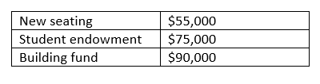
- On page 2, increase the indent of the last paragraph of text (which begins “Please consider sponsoring…”) by one level.
- On page 2, move the insertion point after the period in the sentence “Please consider sponsoring at any level.” and insert a footnote that contains the following sentence:
Our new Platinum-level sponsorship will be available next year.
- Use the Spelling & Grammar checker to identify and correct any spelling errors. (Hint: Ignore all grammar errors and proper nouns. You should find and correct at least one spelling error.)
Your document should look like the Final Figure on the following pages. Save your changes, close the document, then exit Word. Follow the directions on the SAM website to submit your completed project.

Final Figure
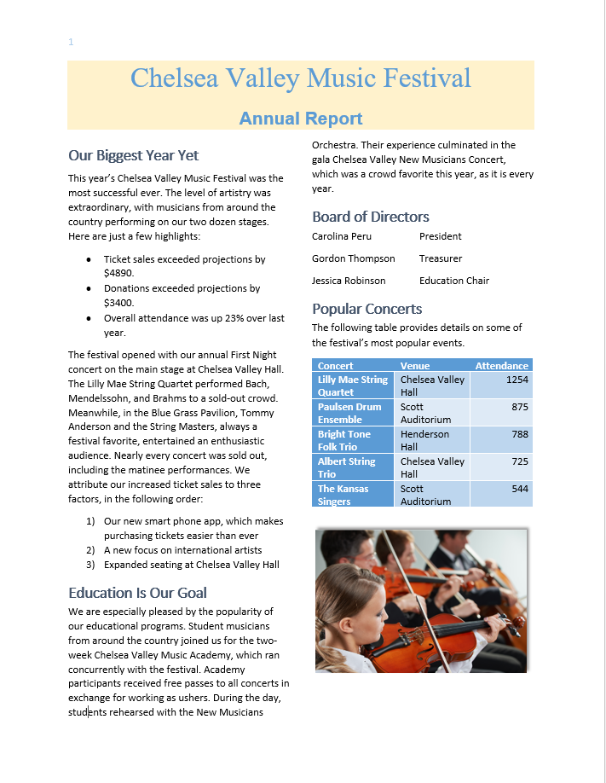
© Stokkete /Shutterstock.com

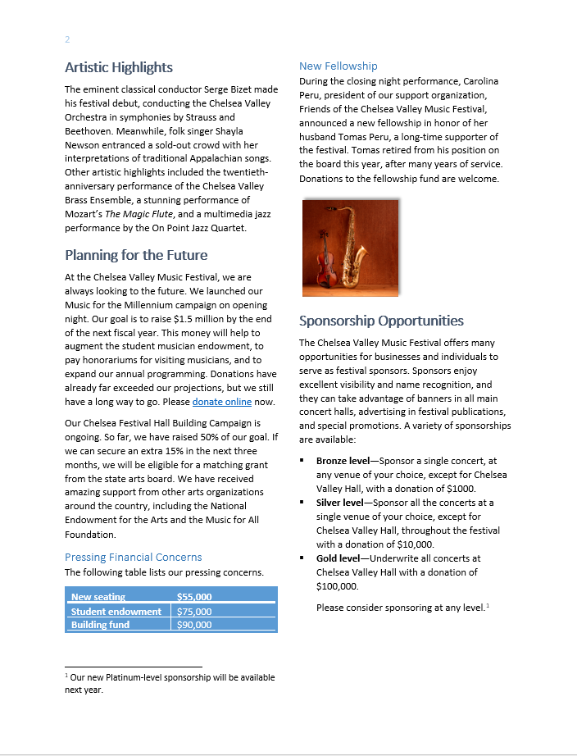
© holbox/Shutterstock.com

