Illustrated PowerPoint 2016 | Modules 1–4: SAM Capstone Project 1a
Picture Perfect Passwords
creating, modifying, AND inserting objects, and finishing a presentation

GETTING STARTED
- Open the file IL_PPT16_CS1-4a_FirstLastName_1.pptx, available for download from the SAM website.
- Save the file as IL_PPT16_CS1-4a_FirstLastName_2.pptx by changing the “1” to a “2”.
  - If you do not see the .pptx file extension in the Save As dialog box, do not type it. The program will add the file extension for you automatically.
- To complete this Project, you will also need to download and save the following support files from the SAM website:
  - Support_IL_PPT16_CS1-4a_Logo.png
  - Support_IL_PPT16_CS1-4a_Outline.rtf
- With the file IL_PPT16_CS1-4a_FirstLastName_2.pptx still open, ensure that your first and last name is displayed in the presenter notes on Slide 1.
  - If the presenter notes do not display your name, delete the file and download a new copy from the SAM website.

PROJECT STEPS
- You work for Picture Perfect Passwords, a computer security startup that manages users’ passwords and online information. Picture Perfect Passwords is preparing for a funding cycle, and you will help the company edit and modify its presentation, beginning with the title slide.
  - On Slide 1 (no title), enter Picture Perfect Passwords as the slide title.
  - Enter Easy. Effective. Affordable. as the subtitle. (Hint: Include the periods and spaces.)
  - Change the character spacing of the subtitle text object to Loose.
- With Slide 1 still displaying, select the keyhole shape, then select the rectangle. Merge the two shapes using the Combine option. Refer to Figure 1 below. (Hint: Be sure to select the keyhole shape first.)

Figure 1: Combined Shapes on Slide 1
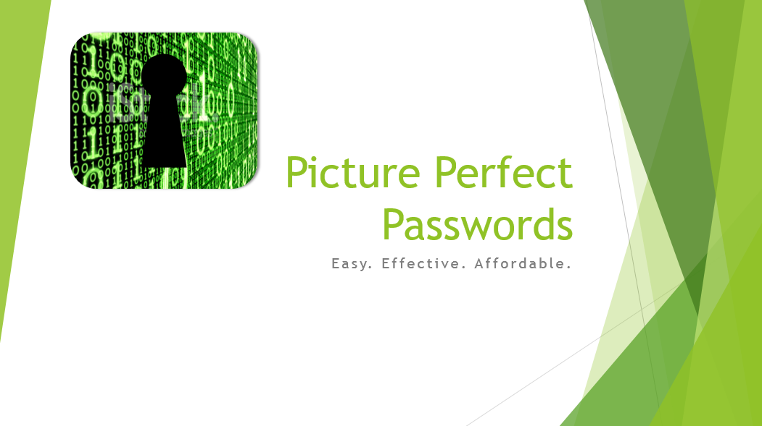
- On Slide 2 (“Why manage your passwords?”), convert the bulleted list to SmartArt using the Hierarchy List layout shown in Figure 2 below.

Figure 2: Hierarchy List SmartArt Layout
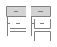
- With Slide 2 still displaying, apply the Moderate Effect SmartArt style to the SmartArt.

- Open Slide Master view and navigate to the Facet Slide Master layout. Modify the Facet Slide Master layout as follows:
  - Insert the picture from the file Support_IL_PPT16_CS1-4a_Logo.png, available for download from the SAM website.
  - Resize the picture to a height of 1.1" and a width of 0.45".
  - Use Smart Guides to move the picture to the upper-right corner of the slide master in the light green diamond, as shown in Figure 3 below.
  - Close Slide Master view.

Figure 3: Position for Picture on Slide Master
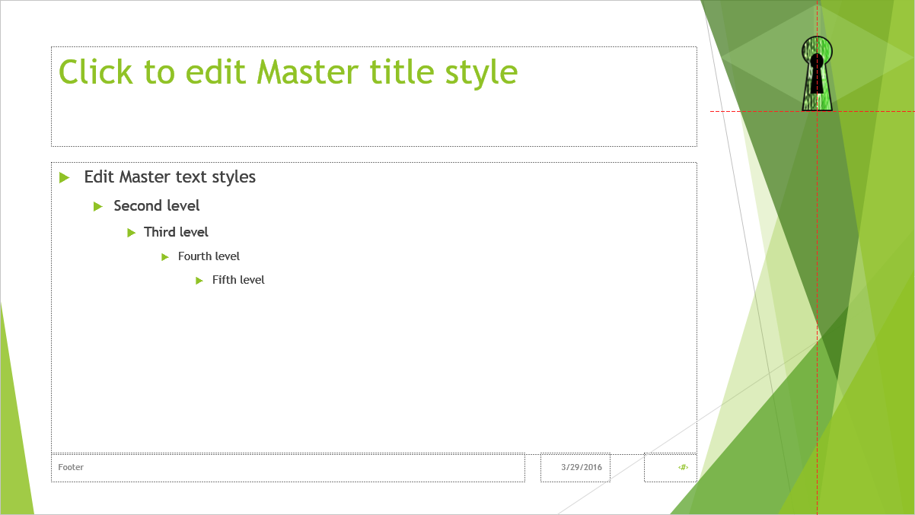
- Add a new Slide 3 using the Title and Content layout.
- On the new Slide 3 (no title), enter text describing the features of Picture Perfect Passwords as follows:
  - Enter Key features as the slide title.
  - In the placeholder, enter a bulleted list with the following items:
Custom synching
Multiple devices
Local or cloud storage
Easy updates

- The staff at Picture Perfect Passwords has prepared an additional slide in Microsoft Word highlighting the software features. Insert a new slide as follows:
  - Insert a new Slide 4 from the outline Support_IL_PPT16_CS1-4a_Outline.rtf, available for download from the SAM website.
  - Reset the slide you inserted so that it matches the current theme of the presentation.
- On Slide 5 (“Next release highlights”), insert WordArt as follows:
  - Insert WordArt using the Fill – Green, Accent 1, Shadow WordArt style.
  - Change the font size to 44 pt.
  - Enter Join the Beta Program in the WordArt text box.
  - Apply the Warp Up Transform effect in the Warp section of the Transform gallery. (Hint: Depending on your version of Office, the text effect name may display as Can Up instead.)
  - Use Smart Guides to move the picture to the bottom of the slide, as shown in Figure 4 below.

Figure 4: Position for WordArt on Slide 5
- With Slide 5 still displaying, draw extra emphasis to the Beta Program WordArt by formatting the background of the slide with the Canvas texture fill at 90% transparency.

- On Slide 6, (“More highlights”), adjust the bulleted list as follows:
  - Decrease the indent of the “Biometric scanning” bullet one level.
  - Increase the indent of the “Fingerprint” bullet one level.
- With Slide 6 still displaying, insert and format a text box as follows:
  - Insert a text box and enter the following text:
Free Version
  - Change the shape fill color to Green, Accent 1, Lighter 40% (5th column, 4th row of the Theme Colors palette).
  - Center the text in the text box.
  - Resize the text box to a height of 0.4" and a width of 2.26".
  - Use Smart Guides to move the text box within the frame at the bottom of the slide as shown in Figure 5 below.

Figure 5: Position for Text Box on Slide 6

- On Slide 7 (“Sales analysis”), use the content placeholder to insert a Clustered Column chart with the data shown in Table 1 below.

Table 1: Data for Column Chart on Slide 7

 | Last Year | This Year | Next Year
Consumer | 170 | 245 | 345
Business | 130 | 145 | 215
Government | 50 | 130 | 210
Total Sales | 350 | 520 | 770

- With Slide 7 still displaying, modify the chart as follows:
  - Enter the text Sales by Sector as the chart title.
  - Change the chart style to Style 11.
- On Slide 8 (“Why we’re ranked #1”), use the content placeholder to insert a table with four columns and five rows and the data shown in Table 2 below.

Table 2: Data for Table on Slide 8

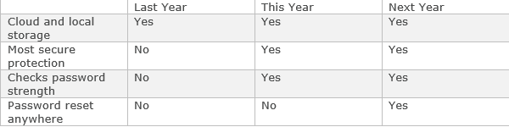
- With Slide 8 still displaying, format the table as follows:
  - Apply the table style Themed Style 1 – Accent 1.
  - Center the contents of columns 2–4.
  - Vertically center the contents of rows 2–5.
- With Slide 8 still displaying, format the red and orange shapes as follows:
  - Change the stacking order of the red arrow so it appears in front of the orange curved shape.
  - Group the red arrow with the orange curved shape.
- With Slide 8 still displaying, animate the grouped rocket shape as follows:
  - Apply the Fly In Entrance animation.
  - Apply the From Right effect option.
- With Slide 8 still displaying, animate the title placeholder as follows:
  - Apply the Wipe Entrance animation.
  - Change the duration to 0.25 seconds.
  - Reorder the animations so that the animation to the slide title plays first.
- On Slide 9 (“Partnerships”), format the oval callout shape as follows:
  - Enter the text Coffee and a Password in the shape.
  - Change the style of the oval callout shape to Moderate Effect – Brown, Accent 6.
  - Apply the Preset 5 preset shape effect.
- With Slide 9 still selected, format the picture of the card as follows:
  - Apply the Sharpen: 25% correction.
  - Apply the Simple Frame, Black picture style.
- Add transitions to the presentation as follows:
  - Select the Push transition.
  - Use the From Right effect option.
  - Change the duration of the transition to 1.50 seconds.
  - Do not allow slides to advance on a mouse click.
  - Advance each slide after 00:04.50 seconds.
  - Apply the transition settings to all slides.
- Add a footer as follows:
  - Display the slide number.
  - Enter the following text:
Picture Perfect Passwords
  - Show the footer on all slides except the title slide. (Hint: Use the “Don’t show on title slide” check box in the Header & Footer dialog box.)
- Check the Spelling in the presentation to identify and correct any spelling errors. (Hint: You should find and correct at least one spelling error.)
In Slide Sorter view, your presentation should look like the Final Figure on the following page. Save your changes, close the presentation, then exit PowerPoint. Follow the directions on the SAM website to submit your completed project.

Final Figure
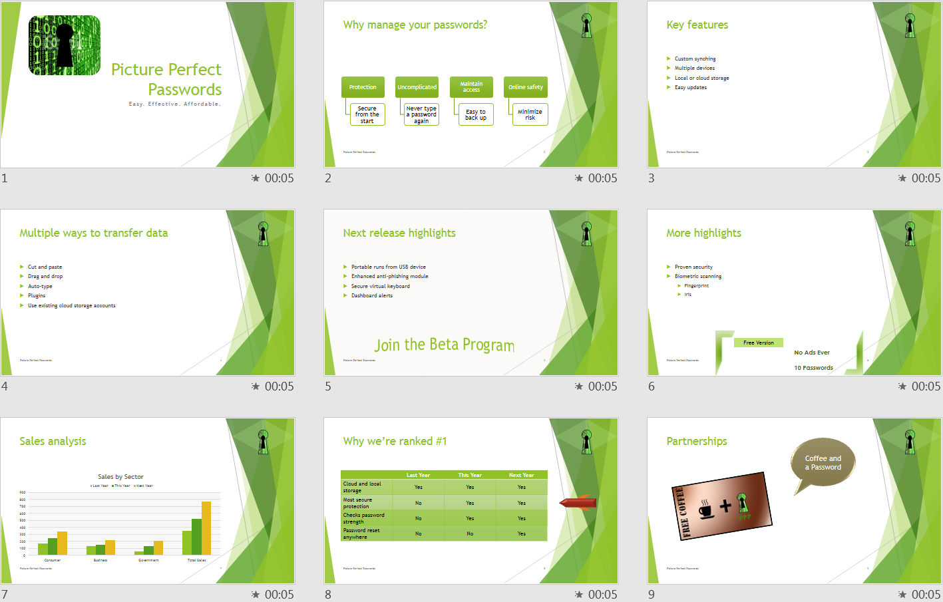
© fpm/iStockphoto.com

