**Name: ______________________________________**

**Module 01 Homework Assignment**

1. Based on the statement below, answer the following questions:

***A survey of 1500 U.S. adults found that 78% of adults use the Internet as their primary news source.***

1. Identify the population.
2. Identify the sample.
3. Based on the adults surveyed, determine the number of people who chose the Internet as their primary news source.
4. Based on the statement below, does the numerical value represent a parameter or statistic? Explain your reasoning.

***In a recent survey of all Business majors at a University, 25 students chose to minor in Political Science.***

1. Classify the variables below as either ***Quantitative*** or ***Qualitative***.
2. Political Party Affiliation _________________________
3. Income______________________________
4. Age _______________________________
5. Telephone Number _______________________________
6. Based on each example below, which of the four levels of measurement is most appropriate (nominal, ordinal, interval, and ratio)?
7. Top 10 restaurants in the United States _______________________________
8. The years that the New York Yankee’s won the World Series __________________________
9. Car Make and Model ______________________________
10. The yearly gross income of company executives ___________________________
11. A survey was administered to 30 randomly selected registered voters in Lake County to determine their political affiliation. The raw data is shown in the chart below. Organize the data by constructing a categorical frequency distribution.

D = Democrat, I = Independent, R = Republican, O = Other



|  |
| --- |
|  |

1. What can you conclude about the political affiliation of registered voters in Lake County?
2. Using the frequency distribution created in Question 6, construct the Relative and Cumulative Frequencies.

|  |
| --- |
|  |

1. Based on the relative and cumulative frequencies, what can you conclude about the political affiliation of registered voters in Lake County?
2. A survey was taken to determine the heights of randomly selected shoppers entering the mall on a Saturday afternoon. The histogram below provides a summary of the shopper’s heights. Based on the histogram, answer the following questions:

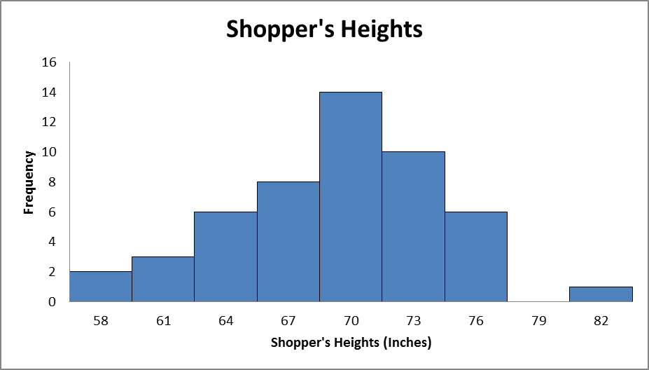

1. What is the approximate number of shoppers surveyed?
2. What is the class width of the first class?
3. What is the approximate height of the tallest person surveyed?
4. What is the approximate height of the shortest person surveyed?
5. There is a gap in the data for shoppers with a height of 79 inches. Provide an explanation for this gap.
6. Comment on the shape of the distribution of shopper’s heights? Explain.