‘AUTHOR’ table with ‘AUTH_ID’ as Primary Key
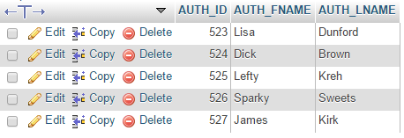

‘BOOK’ table with ‘BOOK_ISBN’ as Primary Key
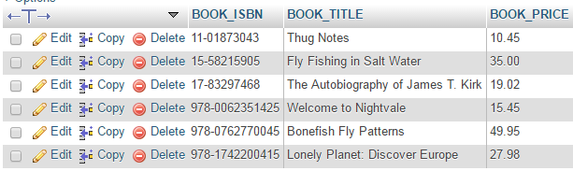

‘AUTHOR_BOOK’ table
with ‘AUTH_ID’ as Foreign Key AND ‘BOOK_ISBN’ as Foreign Key (NO Primary Key)
referential integrity is enforced
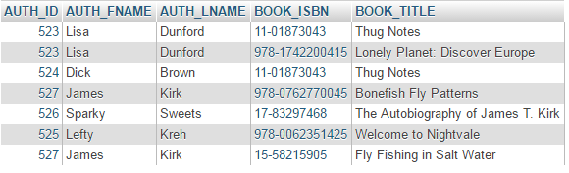

My Problem
I need to run a query that:
  - Displays the AUTH_FNAME, AUTH_LNAME, BOOK_TITLE, and BOOK_PRICE fields
  - Sorts in descending order by BOOK_PRICE.

This is the SQL I have so far, but I keep getting an error

SELECT AUTH_FNAME, AUTH_LNAME, BOOK_TITLE, BOOK_PRICE
FROM AUTHOR_BOOK INNER JOIN BOOK
ON AUTHOR_BOOK.BOOK_ISBN = BOOK.BOOK_ISBN
ORDER BY BOOK_PRICE DESC

The error says “#1052 – Column ‘BOOK_TITLE’ in field list is ambiguous”
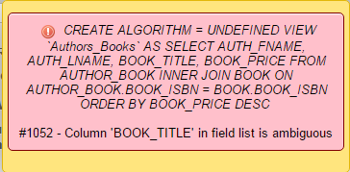

What did I get wrong? please give me the correct SQL to populate the correct information.

