1.

SELECT emp_ssn, emp_last_name, emp_dpt_number, emp_salary AS [Max Department Salary]
FROM employee AS [e1]
WHERE emp_salary = (
SELECT MAX(emp_salary)
FROM employee AS [e2]
WHERE e2.emp_dpt_number = e1.emp_dpt_number)
ORDER BY emp_dpt_number ASC;

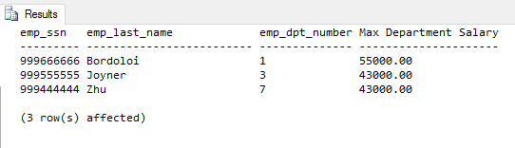

2.

SELECT emp_dpt_number, MAX(emp_salary) AS [Top Salary]
FROM employee
GROUP BY emp_dpt_number
ORDER BY emp_dpt_number ASC;

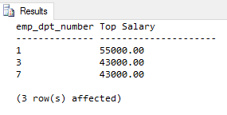
While you can get the top salaries from each department, you cannot get it in a format which would allow you to include the social security number or employee last name due to those being UNIQUE. If you include the employee social security number and employee name in the above SQL, you will get the following:

SELECT emp_ssn, emp_last_name, emp_dpt_number, MAX(emp_salary) AS [Top Salary]
FROM employee
GROUP BY emp_dpt_number
ORDER BY emp_dpt_number ASC;

Msg 8120, Level 16, State 1, Line 1
Column 'employee.emp_ssn' is invalid in the select list because it is not contained in either an aggregate function or the GROUP BY clause.

Therefore, the use of Grouping and Aggregation while only get you so much information but not in the format requested.

3.

SELECT work_emp_ssn, work_pro_number, work_hours AS [Highest Work Hours]
FROM assignment AS [a1]
WHERE work_hours = (
SELECT MAX(work_hours)
FROM assignment AS [a2]
WHERE a2.work_pro_number = a1.work_pro_number)
ORDER BY work_hours DESC;

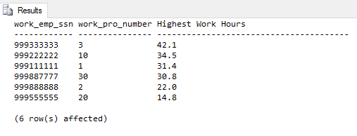

4.

SELECT work_emp_ssn, CONCAT(emp_first_name, ' ', emp_last_name) AS [Name], emp_dpt_number, work_pro_number, work_hours AS [Highest Work Hours]
FROM assignment AS [a1] JOIN employee AS [e] ON (e.emp_ssn = a1.work_emp_ssn)
WHERE work_hours = (
SELECT MAX(work_hours)
FROM assignment AS [a2]
WHERE a2.work_pro_number = a1.work_pro_number)
ORDER BY work_hours DESC;

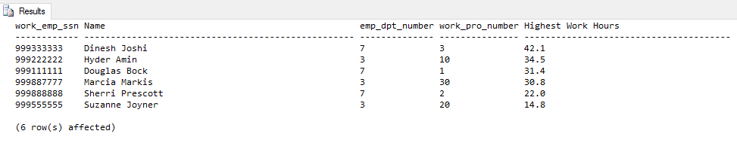

5.

SELECT emp_last_name AS [Last Name], emp_first_name AS [First Name]
FROM employee
WHERE emp_ssn IN
(SELECT work_emp_ssn
FROM assignment
WHERE work_hours >= 8 AND work_pro_number IN
(SELECT pro_number
FROM project
WHERE pro_name = 'Payroll') );

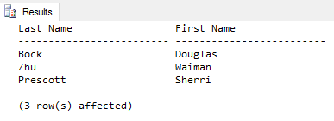

6.

SELECT dpt_name AS [Department Name], pro_number AS [Project Number], pro_name AS [Project Name], pro_location AS [Project Location]
FROM department d INNER JOIN project p ON (d.dpt_no = pro_dept_number)
WHERE pro_location = 'Edwardsville'

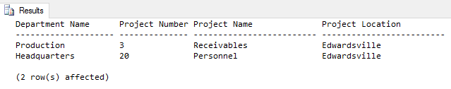

7.

SELECT emp_last_name, emp_first_name, work_pro_number, work_hours
FROM employee e LEFT OUTER JOIN assignment a ON (e.emp_ssn = a.work_emp_ssn)
ORDER BY emp_last_name

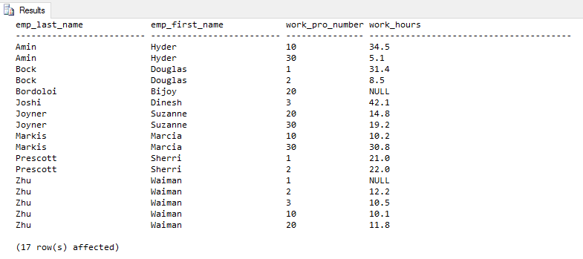

8.

SELECT emp_last_name, emp_first_name, work_pro_number, work_hours
FROM employee e LEFT OUTER JOIN assignment a ON (e.emp_ssn = a.work_emp_ssn)
WHERE work_hours IS NULL
ORDER BY emp_last_name

