
authors
BOB LI || PARIN patanasiri || SHAHAB GHAZI || YAOCHUN YANG || WEIJIE duan
Needs Analysis Report Genre Book Project
AUT University | GENRE BOOK BOOKSTORE PROJECT 2016 GROUP 8
2016

Executive Summary
This report has been compiled for the Genre Book Bookstore to analyse its current situation thereby providing a strategic plan for it.
The Genre Book Bookstore first store opened immediately after the owner graduated before 1999 from a business degree at AUT. The owner then later opened two more stores in Ponsonby and Newmarket based in central Auckland. The owner has decided to open up several other branches in South Island preferably Christchurch and this report contains strategic plan in order for a successful and profitable business.
This report has been compiled by the IT consultant group and it identifies and analyses the objectives as well as strategies to successfully achieve those objectives. We have also developed conclusions, which gives detailed summary of how the client may take the step forward with their business and reach their goals. During the process of analysing, we will determine the needs and provide the best strategic options and ideas to ensure that the business strategic plan fulfils the needs of the business for a successful expansion.
As the IT consultant group, we have decided to use two analysis methods, which are SWOT and Porters Five Force Model. Some issues have been identified that might affect the business and solutions have been provided. One of the issue stated is that some staff is inexperienced because they are newly graduates; the manager with IT experience is not familiar with the current technology while the other manager has some experience with advertisement and marketing.
All of the problems are dealt with and the solutions provided through the two methods. Recommendations are listed for the issues at hand and some recommendation or solutions are that staff be professionally trained, fundraising for the business, yearly auctions held to increase business popularity and budget as well as marketing and advertisement methods. The marketing and advertisement being a very important success factor we have provided some recommendations such as handing out pamphlets and brochures in other business events and posters on public transport vehicles such as shuttles and busses. In addition, a new website designed by graphics artists working alongside with the current staff is a great way to increase business popularity and growth. Systems including an ordering system, in store self-service system, human resource management system and networking systems have been recommended.

Table of Contents
Executive Summary 1
Background 3
Strategic Plan 3
Value Chain 8
Direct Activities 8
Indirect Activities 8
Quality assurance 8
Inbound logistics 8
SWOT Analysis 9
Porter’s Five Forces Analysis 10
Work Systems 11
Conclusion 12
Summary of Recommendations 12
Reference 14

Background
The Genre Book Bookstore business owner Edward Barnabay currently owns three stores based in central Auckland. The stores are located in Ponsonby, Newmarket and high street. The owner is an AUT graduate and has attained business degree; he opened his first store in Ponsonby before 1999 immediately after he graduated.
The owner has basic idea of how he wants his business to run and expand which includes a few strategies. However, approaching and carrying out those objectives is something they are unsure about therefore, we as the IT consultant group, have provided the methods required taking the next step in order to expand the current business to South Island locations within 12 months and then to international locations. Goals for long term and short term needs to be met in order for the Genre Book Bookstore to expand to other locations.
The short-term goals are using up to date technology to full extent, professionally training the staff to use the technology, accounting system, advertising the business through means of website and media like TV commercials as well as raising money for the business through tips or holding fundraising events. Advertisement and raising money in the required time is important, as this will directly benefit the business growth. Customer service is very important which is why a customer loyalty programme is necessary to keep customers and attract more customers by providing great customer care. Without enough budget, it is not possible to expand to other locations, in which case the business expansion process needs to be put on hold until it is possible to move forward. Our job is to make sure that does not happen, and the business can move forward in a profitable manner to expand to other locations. In order to successfully reach the business goals, all the objectives and strategical objectives needs to be accomplished.

Strategic Plan
Key indicators
  - Technological features
  - Human resources team
  - Business growth through expansion
  - SWOT analysis
  - Value Chain
  - Work System
  - IT Solutions & Recommendations
Goal 1: Technological features
To take full advantage of modern day technology in order to strengthen its customer service.
Tactical Objectives
- Design a public website (www.genrebookstore.co.nz)
- Item look up
- Description of products and services
- Feedback
- Customer login
- Communication devices
- Efficient system that would ensure communication between all of the stores
- Hardware and Software
Strategical Objectives
- Design a business website
- Hiring a new web designer who will work alongside with graphics artist in order to create a new website for the business. The new website should have features such as feedback, where customers can place feedback, item lookup and customer login. Customers should be able to find different store locations. Customers should be able to buy products from the website, and a (GST) receipt should be emailed to their registered email address.
- Reliable network
- hiring an IT specialist is necessary to set up and install all of the hardware and software solutions. Set up reliable network that would connect all stores. Be able to send/receive files and folders across all locations. Data centre companies such as Dropbox, cloud, google provides such services to store files and share them immediately at low cost.
- Staff training
- staff training is very important part in order for the business to run efficiently and increase profit. All staff who needs to use the system should have basic trouble shooting knowledge and simple network related issues.
Critical Success Factors (CSF)
Successfully meeting the strategic and tactical objectives means a profitable business. The key success factors for a profitable business are:
- Increasing customers
- Acquire customer needs information
- Technology maintenance – keeping the technology working and up to date
- Implementation of computerized system – for customer service

Goal 2: Human Resources Team
Tactical Objectives
- System Maintenance
- Professional Staff Training
- Prevent Inaccuracies of Financial System
- Hire temporary staff

Strategical Objectives
- Roster system necessary to manage staff
- Regular checks to make sure system features functions properly
- Log book to monitor all system features and its functionality
- Hire two skilled contractors on one-month temporary contract to train staff
- Assign staff a position according to their previous knowledge and skills
Critical Success Factors (CSF)
- Professionally train the staff to maintain high customer service. This means reduction of mistakes that may occur by the staff and this will give the staff good knowledge about system.
- Better communication between staff and customer means better quality of service
- Staff with multiple background languages or cultural experiences will be better suited for that specific customer.
Goal 3: Business Growth
To increase and strengthen the reputation of the Genre Book Bookstore thus increasing profitability and expansion of the business. Business to be expanded to South Island within 12 months.
Tactical Objectives
- Growth
- Monitor business profit
- International expansion
- Increase business budget
- Providing more discounts for products and services
Strategical Objectives
- Hold auction couple of times a year to sell unwanted products
- This will also be form of advertisement for the business as it will bring in other customers
- Fundraising
- Staff should be encouraged to put money in tip box and customers too
- Current experience should be used for future expansion. Weakness and threats considered in order to prevent and reduce future risks
- Donation events
- Business should encourage donation events to raise extra money
- Apply discount to sale tickets
- Lease spare space
- Business budget can increase to lease spare space to other businesses which are not needed. This can attract more customers too.

Critical Success Factors (CSF)
- Positive status for the business - A positive and solid status is necessary for maintaining the business credibility and reputation.
- Business Maintenance - maintain the business in order to increase its growth and profitability. This can be achieved by monitoring staff progress with customers, products and services availability and the business direction.
- Bookstore in specified areas – business expansion branches should be in specified areas where there is recognition of the business fine arts, crafts and music.
Goal 4 – Advertisement
To recommend our store into the existing market, and show the originality of the business.
Tactical Objectives:
The objective is recognised that there are some suitable and necessary plan or opportunities which could be used to get advance of the bookstore.
- appropriate advertising should be created for not only local New Zealanders but also foreigners alike.
- Identify the purpose, reflect the future direction.

Strategical Objectives:
- Well-known advertising companies should be selected or considered to support and assist the bookstore with an advertising strategy.
- Using the New Zealand media to deploy an advertising activity including TV, radio (YouTube), newspaper, magazine, website banners and posters which can be distributed to university.
- To consider and design a characteristic brand name with unique and classical style.
To achieve this goal, the main point is that sufficient funds to support the range of services which provided, and products that offered and advertising fee.

Goal 5 – Quality of products and service
Quality of products and service: ensure the overall quality of the products which has been sold and the customer service we provide.
Tactical Objectives:
- Select reliable and reputable supplier
- Carefully select good quality products
- Analyse the other bookshops and learn from their advantages and disadvantages
Strategical Objectives:
- Assess any previous experiences with suppliers
- Communicate with old and potential customer and identify what kind of products (books or DVDs) they really interested in based on our bookstore categories (arts, crafts, music and culture, etc.).
- Select suitable content of products.
- Clearly review both the advantages and disadvantages that other bookshops have had in relation to their previous experiences.
Critical success Factors:
- Receive suitable feedback from potential customers, bookshops staff could create an agitprop and problems, once bookshop receive any feedbacks from surveys, we can select useful and validate information to change our shop better.
- To select the feedback, the information that we collected must be true and then we can analyse the data to make the plan for previous products that would be offered and connect to supplier efficiently.

Goal 6 – Exploit Advantages
Exploit the bookstore’s strengths and opportunities in existing markets.
Strategic Objectives:
- It is better to find out the bigger market and market should be more insistent to build market share from each different companies.
Tactical Strategies:
- Establish a customer loyalty programme which is necessary for bookshop to obtain popularity. For example, some
Loyalty card with different levels could be better for attracting customers demand.
- Establish some activities such as reduce prices and provide discounts to promote sales
- Deploy e-business with other countries suppliers, customers or companies, which is suitable for customers to enjoy online services.
- Variety of products, import from various countries, suitable for the diverse cultural affiliations in our customers.
- Export our very own sources of native arts and literature products to overseas countries, recommend other countries’ customers to enjoy our own culture and find out the differences and advantage.

Critical success Factors:
- Customer loyalty program should be efficient and reliab. Once add new customer into the loyalty program, thoroughly test every program before running it.

- Select appropriate product to create activities for discounting products, some popular and useful products should have each suitable discount to attract more and more customers, even more importantly, increased their interest by our unique style of products.

Value Chain
In this part, the value chain will be the main topic. The value chain is a necessary part in business process. Value chain can show every details in business process, such as supply and demand relationship, sale and services goal. The Genre Book project must achieve every activity of the value chain.
(Katherine Arline, 2015)
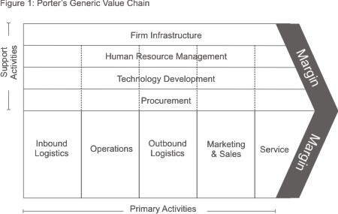
Mind Tools Editorial Team. (n.d.)

Primary activities
 | Direct Activities | Indirect Activities | Quality assurance
Inbound logistics | We get items from suppliers, they manage our items prices and quality. Suppliers provide unique and especially we ask for books. The coats of lease store. | The salary for every staff. The cost to maintain the books inventory. Suppliers provide correct quantity, date and location of our orders. Suppliers provide books are good for the owner and our consumers. | Check our orders’ quantity and quality are compliance with our requirements.
Operations | Control and location the stocks. Provide good services to our consumers. Edit the website. | Training the staffs, make sure they can expertly use the software to improve working efficiency. | Improve working efficiency and keep the efficiency in high level. Manager keep the stocks in correct order.
Outbound Logistics | Consumers can check the stocks in website and in our store. Consumers can buy books in lower price with higher quality. | To sole concern and focus being to maintain customers. | Provide best services and products. Customers like to buy and rental our items.
Marketing & Sales | Prices for sale and rental items. Make the sale process in an easy and convenient way. | Keep sold information and member information. | Have good sales records and sustainable growth financial situation.
Service | Lower price and good services. | Quality of items and refund policy. | Shopping experiences are no difference between every store. Customers like to use website to choose items.

Support Activities
 | Direct Activities | Indirect Activities | Quality Assurance
Infrastructure | The three different bookstores. Online shopping website. Books warehouse. | The cost of set up the website and lease the bookstores. | Manager should control the costs and use wright way to set up the website.
Human Resources | Training staffs, include part-time staffs, full-time staffs and managers. | Choose helpful “think tank” group. | Use feasible way to manage employees’ timetable. Employ suitable staffs to do the jobs.
Technology | Sit up the website from hardware and software side. | Use wright ways to finish jobs. Ensure the servers are able to get a good operation. | Managers have enough training in how to use the system. The benefits of the new system can be showing in business process.
Procurement | Purchase or lease storefront, rent website servers, update computers’ operating system and any necessary office appliances. | Control the cost of maintain hardware and software. Try to spend less many on extra cost example the power fee. | Have a good result of cost control and never reduce the quality of service.

SWOT Analysis
The SWOT analysis is a method that would test the strength, weaknesses, opportunities and threats for the Genre Book Bookstore business. It helps the business by analysing itself and the market thereby making better decisions to profit the business. There are weaknesses such as the demands books and DVDs for selling and hiring, as well as availability of products within time. Some staff lack experience and a highly technological system is required that can cope with current features. The target audience is limited as well as not much popularity and name for the business in the market. By using the SWOT method, the business can analyse its weaknesses and threats to help overcome it.

Porter’s Five Forces Analysis
We have chosen to use Porter’s Five Forces Analysis to have a deep understanding of the business in order to make good decisions. The five forces can help provide competition strategies. In the current market, there are plenty of competition with the same interest as the Genre Book Project. It is important to understand the dominance the supplier has in the market because they are the ones who provide the specific products. They are the only one who can support our business therefore; they must be dealt with the best way and using the previous experience to understand the supplier better.
The customers also have a strong power that can affect the business. If we cannot attract customers, they have other options to visit other bookstore shops for their needs. This can affect the business negatively and the business will lose customers. If another bookstore sells the same products and services for lower price, then the customers will surely go to them. The Genre Book Bookstore should always be open to dropping their prices as well as giving discounts to ticket sales.
There is the competitors who are the threat of new entrants. Although the market demand shows high need for its products and services, there is the concern of the lack of experience for the staff as they are newly graduates. (Mind Tools Editorial Team. (n.d.).)

Work Systems
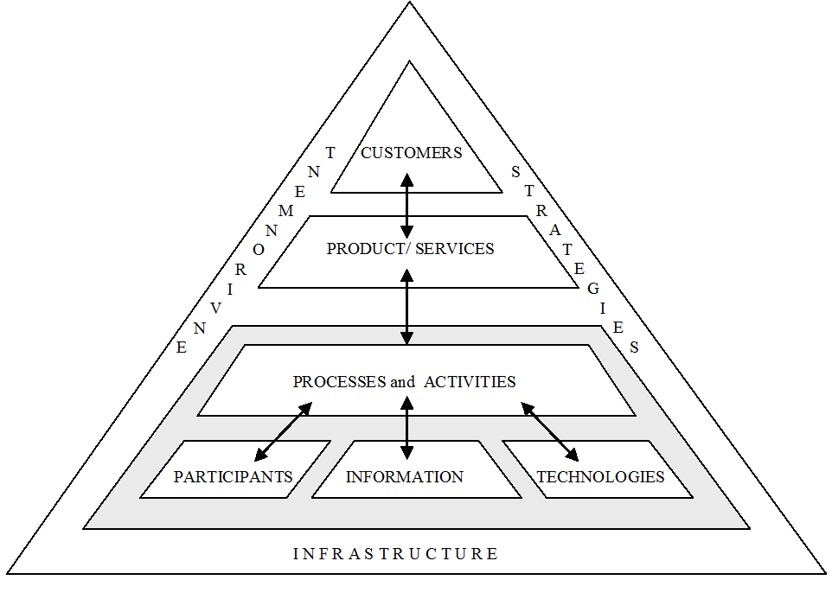
(StevenAlter. (n.d).)
According the value chain, we can analysis the work system as follow:
- Environment. People enjoy on reading books and watching videos, they want to use these ways to relax. Although people like to use other ways like e-book to read books, people still need real books.
- Strategies. The Genre Books store want to set up a website and touch-screen system to search and located inventory books. Will hold more bookstores in the future.
- Infrastructure. Build a website for consumers, training staffs to use the new system. Have a touch-screen system in stores.
- Participants. The business owner, managers and all staffs.
- Information. Compare different suppliers’ offer and choose the best one, analysis consumers’ needs provide the popular items. Tidy finance report to the business owner.
- Technologies. Managers needs to use computers to update inventory information. Web servers can support the website and keep the website in working. The in store touch-screen system is necessary system.
- Process and activities. In this business, we need order items from supplier, take stocks, update information on-line and sale the stocks to our consumers. We have to list the website needs and make sure we have everything on the list.
- Products/Services. Consumers can open the website and find items information that they need. The store focus on rent or sell books and videos products. The bookstore will try to provide best services.
- Customers. The business service for teenagers and adults, anyone who needs to rent or buy books, DVDs.

IT SOLUTIONS AND RECOMMENDATIONS
System | System Description
Human Resource Management System (HRMS) | - Captures all the necessary data  - Identifies workforce potential by monitoring workforce’s strengths and weaknesses  - Feedback for employees for high performing
Ordering System | - Features that would help small business to grow  - Cloud based  - Product management (add, update, remove) and input stock and tax information  - Marketing tools includes customer loyalty program  - View daily income of the business  - Gives clear idea to owner of business to make day to day decisions
Network System | - A system that can optimize entire business  - Implementation of new design to help grow your business  - Help with data growth and associated costs
Touch Screen System in Store | - Customer feedback  - Customer login  - Web browsing  - Scan products  - Rewards/balance checker

Conclusion
The Genre Book Bookstore needs an organized strategic plan in order for the business to expand. The business will require IT specialists staff who can professionally train the current staff, help examine the business networking system as well as outsourced company who can build and maintain a stable connection between all of the business stores. The business will successfully expand if all of the objectives are met.

Summary of Recommendations
 | Recommended Solution | Module | Work System | Strategic Plan item/s
1 | Finance & Accounting System | Financial Accounts | Financial & Accounting | To be able to manage payment from the customers and for the owner to review the record of sales.
1 | Finance & Accounting System | Invoicing, financial reports | Financial & Accounting
1 | Finance & Accounting System | Manage business accounts, income/expense, profit | Financial & Accounting
2 | Ordering System  Touch Screen System (POS self-service kiosk) | Look up products and services, process a payment of transaction | Products and services | To provide the customers a way to buy the products in a more efficient way
2 |  | Scan for product information | Products and services
2 |  | Customer feedback/balance checker/customer loyalty | Products and services
3 | Human Resource Management System (HRMS) | HR Management | Human Resources | To be able to hire more people and train them more effectively
3 | Human Resource Management System (HRMS) | Recruitment Management | Human Resources
3 | Human Resource Management System (HRMS) | Training Administration | Human Resources
4 | Network System | Database | Infrastructure | To develop a system in which one store can communicate with other stores and establish online sales
4 | Network System | Secure connection between different retails | Infrastructure
4 | Network System | Secure internet connection | Infrastructure

Reference
Mind Tools Editorial Team. (n.d.). Understanding how Value is Created Within Organizations.Porter’s Value Chain. Retrieved Aug 18, 2016, from
https://www.mindtools.com/pages/article/newSTR_66.htm

Mind Tools Editorial Team. (n.d.). Assessing the Balance of Power in a Business Situation.Porter’s Five Forces. Retrieved Aug 18, 2016, from
https://www.mindtools.com/pages/article/newTMC_08.htm

Halogen Team. (n.d). Talen Management Made Easy.Halogen TalenSpace. Retrieved Aug 23, 2016, from
http://www.halogensoftware.com/landing/free-trial/talent-management?source=Capterra&c=Search-TM&kw=Human+Resources

Andrew Duncan. (n.d). NSP IT System Engineers.Infrastructure. Retrieved Aug 23, 2016, from
http://www.nsp.co.nz/about-network-service-providers/

Espy. (n.d). Engage on a whole new level.Espy. Retrieved Aug 23, 2016, from
Espy.nz

StevenAlter. (n.d). Work System Basics.Work System. Retrieved Aug 23, 2016, from
http://www.stevenalter.com/work-system-basics-2/

Katherine Arline.(2015 January 26). What is a Value Chain Analysis?.Retrieved August 24, 2016, from
http://www.businessnewsdaily.com/5678-value-chain-analysis.html

