- Database Design:
The data to be used in the system are stored in various tables. The number of tables used and their structure are decided upon keeping in mind the logical relation in the data available.
The database used for this project was MySQL. Figure 4 below shows the entity relationship diagram for the database used by this website.

- Entity relation diagram

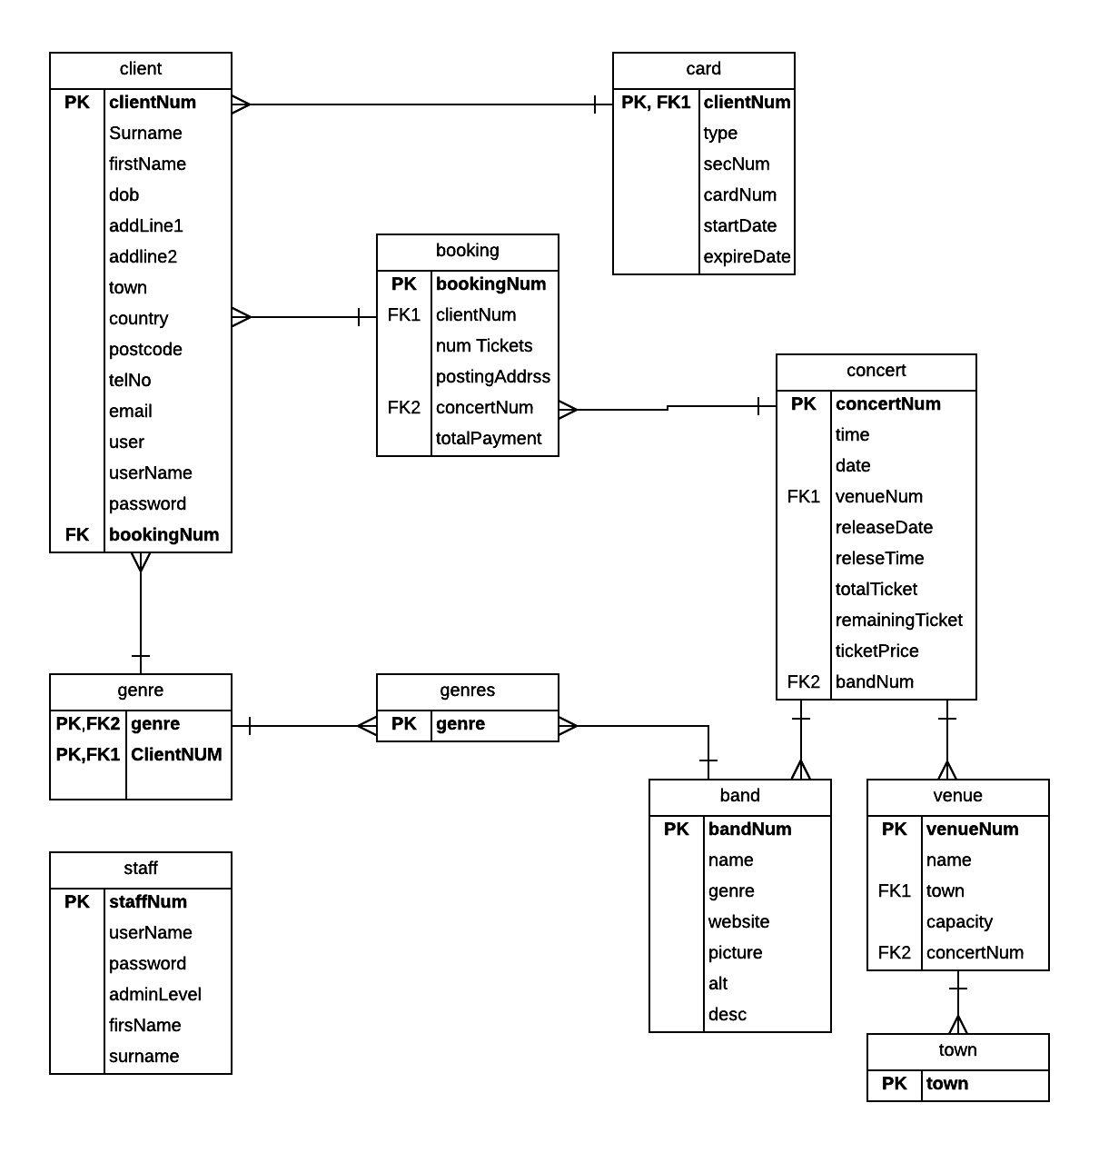

Figure 4- Entity Relation Diagram

