Case Analysis Overview

This Case Analysis includes material from the weeks beginning February 27, March 6, 13, 27, and Apr 3.
Please base your answers on material discussed in the following units: Data Integrity Management, Data Import, Data Aggregation continued, Data Manipulation & Printing.
Your answers to the questions will be entered in the Case Analysis TurnItIn Template document (separate from this document, also found on D2L).
Total points possible: 35

Business Communication Assessment Points

Since you are writing a business document, 7 points of your assignment grade will be based on your overall business communications skills. Therefore, your response should be well organized, written in standard English using complete sentences, appropriate grammar, punctuation, and formatting/presentation.

Important Note for Mac Users

As mentioned in the syllabus, this class uses Excel 2016 on Windows. Of particular importance for those who use Office on the Mac OSX operating system: Office 2011 does not have support for “slicers.” You will need to use slicers to complete this assignment. Therefore, if you have a Mac, you will need to run
the Windows version of Office (e.g., through Parallels), or use a Windows computer at a campus lab.

Assignment Overview

To complete the Case Analysis, please fill in answers for each of the following questions. An expected answer size is also provided for each question.
All explanations must be in your own words (i.e., not copied from the book or any other source).

Question 1 [4 points]
Examine the image below which shows a validation error in cells A6 and A10 of a spreadsheet.
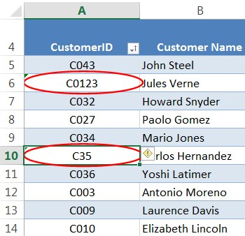

Task 1(a): Explain (25-50 words) what kind of data validation rule (focus on the validation criteria) you think is in place for cells A5-A14, and how you reached that conclusion. Task 1(b): Explain (10-25 words) how you would attempt to resolve the error.

Question 2 [21 points]
You are working for a hypothetical company, Arizona Financial Services (AFS). AFS is analyzing stock market transactions placed by its customers. They have requested you to help with the data analysis. The data (contained in the RawData worksheet) contains the following columns: transactionID (each transaction has its own unique identifier), customerID (the identifier of the customer making the transaction), State (where the customer lives), Ticker (stock ticker symbol), Qty (number of units of the stock bought or sold), UnitPrice (unit price for the stock market transaction), Sector (of the stock, e.g., AAPL belongs to the sector Information Technology) and total dollar value of the transaction (i.e., Qty * UnitPrice).
- Download the attached Excel workbook called: financial_data.xlsx

In the Analysis worksheet:
- Enter your 8-digit studentID (do not use your CatCard number) in Cell B1.
- Enter your name in cell B2 (using the format: LastName, FirstName).
Note: Once you have entered the data, you should see values you need to use for the Pivot Table row-label filter, and locations to use in the slicer. There should be 5 sectors listed in cell B3 (for the row label filter), and 5 locations / states in cell B4 (for the slicer).

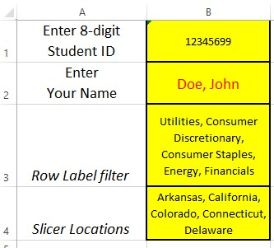

SAMPLE
:
your
data may differ

Task 2(a): To show us your work, please do the following.
Copy and paste from your Excel spreadsheet, the cells (A1 through B4) containing your student ID, name, row-label filter, Slicer values. Please paste the cells into your Word Turnitin Template document in the space provided. The data should be pasted as a table (not as an image, nor an embedded Excel object/file). Make sure all parts of your answer are easily readable (adjust column widths and row heights as necessary). See the accompanying screenshot for an example. Your categories and numbers will be different depending on your category filter and slicer locations.

In the RawData worksheet: enter formulas to complete missing column entries (note: you must complete this step before proceeding to the creation of the pivot table).
- The State column (column C). Use a VLOOKUP() function to find the state each customer lives in (based on the CustomerID in the RawData worksheet). The Customer data (including IDs, names and states) can be found on the Customers worksheet. Note: customerIDs are not sorted – think about whether or not this should affect your VLOOKUP() formula.
- The Sector column (column G). Use a VLOOKUP() function to find the sector for each stock (based on the Ticker symbol in the RawData worksheet). The Stock data (including Ticker symbols, stock name and sector) can be found on the Stocks worksheet.

Task 2(b): Copy and paste the formulas (so we can see how you used VLOOKUP()) from the Raw Data table for the following items.
2(b)(i) State
2(b)(ii) Sector
Paste the formula into your Word Turnitin Template document in the space provided. You can use the VLOOKUP-based formula from the first row of the raw data table.

Create a PivotTable and answer the analysis questions based on the instructions below.
- In the Analysis worksheet: navigate to cell A7. Insert a PivotTable based on the (entire) table of data in the RawData worksheet (the table is named TabRawData). The Pivot table should be inserted on the Analysis worksheet.
- For Row Labels, choose the Sector column.
  - Change the column heading from Row Labels to Sector.
  - Filter the column, so that only the 5 sector types listed for you in cell B3 are chosen (i.e., corresponding to the row label filter).
- Include in your Values-area the following data to facilitate your answering of Q1-Q4.
  - Number of transactions (use a count). Format the column with a comma separating the thousands column. E.g., “7654” should display as: “7,654” (no decimal places). o Average of quantity purchased per transaction (formatted so that 4567 displays as 4,567.00). Note: Keep in mind that Q2 asks for the average across all displayed sectors; not for a single sector.
  - Average of unit price (use a currency format, e.g., 1234 should show as $1,234.00).
  - Total dollar value of transactions for the sector (use a currency format for this pivot table column; e.g., 1234 should show as $1,234.00).
- Add a slicer to the pivot table, based on state locations. Use the slicer to restrict the data to only the 5 locations specified in B4.
- Also reformat row heights and column widths so data and questions are easily readable.
- Enter answers to questions Q1 – Q4 in the Analysis worksheet (i.e., enter answers in cells F2 – F5). The answers must be determined after applying the filtering criteria (for sectors and locations).

Task 2(c): Please copy and paste from your Excel spreadsheet the cells containing the Pivot table (if you performed the steps correctly, cells A7 through E13).
Paste this material into your Word TurnItIn Template document in the space provided. The data should be pasted as a table (not as an image nor an embedded Excel object or file). Ensure all parts of your answer are easily readable (adjust column widths and row heights as necessary). See the following screenshot for an example. Your data and numbers will be different depending on your row filter and slicer locations.

Sect |   SAMPLE  or |  |  | Count of |  | Average of |  |  | Average of |  |  |  | Sum |  | of Total Dollar
Sect |  |  |  | TransactionID |  | Qty |  |  | UnitPrice |  |  |  | Value
 |  |  |  |  | 657  319 | 6,697.75  6,474.53 |  |  | $117.62 $71.87 |  |  |  | $545,023,893.25  $150,624,180.25
Consumer Discretiona  Consumer Staples  Energy |  | ry
 |  |  |  |  | 374  733 | 6,294.05 |  |  |  |  | $44.63  $72.22 |  | $100,575,558.50
Financials |  |  |  |  | 374  733 |  | 6,658.0  6,391.8 | 2  0 |  |  |  |  |  | $356,997,311.25 $76,943,676.75
Utilities |  |  |  |  | 247 |  |  |  |  |  | $48.23
Grand Total |  |  |  |  | 2,330 |  | 6,557.4 | 6 |  | $78.0 |  | 0 | $1 | ,230,164,620.00

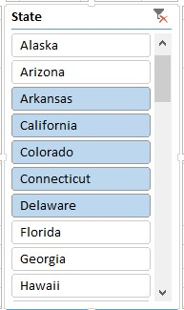

SAMPLE

Task 2(d): Please copy and paste from your Excel spreadsheet, the slicer showing at least 10 locations including the locations you have chosen in the slicer (which show up shaded).
Please paste the slicer as an image into your Word TurnItIn Template document (in the space provided). Ensure it is easily readable. See the screenshot for an example (your data may differ). The locations shaded should match the slicer values in cell B4.

Task 2(e): In the space provided for each question number please write down your answers from your spreadsheet for each question: Q1 – Q4. Question 3 [3 points]
Excel provides you with the ability to use a variety of data validation rules.
Task 3(a): Explain (50-75 words), using an example (e.g., taken from your personal experience or from the financial data used for Question 2) the importance of data validation rules.

