Unit 4 Discussion: Formatting I/O
An important component to understanding the C programming language is having a proper understanding of the formatting of the input and output streams. Input operations involve data that flows from the input device such as a keyboard or hard drive to the main memory. Output operations involve data that flows from main memory out to a device such as the screen, a printer, or the hard drive. How you want your output displayed or formatted on the screen depends on the conversion specifiers you use in your program.
Consider the following four programs:
Program A

Program B
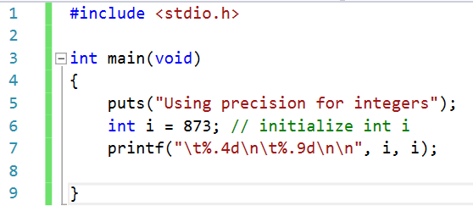
Program C
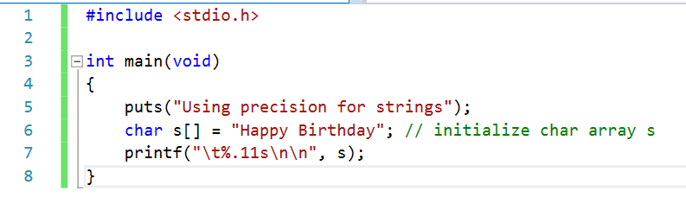
Program D
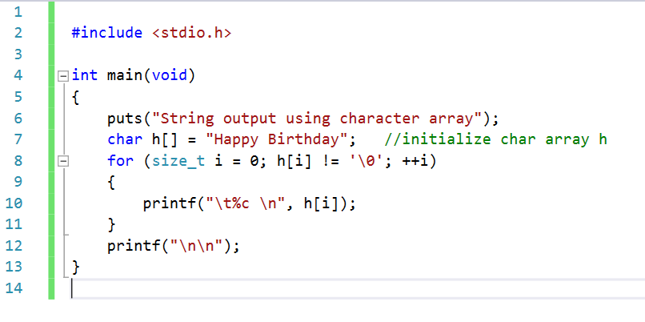
Select one of the four programs above, type the code into Visual Studio, and run it. Explain why the output is being formatted the way it is. Now adjust the code so that the output displays differently and explain what you changed in the code to make it look different. Make sure to upload your revised code into the discussion.

