Name:
Date:
BIOTECHNOLOGY REPORT SHEET

Download the report sheet, complete it, and then submit it via Blackboard email as an attachment. Do not change the format.

All blue shaded areas require answers.

I. DNA replication
Experiment (dry lab)
A. Are the two dsDNA molecules geneticaly identical?

Use the diagram below to address questions B and C.

Template Y Template Z

B. Which N-base was the first to be added to the template Y?

C. Which N-base was the first to be added to the template Z?

Use the diagram below to address question D.

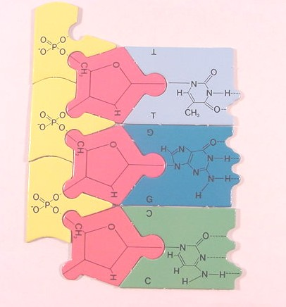

D. Replicate this DNA template. If the template reads: 5’ TGC 3’  what does the complementary DNA strand read? | 5’ __ __ __ 3’

II. Transcription
Experiment (dry lab)
Use the diagram below to address questions E and F.

E. Transcribe this DNA strand. Record your answer in a 5’ to 3’ chemical direction. | 5’ __ __ __ 3’
F. Which N-base was the first to be added to template?

III. Translation
Experiment (dry lab)

Use the image below to address questions G and H.

G. What amino acid does this DNA molecule code for? See slide with the genetic code.
H. What is the tRNA’s anticodon? Record your answer 3’ to 5’ | 3’ __ __ __ 5’

IV. Isolation of DNA
Experiment (at home lab)

Describe the appearance of the extracted DNA.

V. DNA electrophoresis
Experiment (dry lab)

Use the image below to address questions A and B.

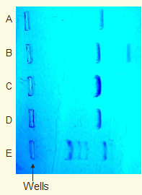

I. Which row (A-E) has the band with the longest strands of DNA (the longest nucleotide sequence)?
J. Which row (A-E) has the band with the shortest strands of DNA?

Use the image below to address question C.
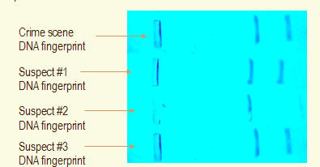

K. Which suspect (1, 2 or 3) matches the DNA left at the crime scene?

Use the image below to address question D.

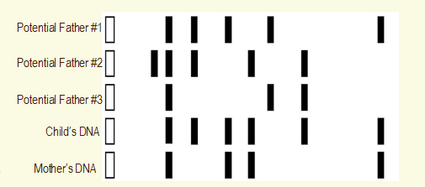

L. At a fertility clinic an ovum (egg) was fertilized by one of three donor sperm. Who is the father of the child, father #1, #2 or #3?
Use the image below to address questions E and F.

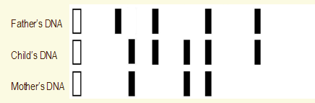

M. How many bands do the mother and child have in common?

N.I. How many bands do the father and child have in common?

End of Lab

