A. Lab BSBA BIS245A-5

B. Lab 5B of 7: Completing Forms

C. Lab Overview—Scenario/Summary

CO(s):

5. Given a physical database containing tables and relationships, create forms which demonstrate effective user-interface design and allow for efficient entry and retrieval of data.

Scenario/Summary

The lab begins with creating a form in Access using the form wizard. After the form is created, the user can use themes to change the appearance of the form. The second part of the lab uses form design to create a form. Finally, the form will be customized.

Upon completing this lab, you should be able to

• create a form using the form;
• create a form using form design; and
• create a form using the form wizard.

D. Deliverables

Submit the MS Access database file that contains the forms created in this lab.

Step | Deliverable | Points
1 | Form 1—Form Tool—step-by-step | 5
2 | Form 2—Form Design—step-by-step | 100
3 | Form 3—Form Wizard—Employee/Customers Multitable Form  —step-by-step | 5
4 | Form 4—Suppliers and Products Multitable Form | 10
5 | Form 5—Orders and Employees Multitable Form Using a Query | 10
 | Total | 40

E. Lab Steps

Preparation
1. Download the Access starter file from the Week 5 Lab page, and save the file to your local drive.
2. Using Citrix for MS Visio and/or MS Access
a. If you are using the Citrix remote lab, follow the login instructions located in the Lab area in the Introduction and Resources module.
b. You will have to upload the BIS245_W5_Lab_AccessStarterFile.accdb file to your Citrix folder. Follow the instructions located on the Lab area in the Introduction and Resources module.
3. Start MS Access
a. If you are using Citrix, click on Microsoft Office Applications folder.
b. If you are using Visio on a local computer, select Microsoft Office from your program menu.

Lab

Step 1: Using the Form Tool
Select employees table as in the following figure. You will see the employees table highlighted.

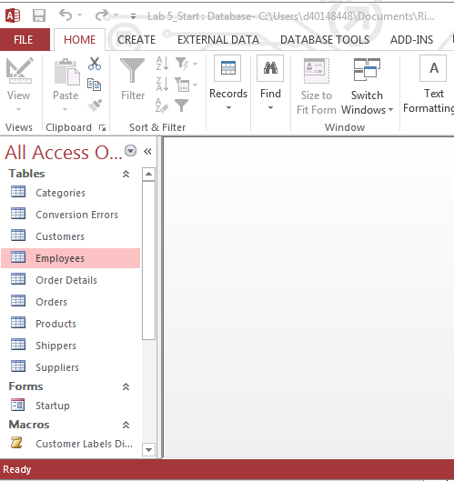

Click the create tab, select the form icon (left in form menu) and then click the employee table.

After clicking the form button, a new form is created by access.

The appearance of the form can be easily modified using the themes option on the design ribbon. As you move your cursor over the various themes, the form will adjust to preview how the modified form would look. You may select any of them for your form.

Click the save button to save the form. Name it Lab5_Form1, and then close the form.

Step 2: Using the Form Design
Click the create tab, then, click on the form design. (Make sure that you do not have any of the tables selected in the tables list on the left side of the screen.)

After clicking the form design, a new form will be shown as the following diagram shows.

Click the add existing fields option, and then click show all tables to show all the tables in the database.

Drag and drop fields from the customer table to the form. You can also double click the fields that you want to add. Select at least eight fields from the customers table. Adjust the location of the fields, then, click the form option in the view list to see the form. The view button is highlighted at the right, or right click the design window at the top and select form view.

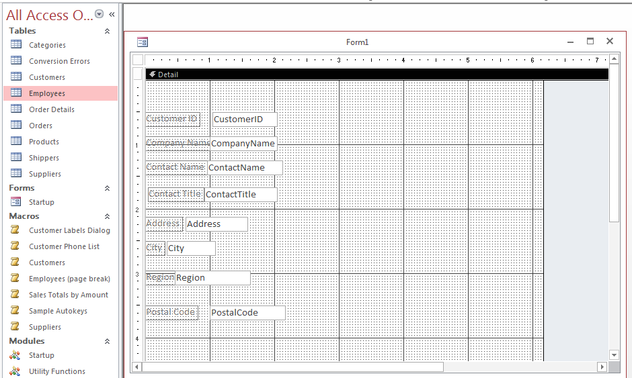

Use these tools to toggle back and forth between form view and design view. See below.

After viewing the form, click the view button again, and select design view to get back to the form design. Save the form as Lab5_Form2.
Step 3: Creating Multitable Forms
You can incorporate data from several tables in a single form. In this step, you will create a form that displays data concerning one employee. The form will also display data concerning the many customers that your employees serve. This type of relationship between employees and customers is called one-to-many relationships (one employee serving many customers). In this relationship, the employees table is the one table and the customers table is the many table.

To create the multitable form using the form wizard,
- click the create tab, then select the form wizard; and
- make sure that the customers table is selected in the table/queries box.
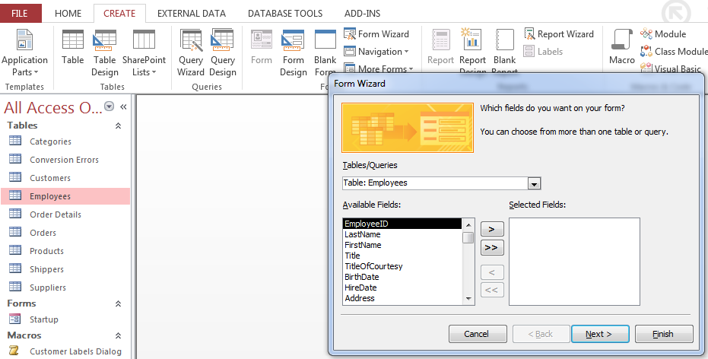

- Select CustomerID, CompanyName, ContactName, ContactTitle, Address, City, Region, PostalCode, Country, and Phone Fields from customers table.
- Back in the tables/queries, click on the down arrow and select employees table. See the illustration below.

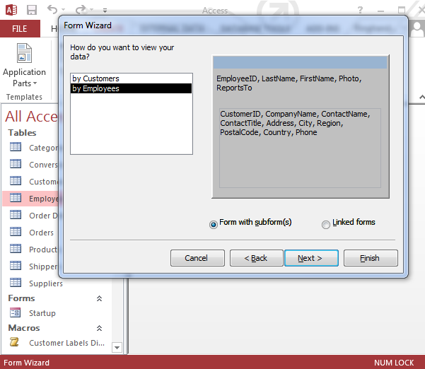

- You also have the option to select form with subform(s) or linked forms. Select form with subform(s), then click next.
- In the next screen, you have the option of selecting the layout of your subform. Select tabular, and then click next.

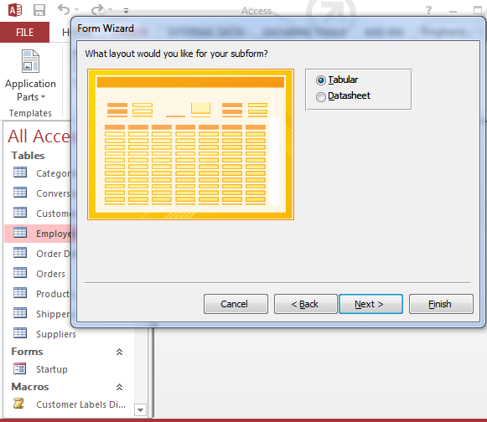

Assign a title to your form (Lab5_Form3) and subform (Lab5_Subform3), and click finish.

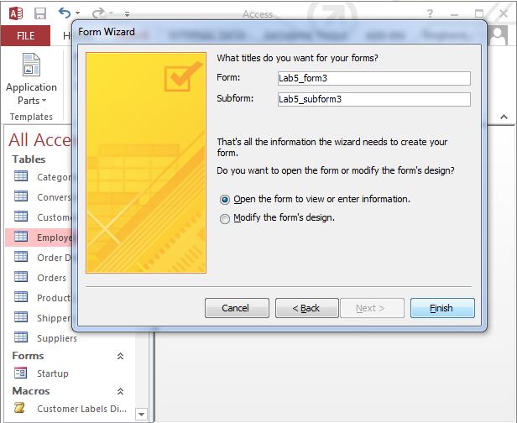

- Click on view, and then view the form in form view.

NOTE: You can drop down the reports by field and see other options.
Before closing the form, go to design view, and change the caption property for the form to employees. Right click the form title field and select properties to see the property sheet on the right. (See below.) Return to the form view before saving your form.

In form view, your form should display nine records, showing employees and the customers that they serve. These records can be cycled through using the navigation options available (in form view only) on the lower left of the application screen.

You will be prompted to save changes when closing the form. Say yes to save changes at the prompt, and then close the form. (From3)

Step 4: Create a Multitable Form
Following instructions provided in Step 3, create a multitable form, showing what products are supplied by which supplier. (Remember to consider the relationships and one-to-many above).

Requirements: There is ONE supplier for MANY products. You must display the following fields: SupplierID, CompanyName, ContactName, ContactTitle, Address, City, Region, PostalCode, Country, and Phone fields along with ProductID, ProductName, and CategoryID.

Your form should look like the following.

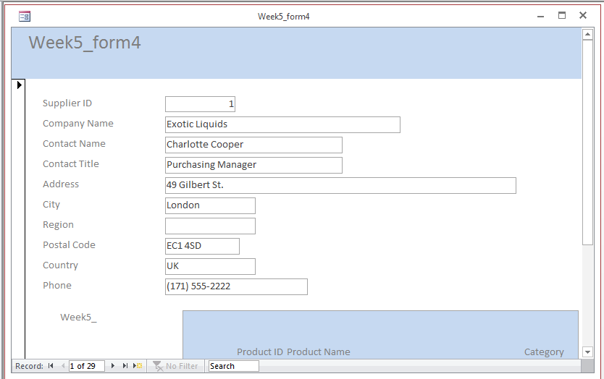

There should be 29 records in your suppliers, each providing numerous products.

Save your form as Lab5_form4 and the Subform as Lab5_Subform4.

Step 5: Building a Form from a Query
Begin by developing a 2 table query using query wizard. Select CustomerID from the customer table and ContactName, CompanyName and Employee ID from the orders table and complete/finish the wizard. Please see below.

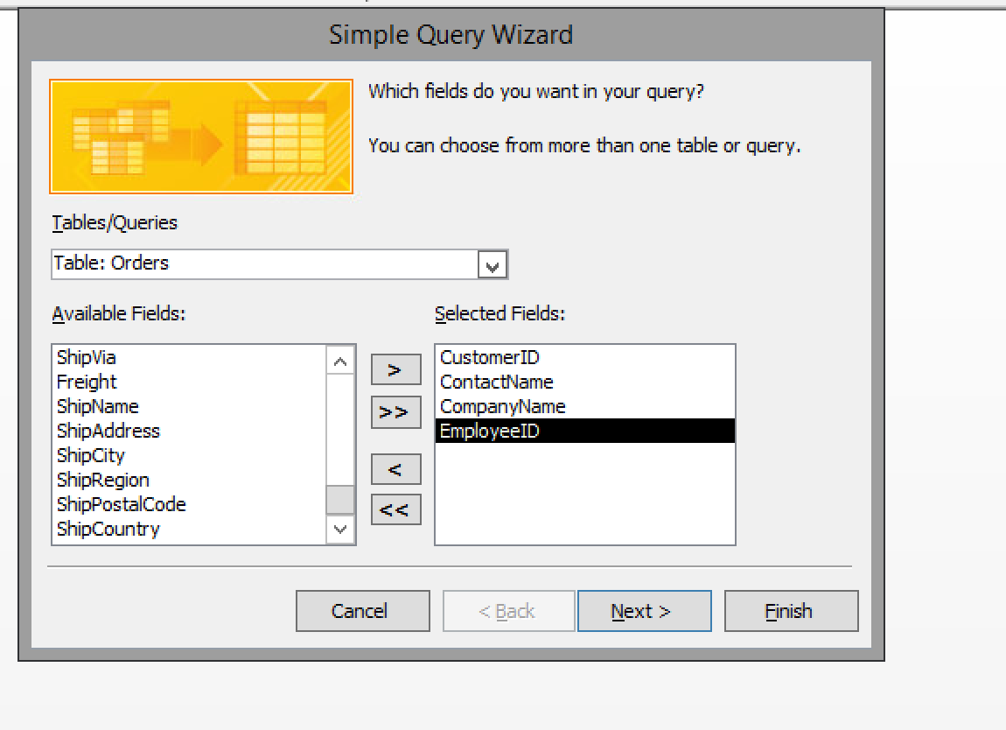

Results should look similar to the query below.

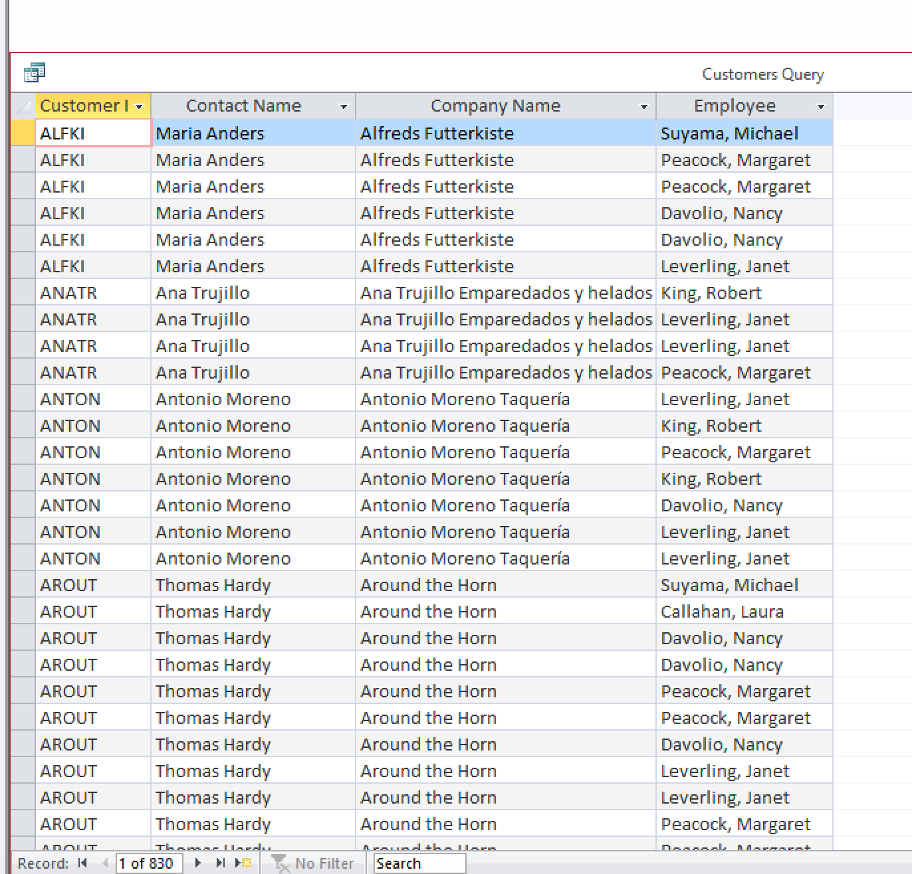

Close the query and it will be saved. See below.

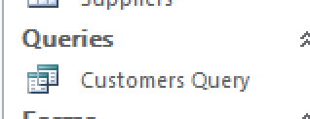

Select the create tab and form wizard link to see the window below. The customers query should appear in the list. Select Query:Customers Query.

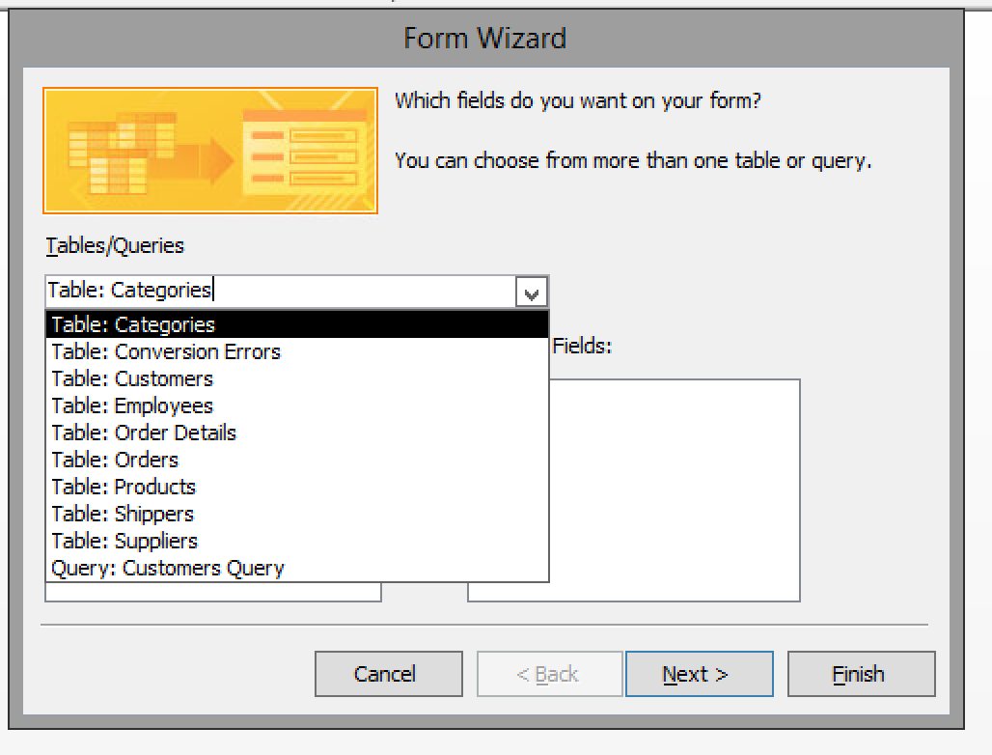

Select all fields, except CustomerID, as it is not needed in the report and select next.

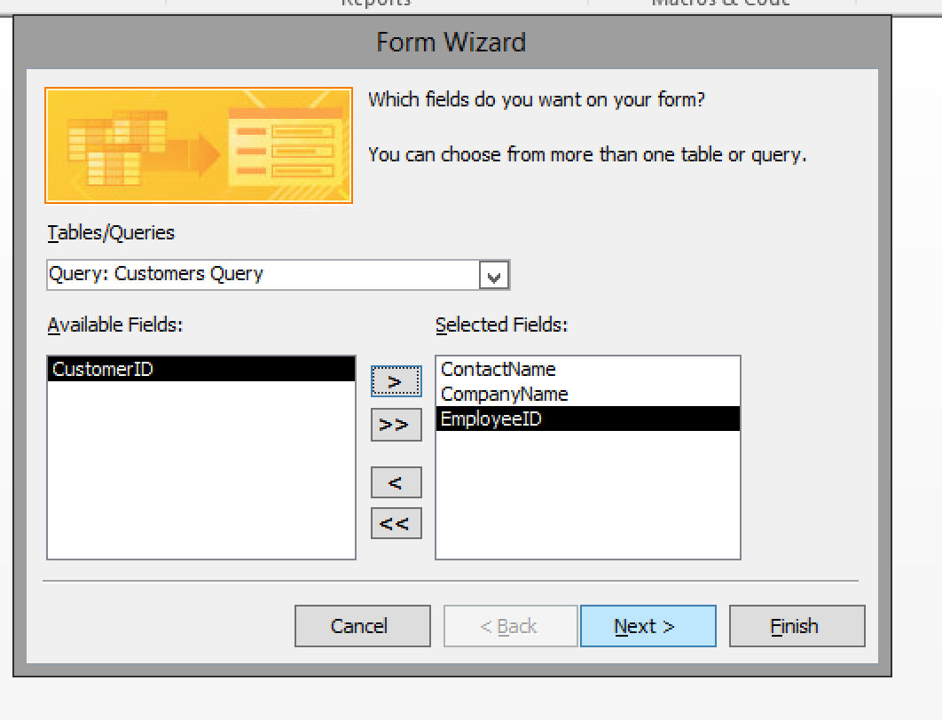

See results below. Click next again.

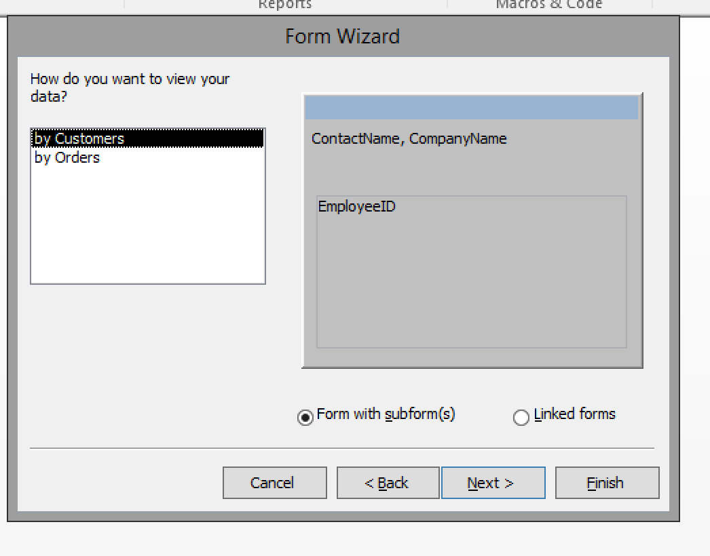

Select tabular and select next.

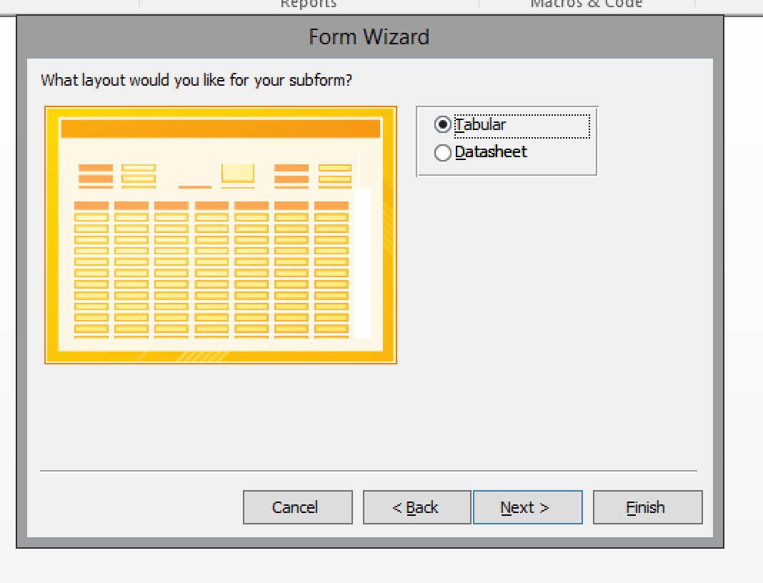

Complete the report by selecting finish.

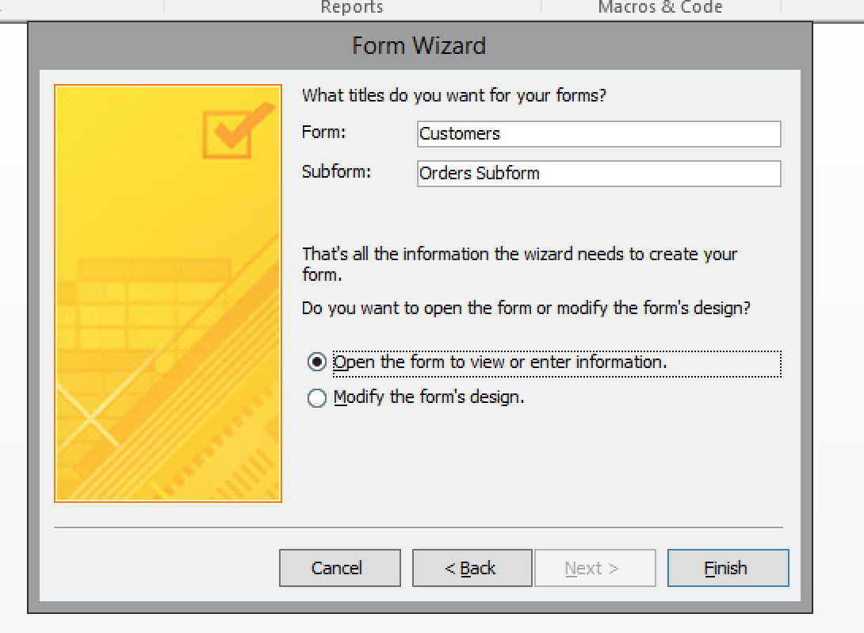

A sample of the report is included below. You can navigate through the companies and see what employees help them by clicking the < or > arrows in the ribbon at the bottom of the report window. This screen prints shows the results after moving through the report. Great job creating this report from a query.
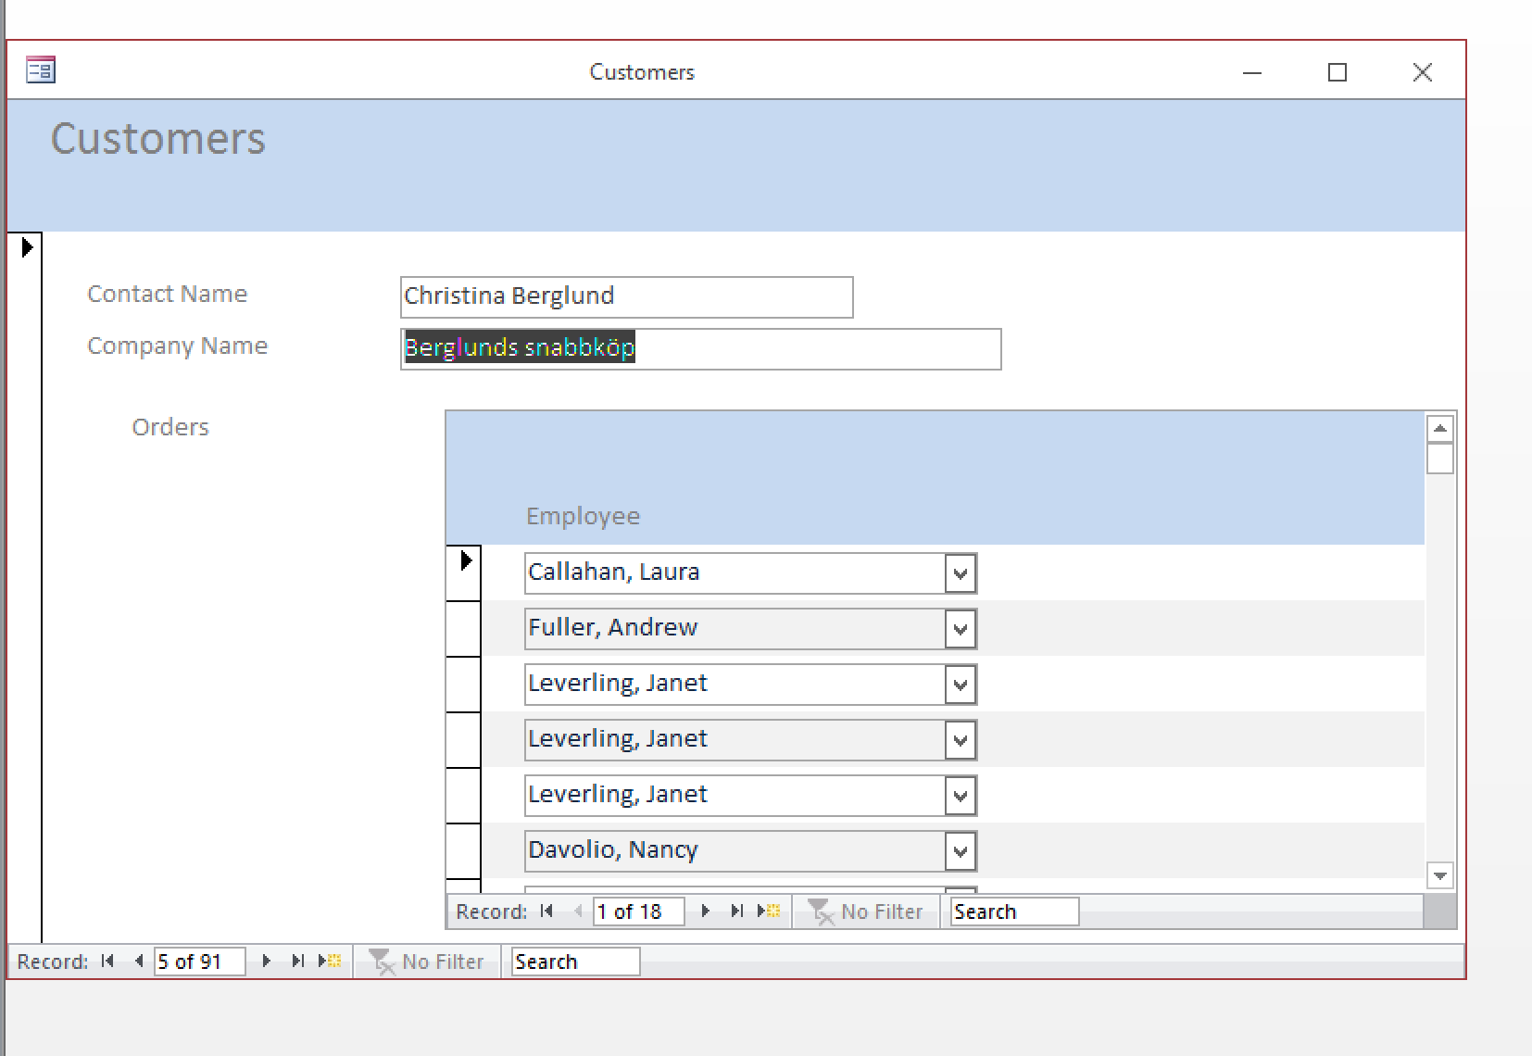

Step 6: Submit deliverables.

Save your MS Access Lab5_Start.Accdb file as YourName_Lab5_Final.accdb

Submit the Access file created during this assignment to the assignment.

END of LAB5B

