DeVry University
Student Lab Activity
BIS245 Database Essentials for Business with Lab

- Lab BSBA BIS245A-6

- Lab 6 of 7: Creating Reports

- Lab Overview—Scenario/Summary

CO(s):
7. Given a database application with a completed relational schema, populated tables,and business reporting requirements, create the necessary reports and make abusiness decision.

Scenario:
The purpose of this lab is to create Access reports. After a report is created, the student willsort the fields in different ways. Also, the student can also delete fields in layout view andmodify the appearance of the report by applying themes. In addition to the report generatedby Access, the lab also uses report design to allow users to design their own reports.

Upon completing this lab, you should be able to
• create a report and apply a theme for professional appearance of the report; and
• use report design to generate your own report.

- Deliverables:

Upload the modified Lab6_Start.accdb file that you saved as YourName_Lab6.accdb to theWeek 6 Lab Assignment.

Section | Deliverable | Points
Part A | Step 1: Create a Simple Report—Lab6_Report1
Part A | Step 2: Create a report using Report Design—Lab6_Report2
Part A | Step 3: Creating Multitable Reports—Lab6_Report3
Part A | Step 4: Adding a Subreport—Lab6_Report4
Part A | Step 5: Create Mailing Labels—Lab6_Report5
Part B | Step 1: Create a Report—Lab6_Report6
Part B | Step 2: Create a Multitable Report—Lab6_Report7

- Lab Steps:

Preparation:

1. Download the Access starter filefrom the Week 6 Lab page and save the file to your local drive.You will want to download it using Chrome, as it does not open correctly using Edge or Explorer.

2. Using Citrix for MS Visio and/or MS Access
a. If you are using the Citrix remote lab, follow the login instructions located in theLab area in Introduction and Resources.
b. You will have to upload the “Lab6_Start.accdb” file to your Citrix folder. Follow theinstructions located on the Lab area in Introduction and Resources.

3. Start MS Access:
a. If you are using Citrix, click on Microsoft Office Applications folder.
b. If you are using Visio on a local computer, select Microsoft Office from your Program Menu.

Lab:

Part A: Creating Reports—Step by Step
Step 1:Create a Simple Report
The basic steps for creating a simple report in MS Access are as follows.

- Select the table for the report in the navigation pane.
- Click the create tab.
- Click the report button in the reports group.

a. Select the customers table. You will see the table highlighted in the left pane.
b. Click the create tab to create a new object.
c. Click report from the reports group to create a new report.

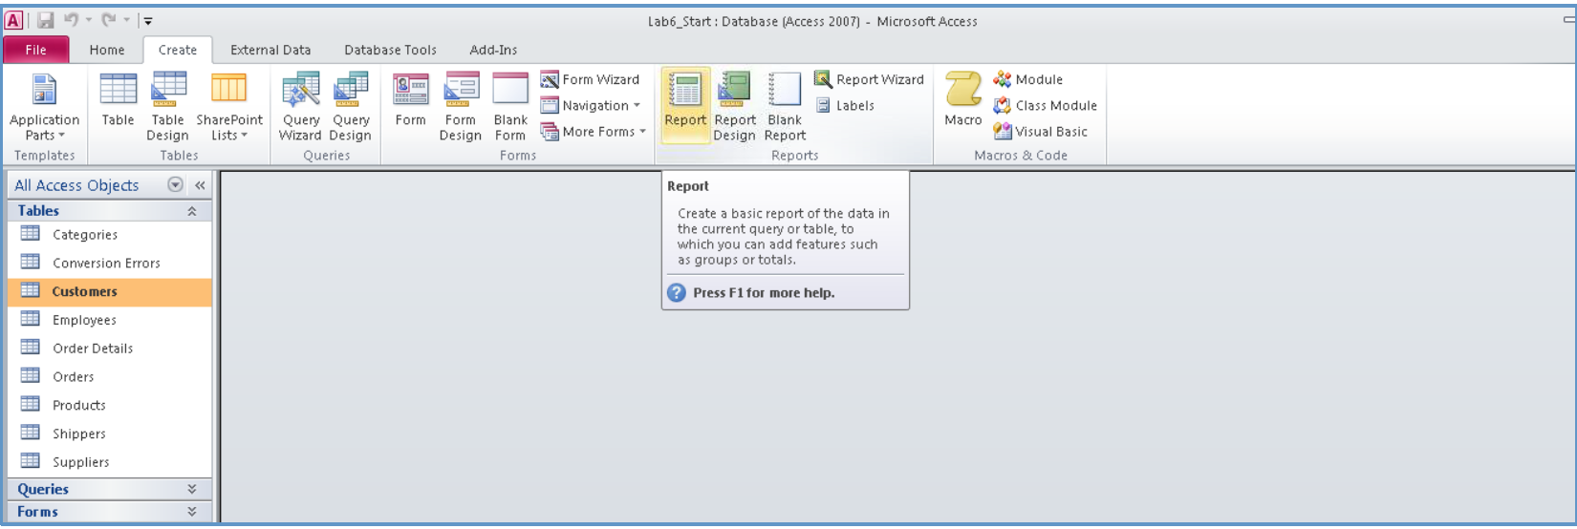

d. After clicking the report button and selecting the customers table, a new report is created that includes all the fields in the customer table. The report will open in the Layout view. Right-click any of the fields to view a shortcut menu.

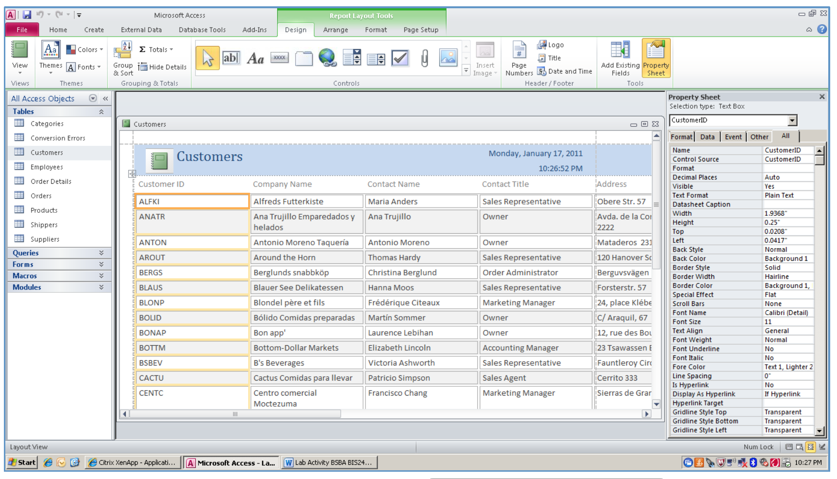

e. Using the shortcut menu, you can sort the data in the report by descending or ascending sequence. You can also use this shortcut menu to delete unwanted fields. Notice that the shortcut menu items are determined by the item you have selected when you right-click the mouse.  Yours may not look exactly like the example shown. | 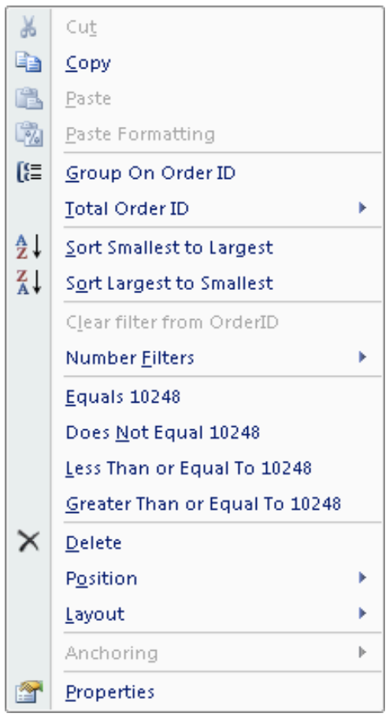
f. Click themes to display different types of formats. Choose any format to see the report format change. Select the one you like best before saving your report.
g. Click save to save the report asLab6_Report1,then close the report.

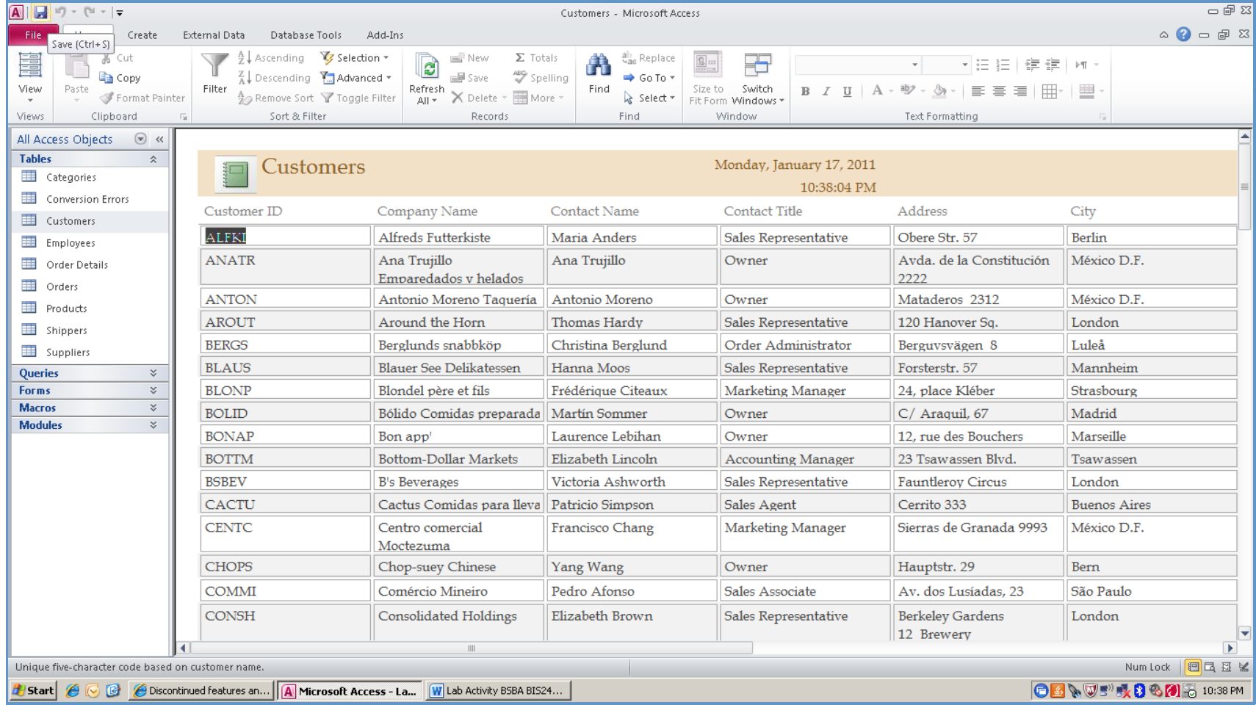
Step 2: Create a Report Using Report Design
a. Click the create tab to create a new object.
b. Click report design from the reports group to create a new report.

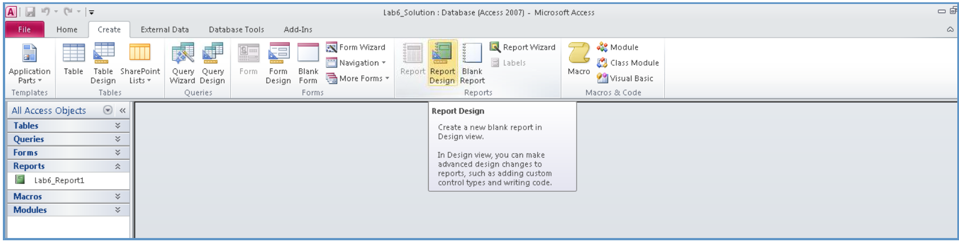

c. After clicking report design, a new report will be shown. Using the add existing fields tool, add the fields needed to generate a customer phone number list. (Customer ID, Company Name, Contact Name, Contact Title, Phone) Right click on each field, from the layout menuchoose tabular format. Alternate method is to depress the shift key while selecting all fields. Then select the tabular option from the arrange tools.

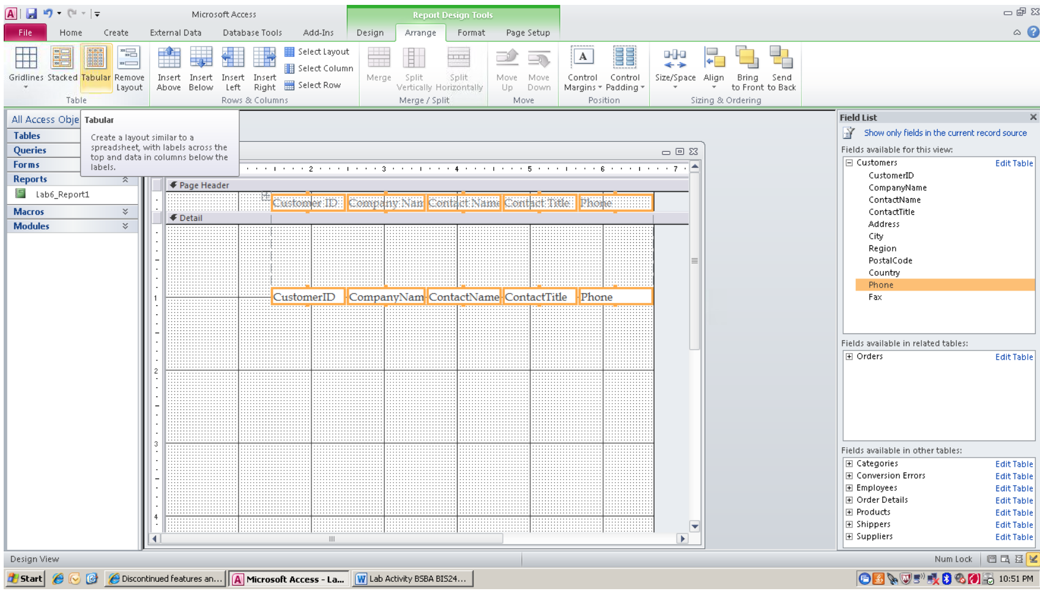

d. After the fields are located on the report, select the design tab and use the view pull-down to select the report view to see the report.
e. After viewing the report, return to the design view to make adjustments to field sizes, and so forth so that the report is readable.

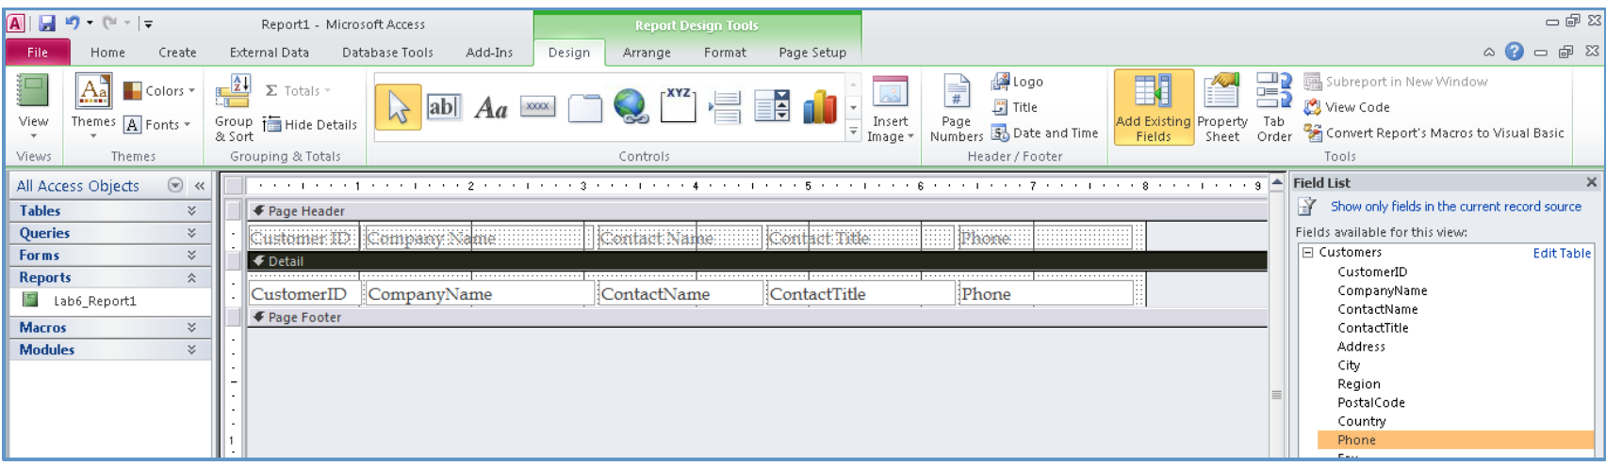

f. Click view again, and select layout view to go back to layout view. Click themes to pick up a pre-existing format.

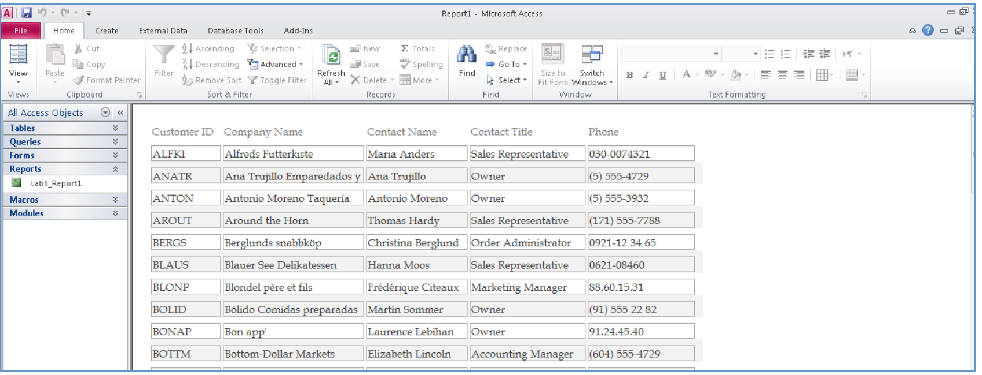

g. View your report by using the view pull-down to select print preview. If the report is not readable, continue to modify the layout until you have a report that works. Save the report as Lab6_Report2.

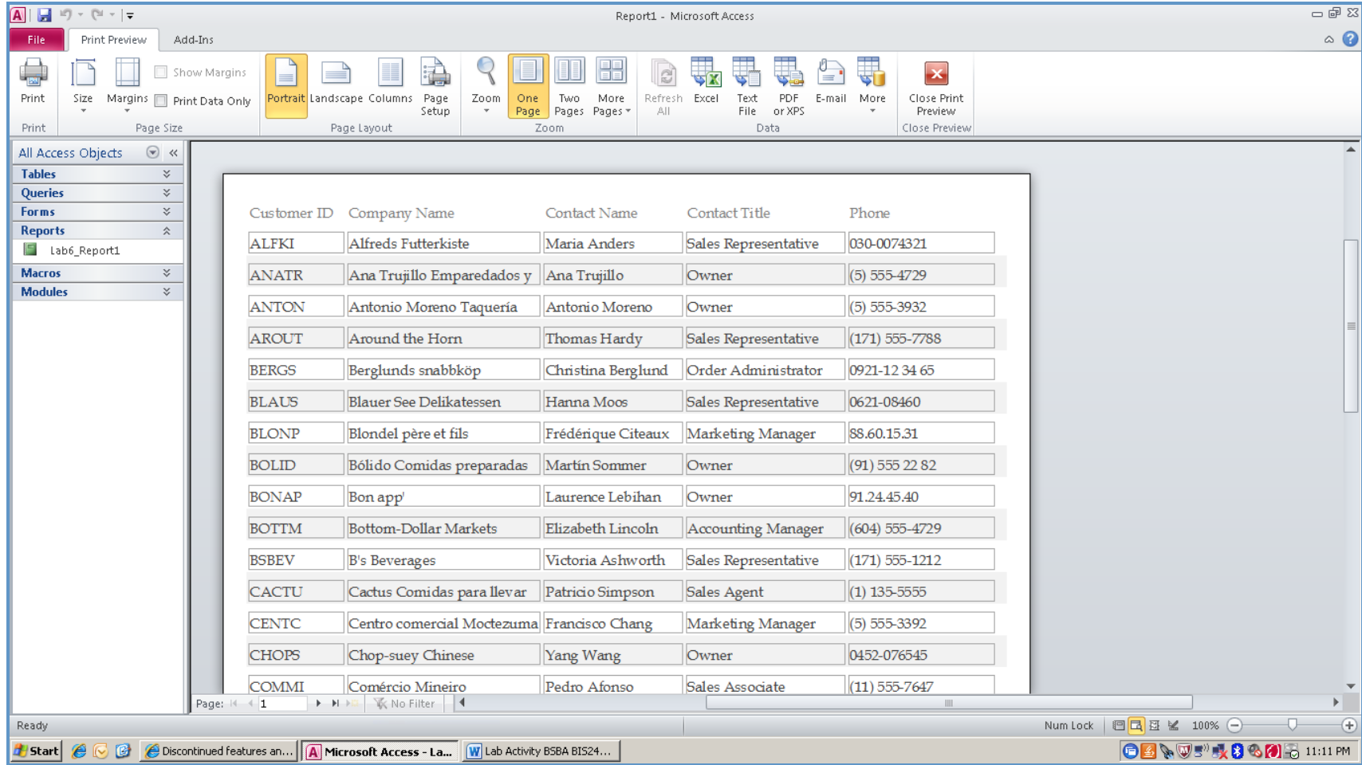

Step 3: Creating Multitable Reports
In this section, you will create a report that involves multiple tables. In this case, you want a list of orders processed by each employee.
a. Select the employees table and then click create tab and select report wizard.
b. Make sure that table: employees is selected in the table/queries selection window.

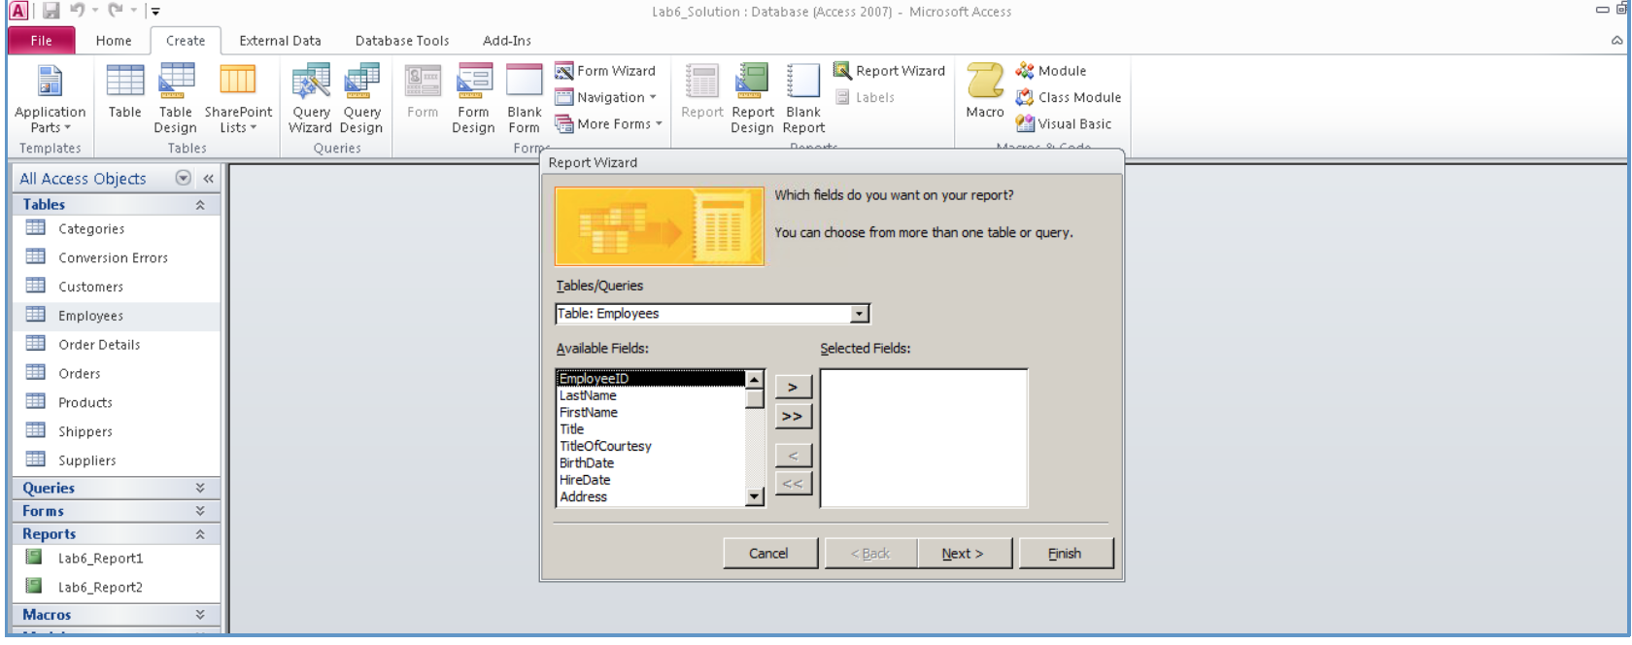

c. Select EmployeeID, LastName, FirstName, Photo, and ReportsTo from the employees table.
d. Click on the down arrow key and then select table: orders. Select OrderID, OrderDate, ShippedDate, and ShipVia from that table, then click next.

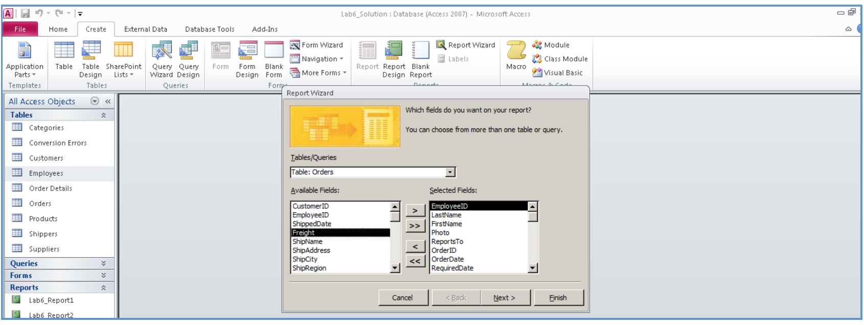

e. In the next screen, you have the option of viewing data by employees or by orders; select by employees, then click next

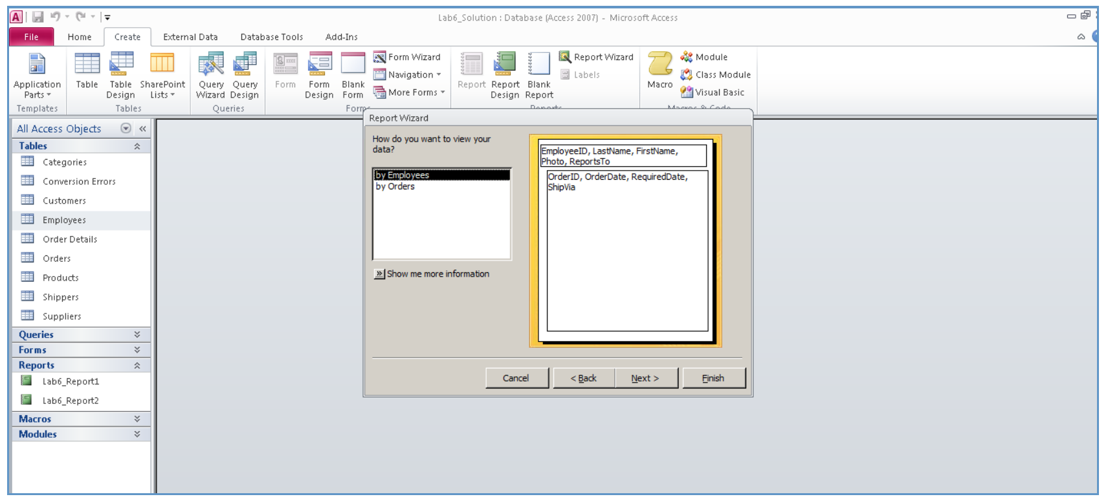
f. In this step, you can select to group your report by any field that you have selected.

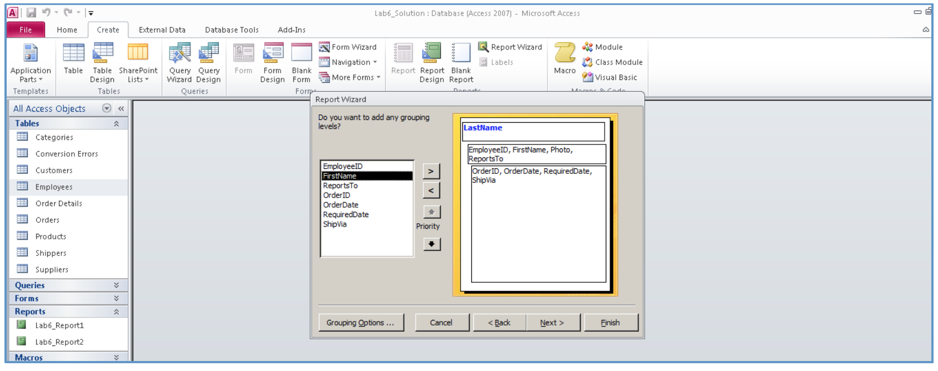

g. In this step, you can add sort order to your report. Select OrderDate, then click next

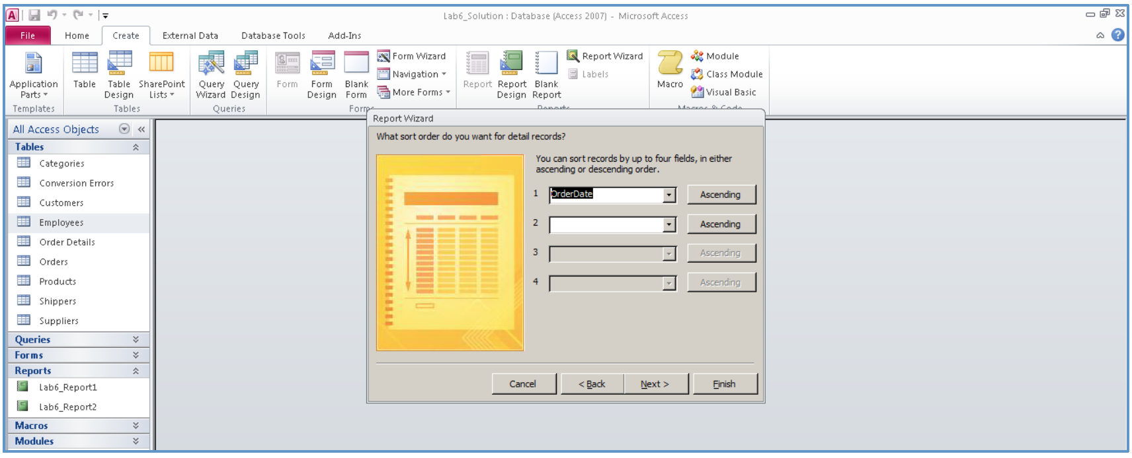

h. In the next screen, you can select a layout for your report. Select stepped layout and then make sure that landscape orientation is used. Click next.

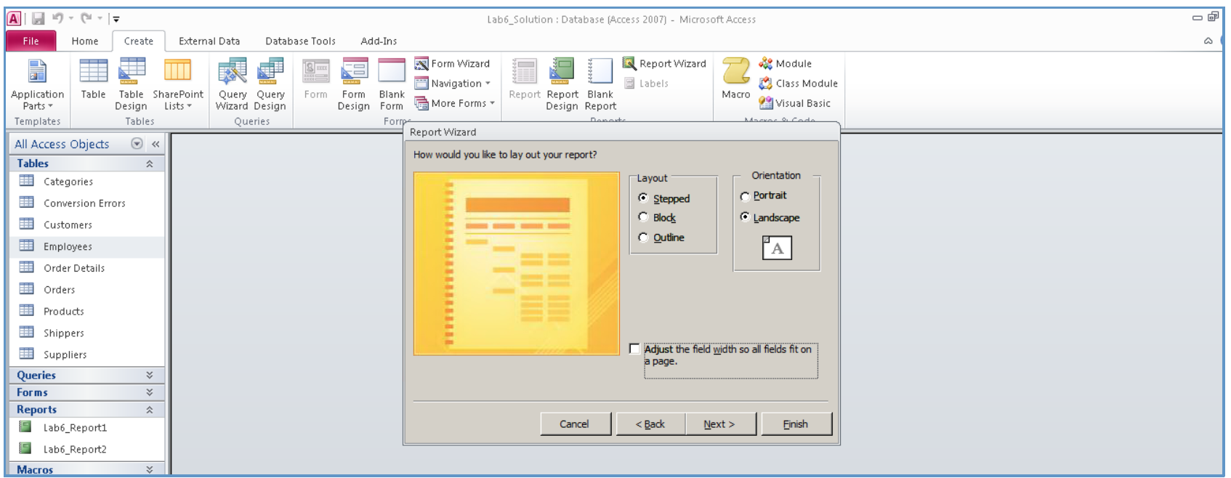

i. Enter Lab6_Report3 as the title of the report, and then click finish.

j. You should be able to see the report for all nine employees and the orders that they worked on.

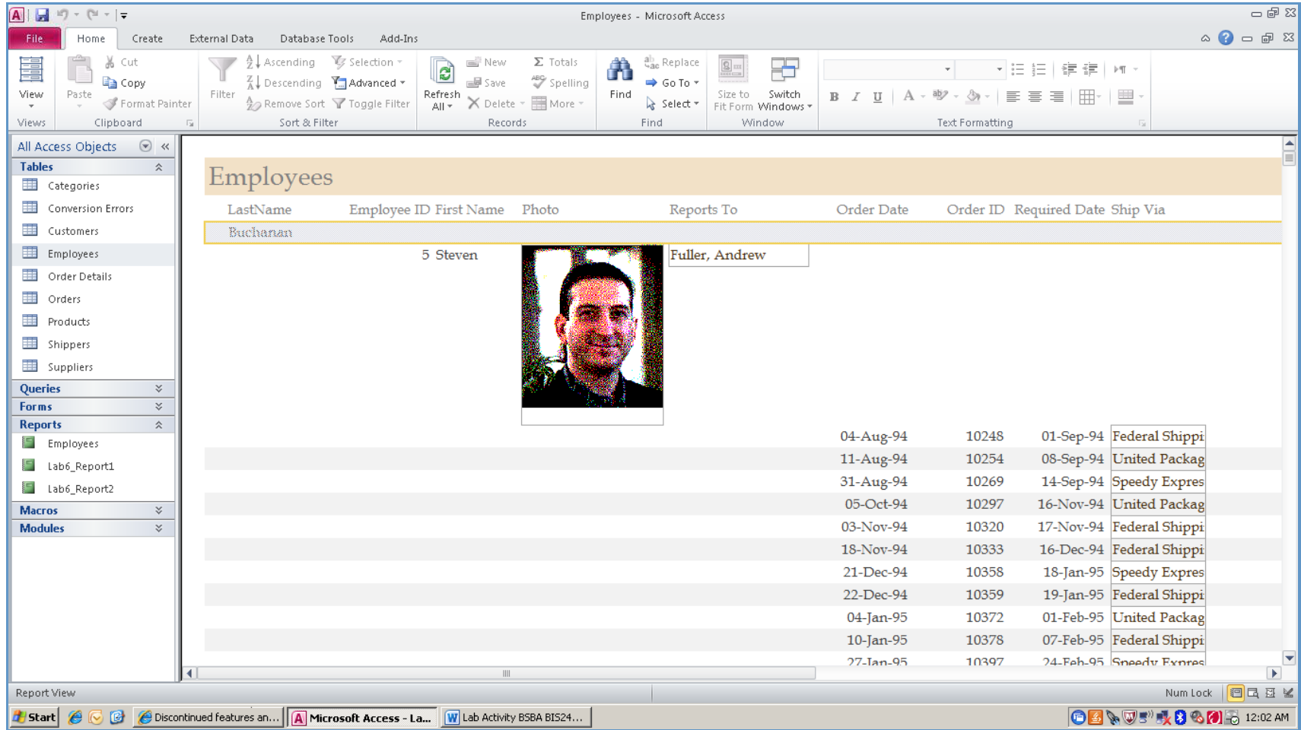

k. You can modify and format your report by going to layout view.
l. Save the changes to the report.

Step 4: Adding a Subreport
To add a subreport to a report, you use the subform/subreport tools on the design tab. In this case, you will create a suppliers report with a products subreport that allows generation of a printed list ofsuppliers with products each supplies.

First, let’s create a new report.

a. Click create, then select report wizard.
b. Select the suppliers table from tables/queries.
c. Select CompanyName, ContactName, Address, City, Region, PostalCode, Country, and Phone from the suppliers table and click next.
d. Select grouping by CompanyName, click the > button to move the grouping criteria to the right hand pane, then click next.

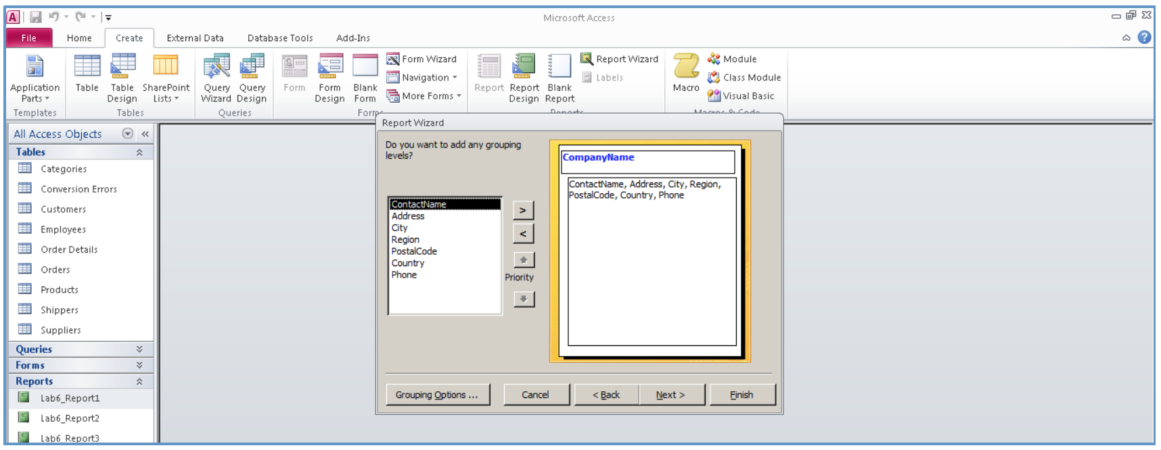

e. In the next screen, select sort by ContactName, then click next.
f. Select stepped layout in the next screen, make sure that landscape orientation is selected, then click next.
g. Enter a report title of Lab6_Report4 and then click finish.
h. You should be able to see the list of the suppliers, sorted in ascending order by
CompanyName.

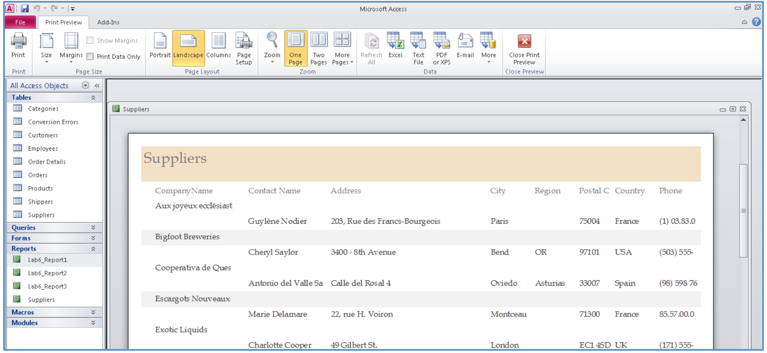

Now, you will add a subreport to your report, showing the products that each supplier provides, and information about the pricing of the products.

i. If you are still in print preview, close print preview and then, while the supplier report is open, click on the view button and select design view.
j. Place your cursor on the bar separating detail and page footer sections, hold the mouse button down, and expand the detail section.

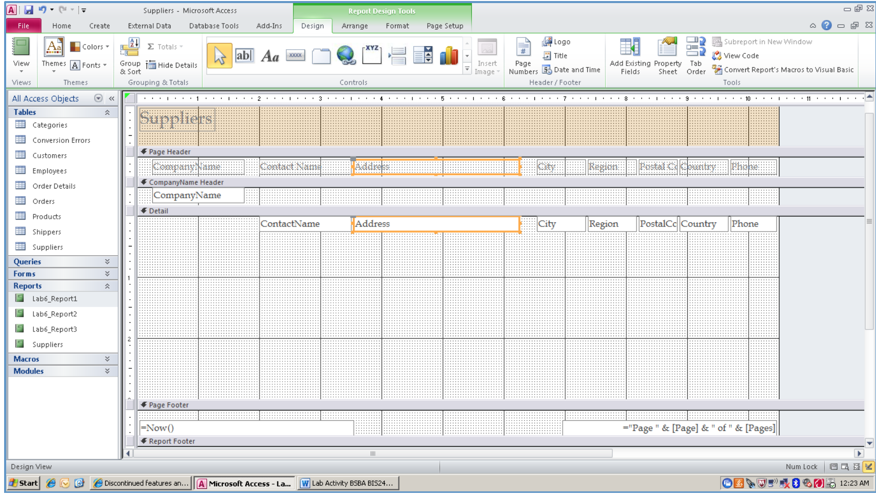

k. From the design tab, click the drop down arrow to show all controls. Make sure that the use control wizards button is highlighted in the controls subgroup menu, then click on the subform/subreport button.

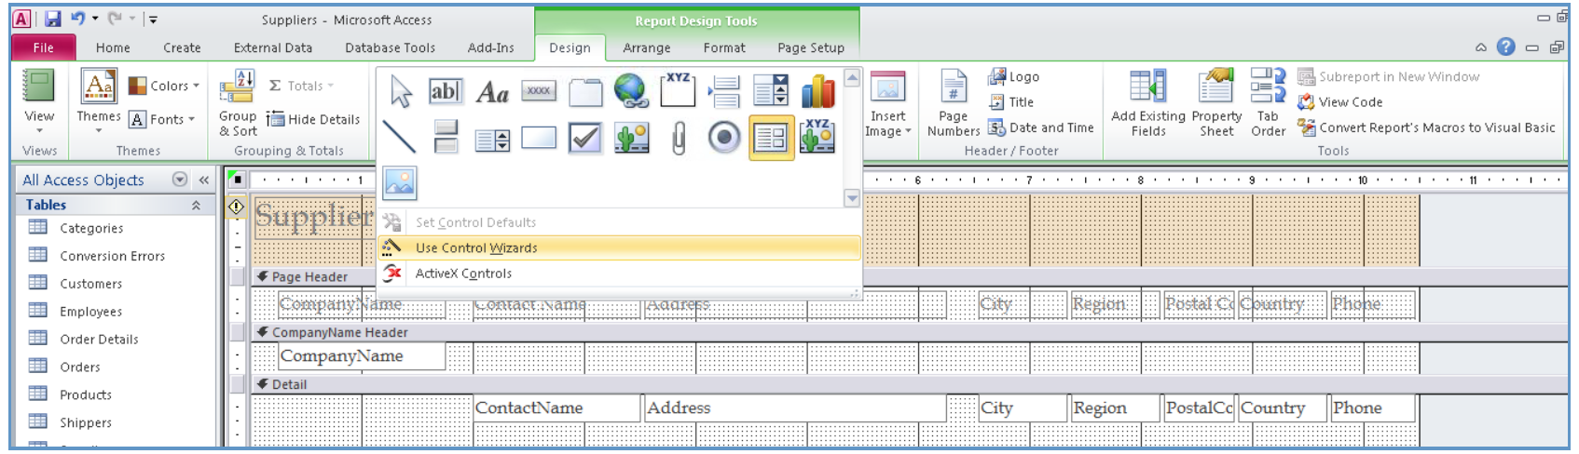

l. Move your cursor to the desired position and click the mouse button.
m. Select use existing tables and queries, then click next.

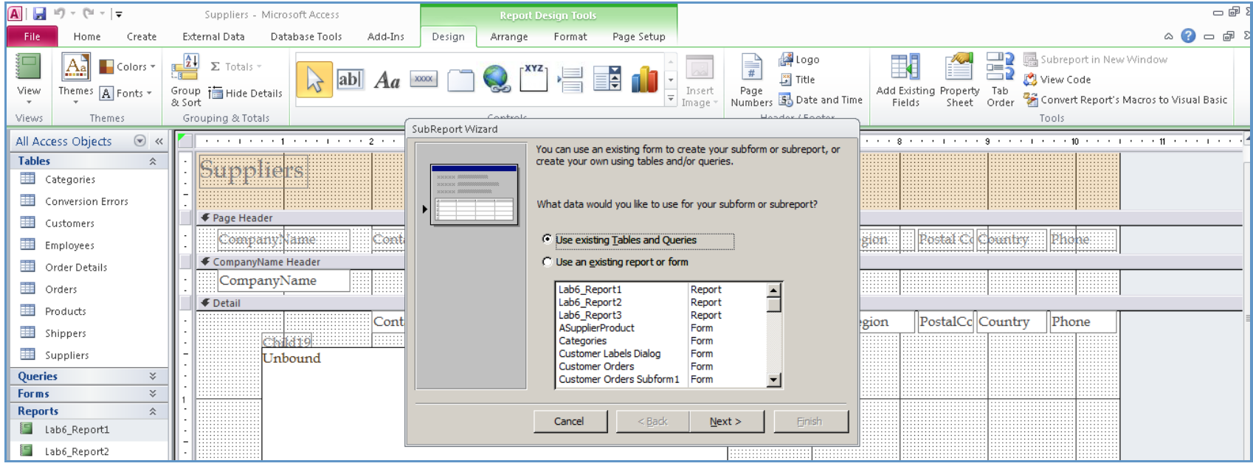

n. Select the products table in the tables/queries box. Select ProductName, CategoryID, QuantityPerUnit, and UnitPrice, and move them to selected fields, then click next.

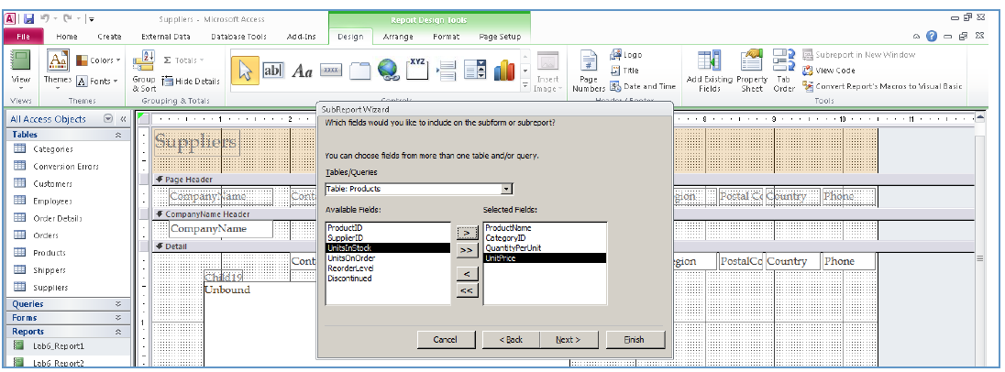

o. In the next screen, make sure that choose from a list radio button is selected, then click finish.
p. Your screen should look similar to the following.

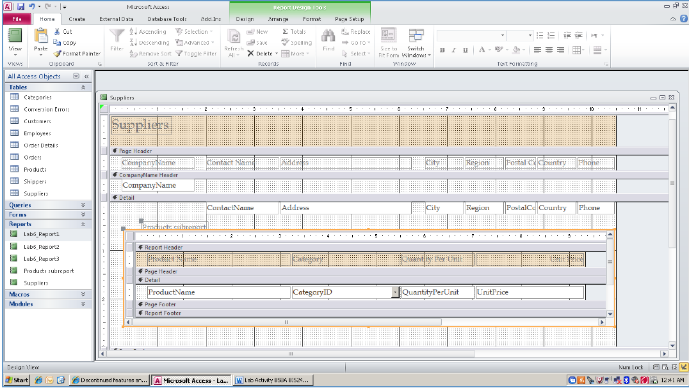

q. Switch to report view; you will be able to see suppliers by the products subreport.

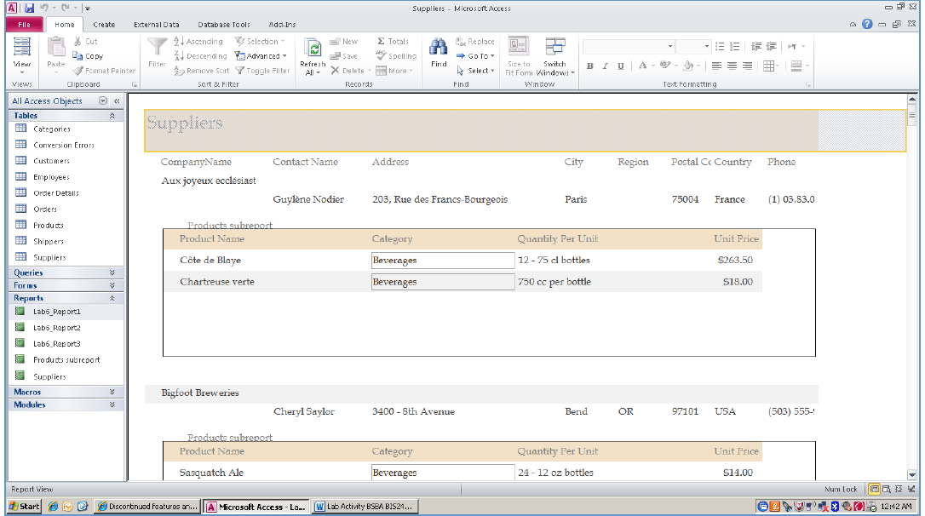

r. Save the changes to the report.

Step 5:Create Mailing Labels
In this section, you will use the customers table to create labels for mailing materials to your customers.

a. Make sure the customers table is selected.
b. Click on create tab in the report group and then click the labels button.
c. Select C2160 as product number, 1 1/2" x 2 1/2” as dimensions, and three as number across.

Make sure that English is selected as the unit of measure, and that Avery is selected as the filter by manufacturer box and then click next.

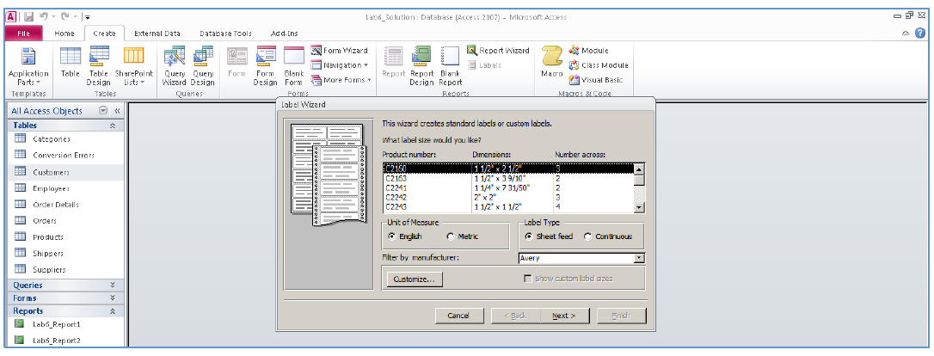

d. In the next screen, you can select font type, size, and color. Make your selection, and click next.
e. In the next screen, select CompanyName,then click > to move it to the prototype label, and then press the enter key.
f. Select ContactName, and move it to the prototype label, then press the enter key.
g. Move the address, then press enter.
h. Move city then type comma (,) and press spacebar, move region, press spacebar, then move PostalCode and press the enter key.
i. Move country. Your screen should look like the following.

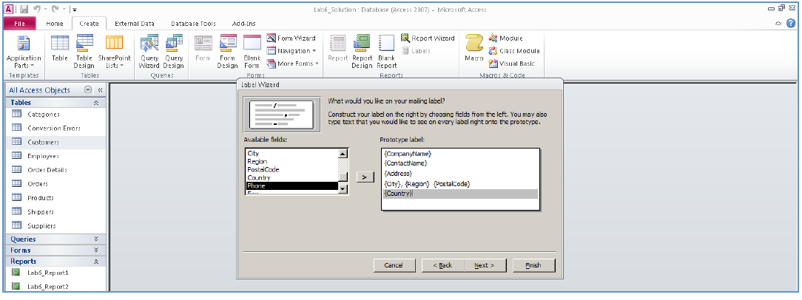

j. Click next. Select country as the sorting field, and then click next.

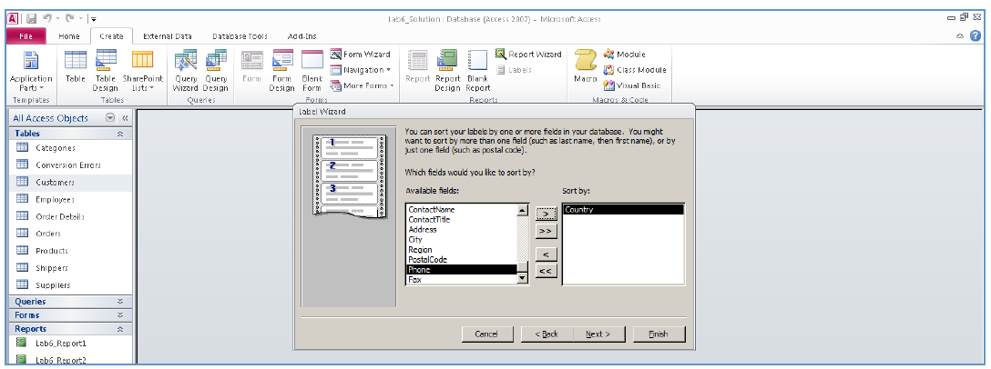

k. Enter a report title of Lab6_Report5, and then click the finish button.
l. The results should look like the following.

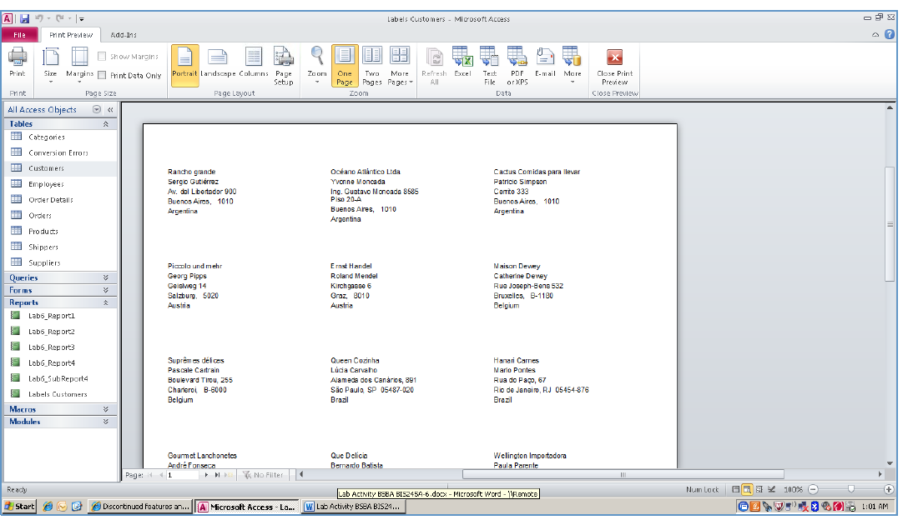

m. Save the changes to the report.

Step 6:Finished with Part A
You are now finished with the step-by-step portion of the lab. Save your database as YourName_Lab6.accdb. Go on to Part B.

End of Part A
Part B: On Your Own
Step 1:Create a Simple Report
- Using your experience from Part A, create a product price list to be used by all employees. Your report should show products listed by category ID and sorted in descending order by the product name. The list should also include the product ID, the quantity per unit, the unit price, and whether the product has been discontinued.See below for an example of the report.
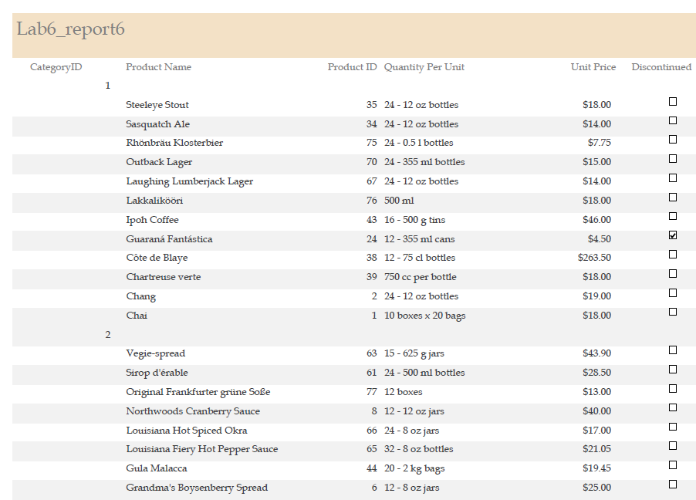
- Save the results as Lab6_Report6.

Step 2:Create a Multitable Report
- Using your experience and skills gained in Part A of the lab and your experience from Week 5 with forms, complete the report on your own. You need a history of products ordered by each customer on each order placed. The report should show the customer ID, company name, contact name, and the phone (Customers). You will also need the order ID, Order Date, and the Date Shipped, sorted by order date so that the most recent order is first (Orders). The report should also show the products ordered (prod id) on each order with the corresponding order ID, the unit price, and the quantity (Order Details). Use a subreport for the product id, unit price, and quantity. See below for an example of part of the first customer’s listing.Using a query that is built with two tables may be the best way to complete your report.
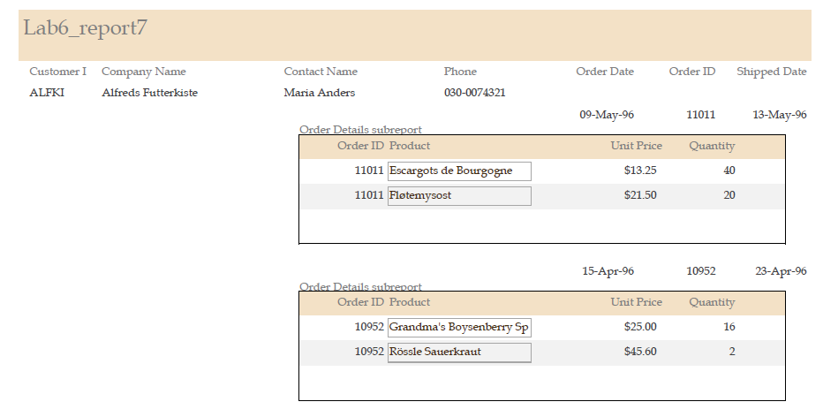
- Save the results as Lab6_Report7.

Step 3: Save and Submit
Save your YourName_Lab6.accdb database. Submit your Lab 6 database to theWeekly Lab Assignment.

End of Part B
END OF LAB

