A.Lab BSBA BIS245A-7

B.Lab7 of7: DatabaseNavigation

C.LabOverview—Scenario/Summary:

COs:

8.Givena databaseapplicationcontainingforms,queries, and reports,automatetasks and createa menu systemwhich allows forefficientnavigationand operationofthe database’sfunctionality.

Scenario:

ThepurposeofthislabistoshowthestudenthowtocreatenavigationsystemsforanAccess application.Studentswillcreateamainnavigationformwhichlinkstoadditionalnavigationforms calledenterdataandviewreports.Additionally,studentswillcreateformstoautomateprinting reportsandclosing/exitingthedatabase.Theenterdataformallowsyoutoopencustomerandcity formsautomatically.Theviewreportsformallowstheusertoautomaticallyopenthecustomerlist andcustomersbycityreports.Theprintreportsformwillallowuserstoautomaticallyprintthe reports.Theexitdatabaseformallowsuserstoclosethedatabaseandexittheapplicationentirely.

Thenavigationformscanprovidesomemeasureofsecuritytothedatabaseastheymayprevent usersunfamiliarwithAccessfromaccessingdatabaseobjectsdirectly;theymakeusingAccessmore intuitivetouseandcanpreventnewusersfrominadvertentlydamagingyourdatabaseobjects.

D.Deliverables:

Upload themodifiedLab7_Start.accdbfilethatyou saved as YourName_Lab7.accdbtothe
Week7 LabAssignment.

Step | Deliverable | Points
Part A | Develop the EnterData,View Reports,PrintReports,and Customer  DatabaseNavigationForms.
Part B | CreatetheClose DatabaseFormand add ittotheMain Database  Navigation Form.SettheDatabaseOptions.

E.LabSteps:

Preparation:
- Download theAccess starter filefromthe Week 7 Lab page, and save thefileonto“c:\”directory(your local drive).
- Using CitrixforMSVisio and/or MSAccess
  - Ifyou are using theCitrixremotelab,followthelogin instructionslocatedin the Lab areaunder Introduction and Resources.
  - You will have toupload theLab7_Start.accdbfiletoyour Citrixfolder.Followtheinstructionslocatedin theLabareaunder Introduction and Resources.
  - StartMSAccess.
- IfyouareusingCitrix,clickonMicrosoftOfficeApplicationsfolder.
- IfyouareusingAccessonalocalcomputer,selectMicrosoftOfficefromyourprogrammenu.

MSAccess Switchboards

In the past, users navigated database applications using a menu system based on a hierarchy similar to that illustrated below.
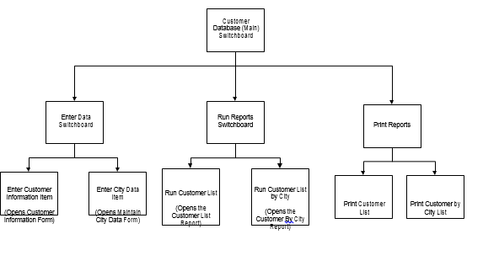

Although this is a logical approach, it was not always efficient or user friendly. Access 2016 allows for development of navigation screens facilitating more efficient movement from one function to another within the database. In this lab, you will create navigation forms that allow users to move through the various objects in a simple Access application. The Access application has two forms (maintain customers and maintain city), and two reports (customer list and customer by city). The navigation system accesses these objects using this structure. Please see below.
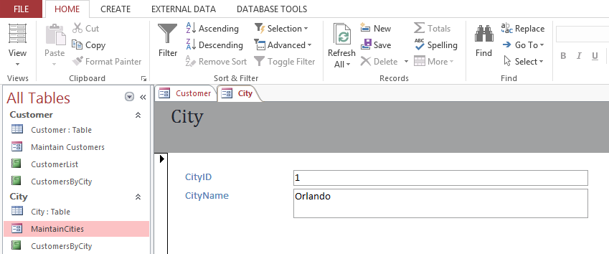
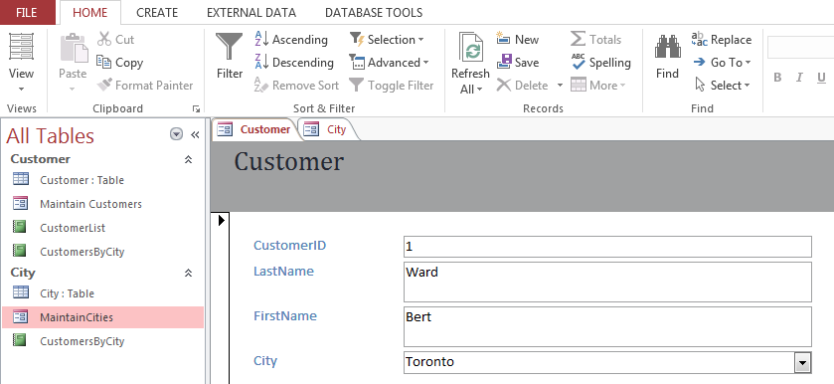
Notice the customer database navigation form with the tabbed options of enter data, view reports, print reports, and exit database. It facilitates easy movement from one object to another, but (in this case) does not allow access to the underlying tables. The enter data tab is currently selected, and it presents two additional tabs to either maintain customers or to maintain cities.

The user can easily go to the database reports by simply clicking the view reports tab in the customer database navigation form. This opens an additional navigation form showing the two reports CustomerList and CustomersByCity.
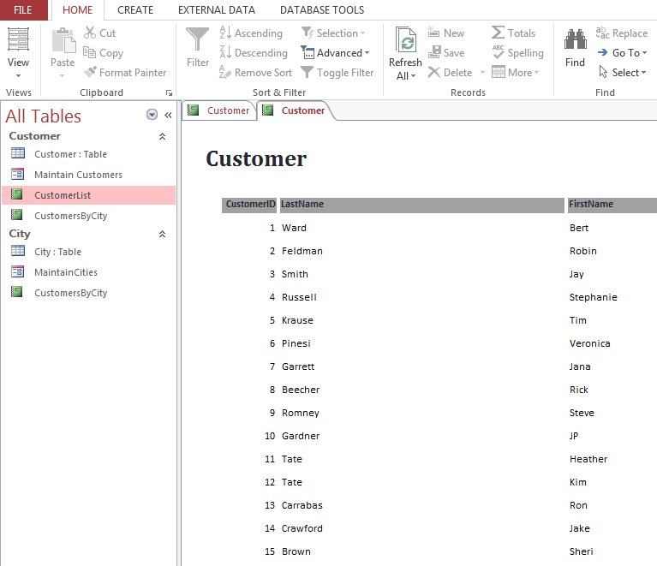

Lab:

Part A: Step-by-Step Instructions to Create Navigation Forms

Step 1: Create the Navigation Forms
- Open your Lab7_Start.accdb Access database file, and become familiar with the contents.
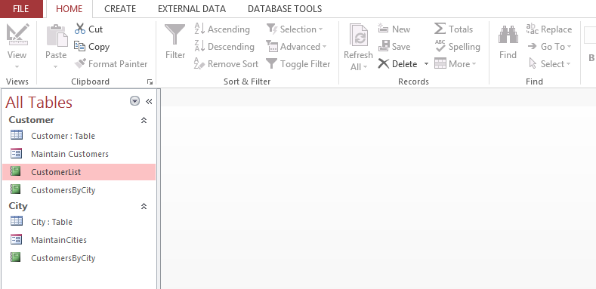

- Go to the create tab and select navigation, horizontal tabs from the forms group.
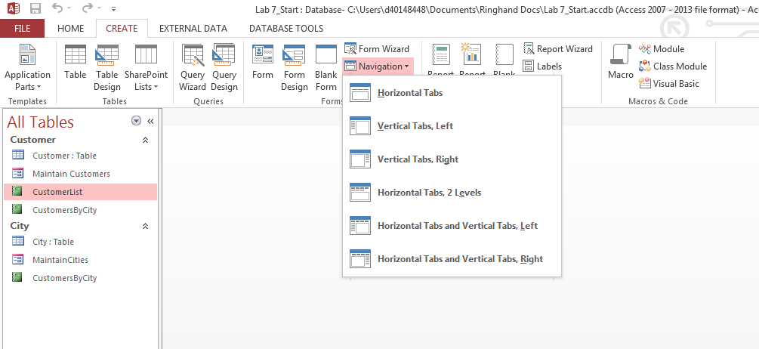
You will see the screen below, which we will use to create the enter data navigation form. Notice that the new navigation form opens in layout view.
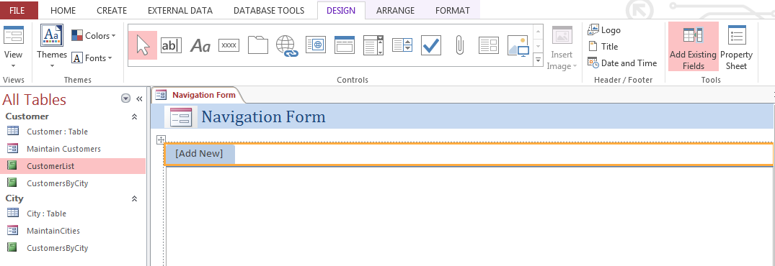
- Click the tab reading add new, and enter maintain customers. Then press enter. Notice the maintain customers form appears in the body of the navigation form. Click to select the maintain customers tab, and drag the right border to widen it so that the complete title shows.

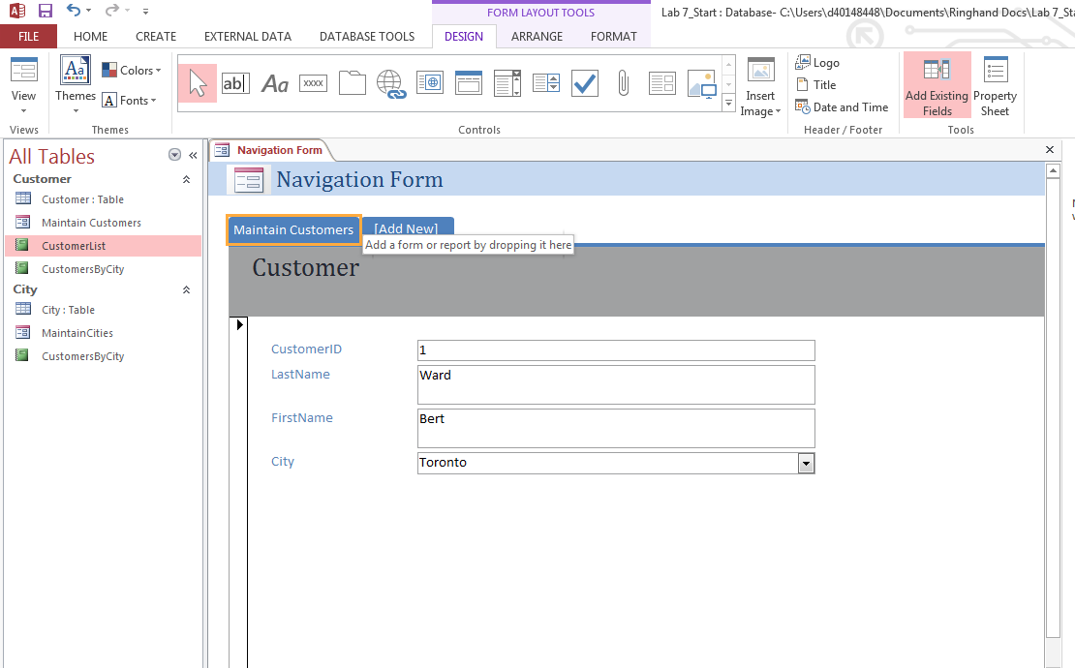
- Now repeat this process to add the MaintainCities form. Notice that in the database objects list, the MaintainCities form name does not include a space between the two words. Be sure you type it exactly the same way in the tab as it shows in the database objects list. Otherwise, your navigation form will not be able to associate the tab with the existing form. Once the new form is added, your navigation form should look similar to the next illustration.
You will need to change the title at the top of the form. Click to select the current title, navigation form and replace it with the new title, enter data.
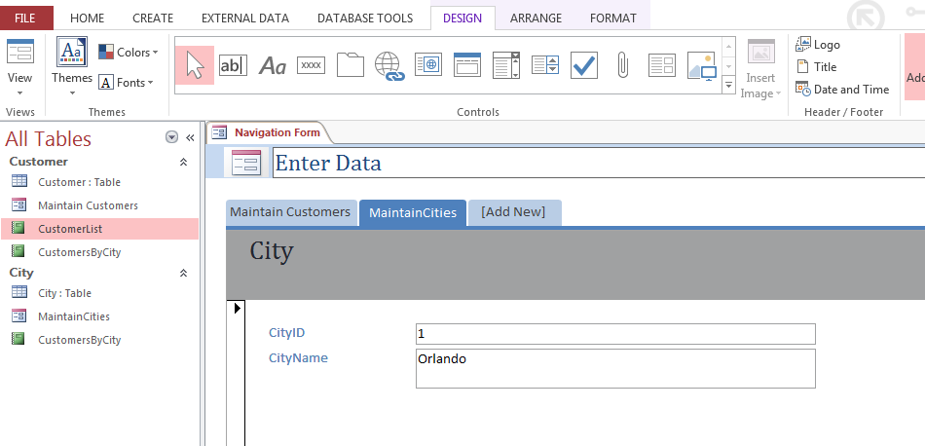
- Click the form view option. If you are satisfied with your new form, you may close it using the object close box circled in the diagram below. When the dialog box appears, click yes and name the form enter data.
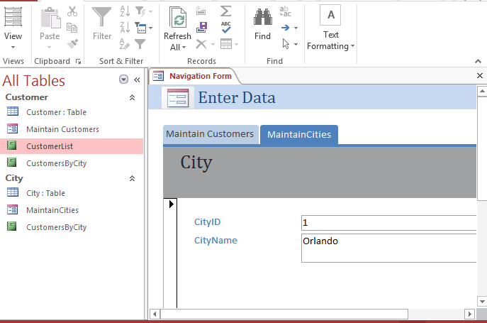

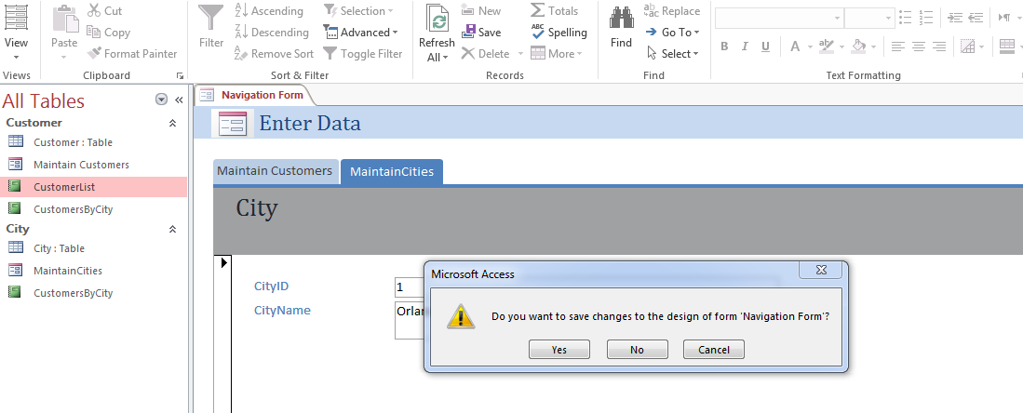

- The new navigation form now appears in the objects list, as shown below.
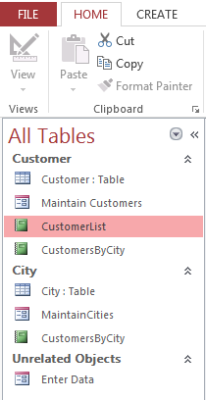

Step 2: Create Navigation Form to View Reports
Repeat the process used in Step 1 to create the view reports navigation form. You will want to add the two reports (CustomerList and CustomersByCity) shown in the objects list. Be sure to change the report heading and to save the form as view reports.
When finished, the form should look as follows in the form view.
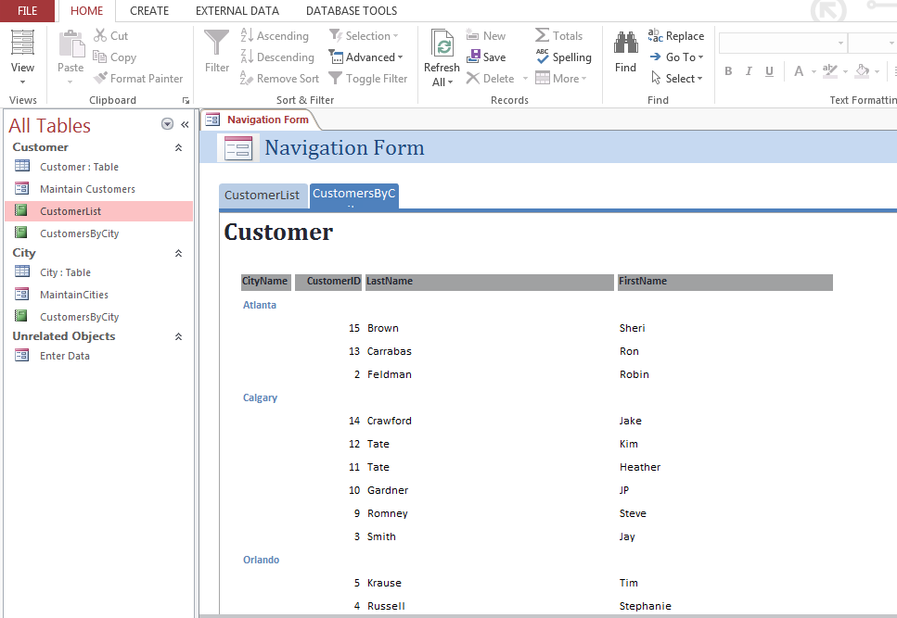
Results should appear in the navigation window below.
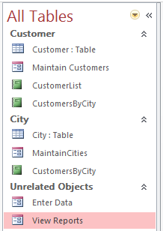

Step 3: Create a Form to Print Reports
- This form will be a little different from those you have created before, as you will use form controls rather than database objects. Begin by opening a new blank form.
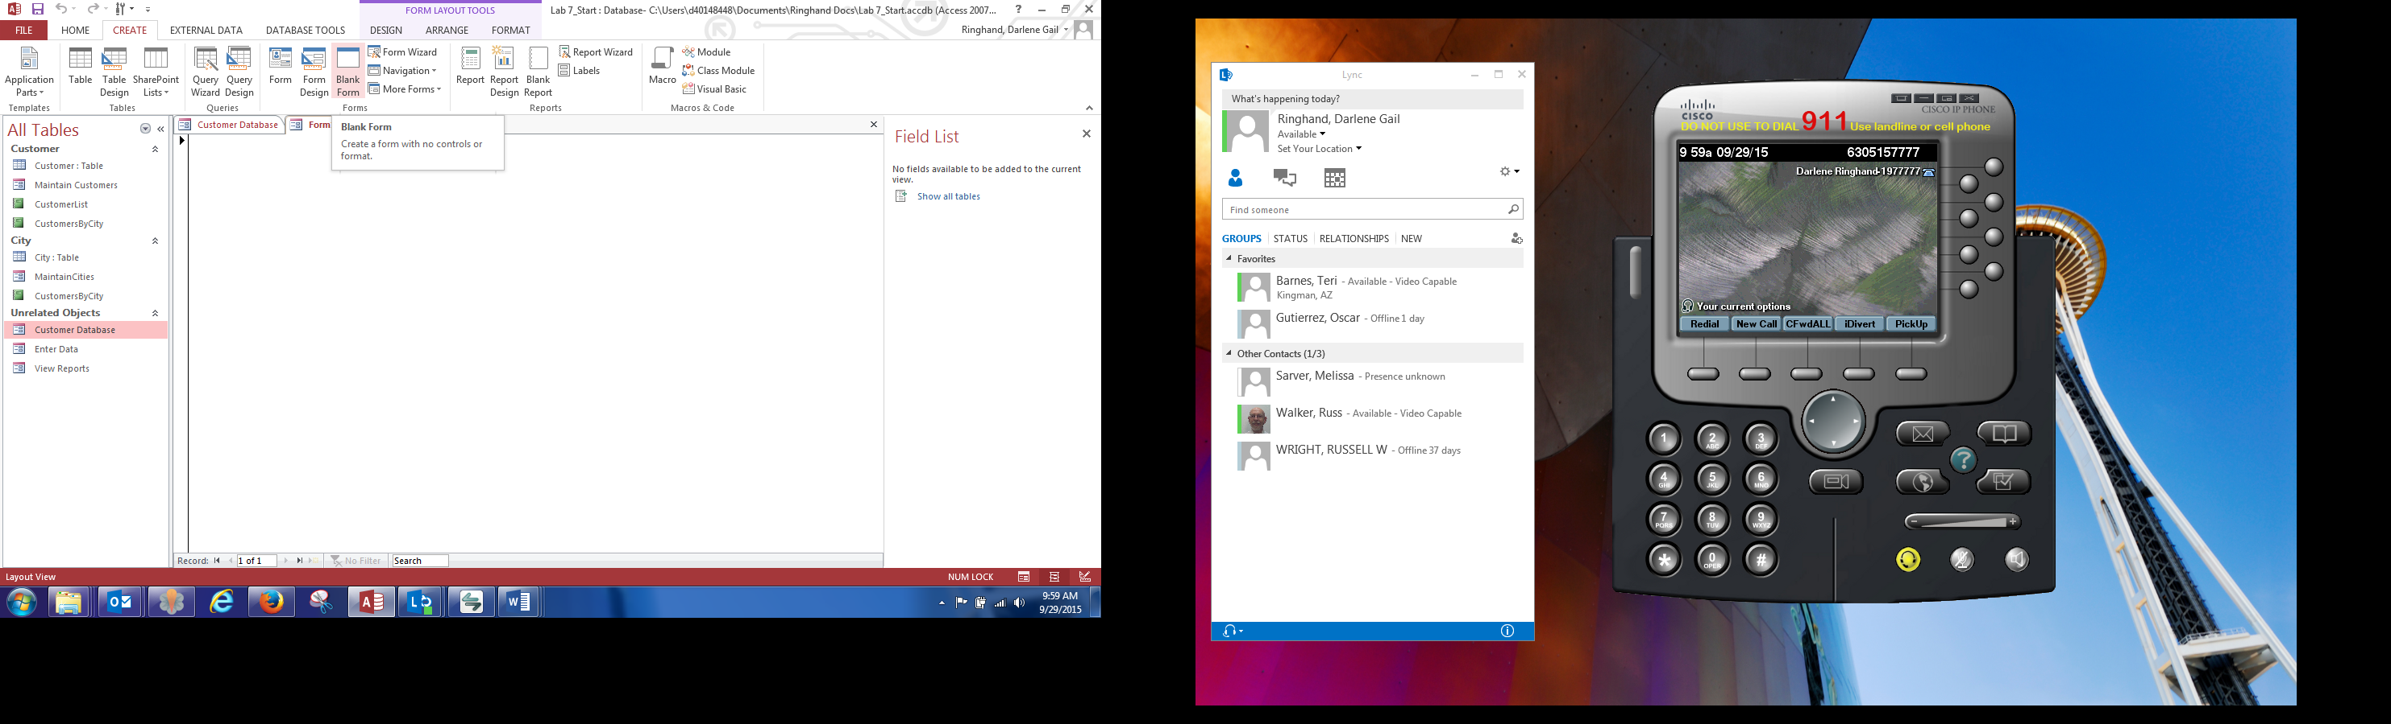
- Click to display the design tab ribbon. Click the arrow on the right side of the buttons there is a scroll bar (very short) with a drop-down arrow at the bottom. Right click to make sure that use form wizards is selected. It may be bolded but it may not be turned on. See below.

- You will then add command buttons and the label to the form. First, click on the labels control and then move your cursor to the body of the form. Your cursor will appear as a plus sign and a capital letter A. Click in the form, and enter the label as follows. Click the buttons below to select and print the desired form. Click and drag to position the label. When label is selected, a plus sign with four arrows appears in the top left corner. Clicking and dragging allows movement of the label to the desired position on the form.
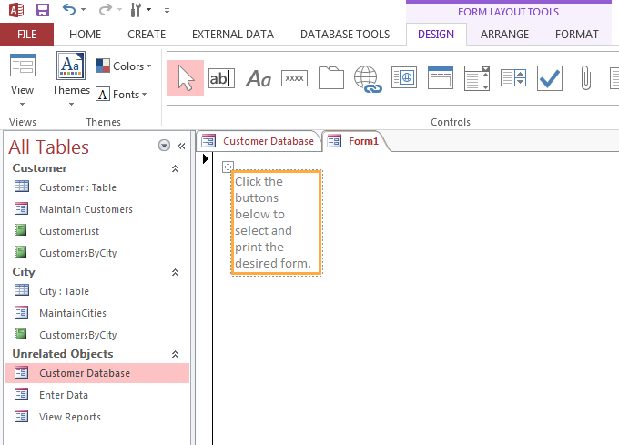

- Withthelabelselected, right clickonthepropertysheetoption found in the drop-down list.Changethetextalignpropertytocenter.Setthefontweighttoboldandthefontsizeto14.Seeillustrationbelow.
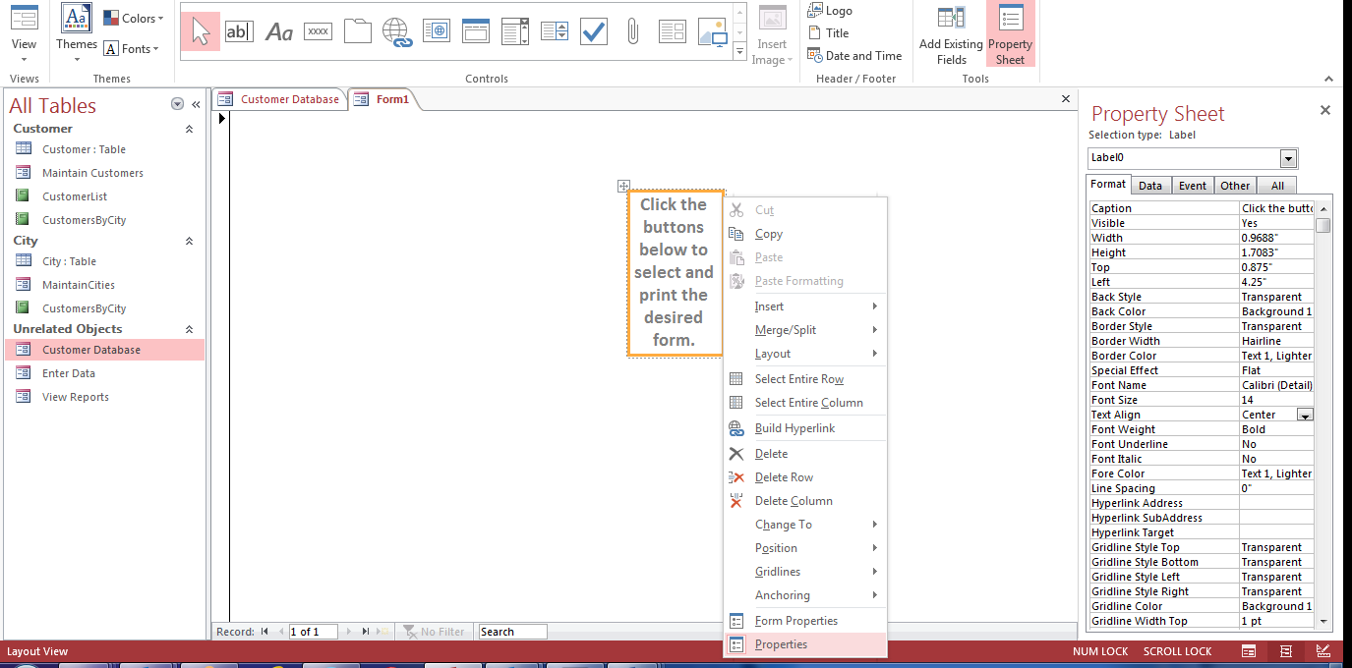

- Now you will add command buttons to print each of the reports. Notice that when you add the command button (rectangle with xxxx that says button when you hover with your mouse) to the form, it automatically moves to the top left corner. That is fine. We will move it later.
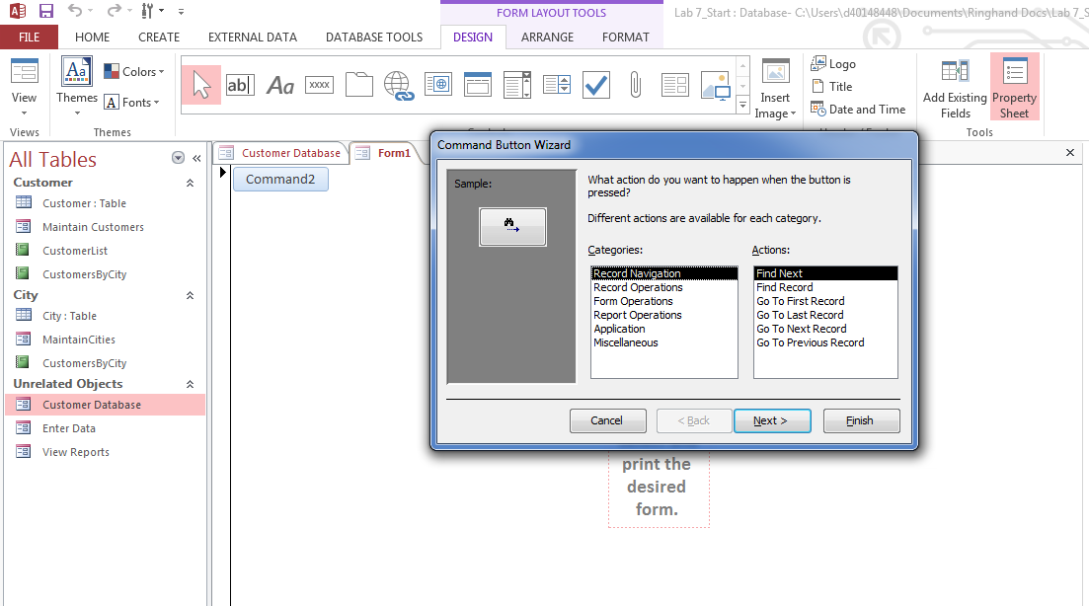

At the same time, the command button wizard opens. In the wizard, select the category report operations and the action print report. Click the next button.
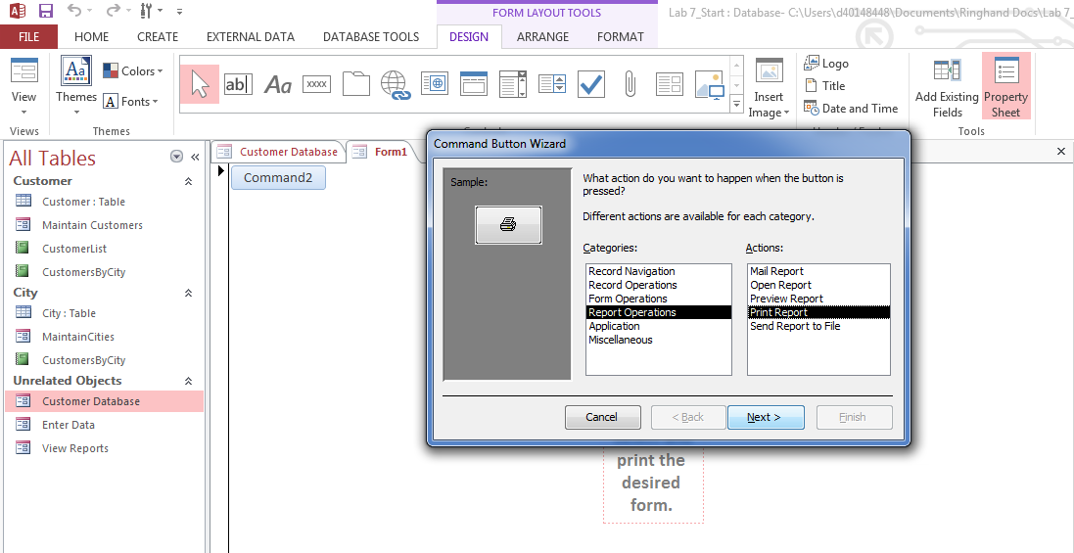
- Notice the next view in the wizard shows the existing reports found in the database. Make sure the first report, CustomerList, is selected, and click the next button.

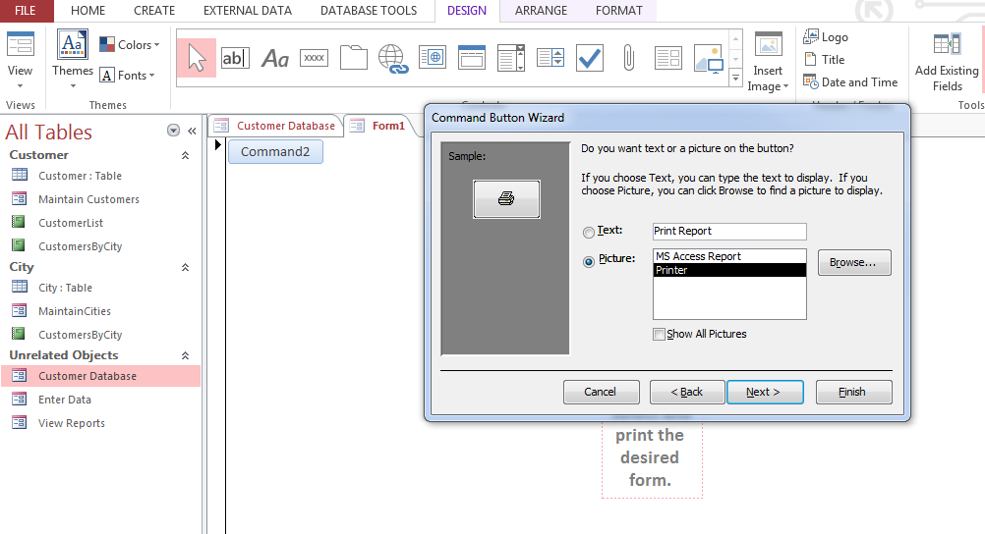

- Select the options to display text on the command button and enter print customer list as the text to display in the properties window. Click the next button.
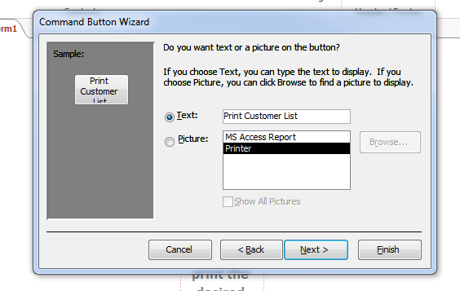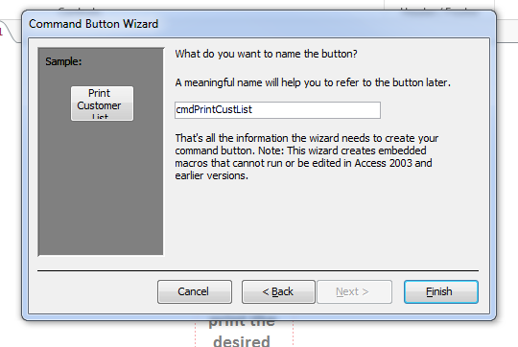
- In the next view, rename the command button as cmdPrintCustList and click on the finish button. The wizard will close, and you will see the command button on the form. The default is that it will be attached to the label previously created. In order to drag and drop it into the desired position, right click on the button to bring up the shortcut menu. Select the LayoutRemove Layout option. Position the command button so that your form looks similar to the next illustration.
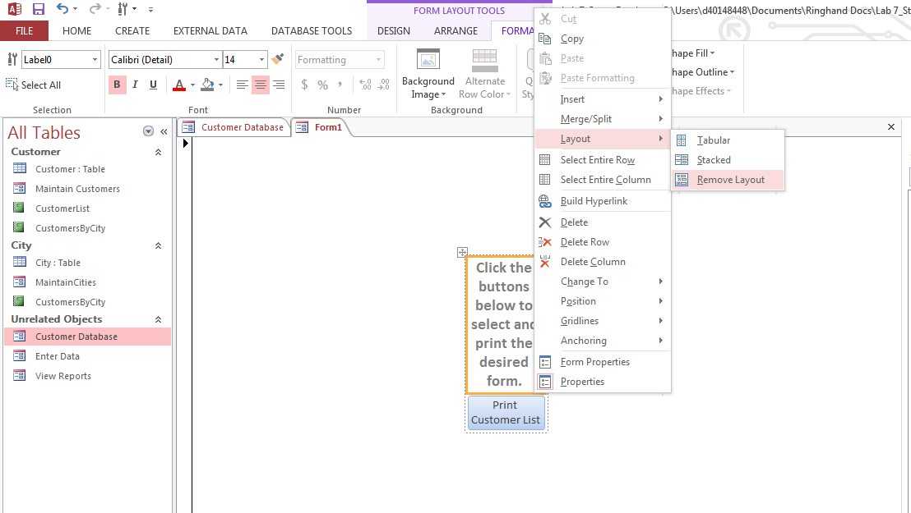

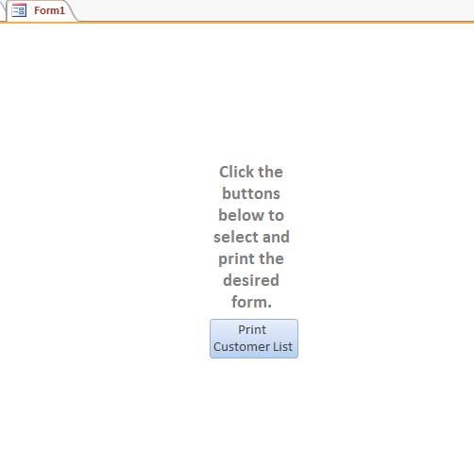
- Repeat the process to add the second command button to print the customer by city report. When completed, your form should look similar to the one shown below.
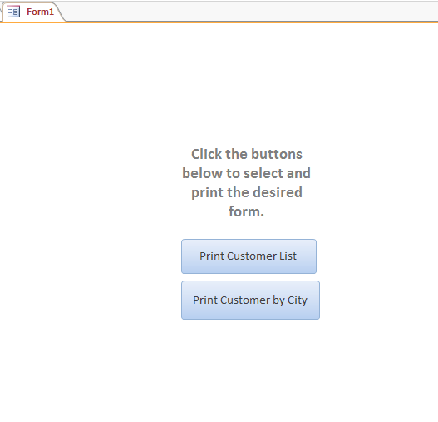

- Before closing the form, change the caption at the top from form to print reports. To do this, select form from the drop-down list at the top of the property sheet. See the diagram below. Once it is selected, enter print reports in the caption property and press enter. See changed caption property below.
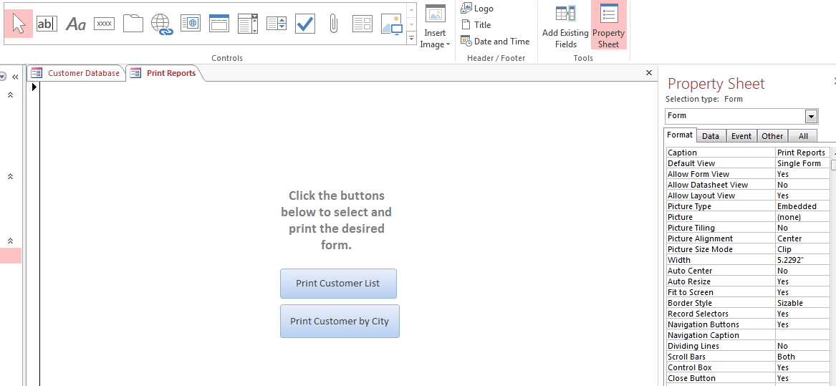

- Press the close object button to close the form. When asked whether to save, say yes and save the form at print reports. It will take a few seconds to save, but the form will then show in your database object list.

Step 4: Create the Customer Database Navigation Form and Add Items.
- Create a new navigations form. Refer back to earlier steps in the lab if you need more detailed instructions.
- Name the add new tab as enter data. It will take a few seconds, but you will then see the enter data navigation form appear as a subform. See the illustration below.
- Add the view reports and print reports form in the same way.
- When the three forms have been added, change the heading (caption) of the main form to customer database.
- Click the close button to close the form. When prompted to save, click yes and name the form customer database. Reopen the form to see it in form view. It should look similar to the one below. Navigate through the various options to be sure the form works as desired.
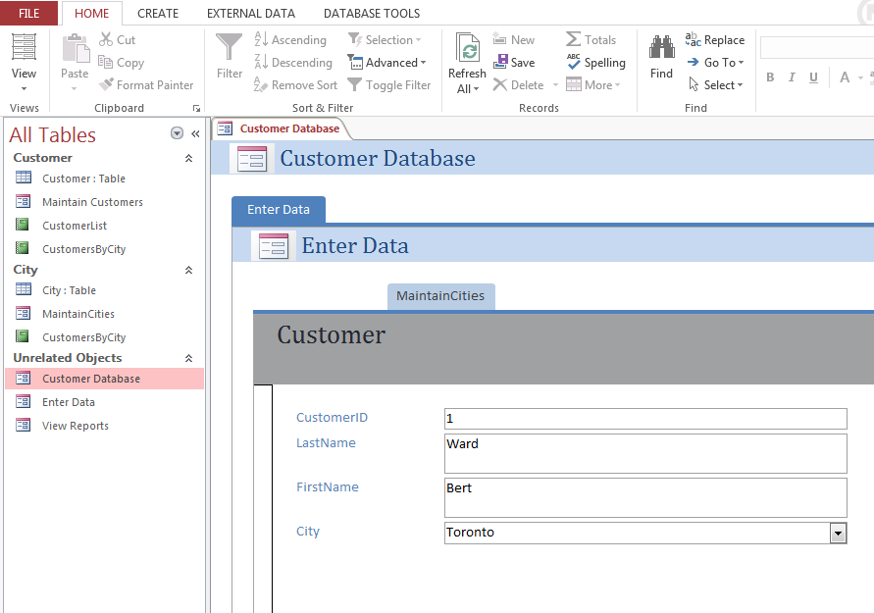

END OF PART A

Part B: Create a form to exit the database and add to the customer database navigation form. Set the database options.

Step 1: Create the Form to Exit the Database and add to the Customer Navigation Form.
- Referring to the instructions in the previous step, create a new blank form to exit and close the database. Note that you will not be using report operations in the control wizard. Look at the various options to locate the selections that will meet your needs.
- When completed, the new addition should appear similar to that shown below.
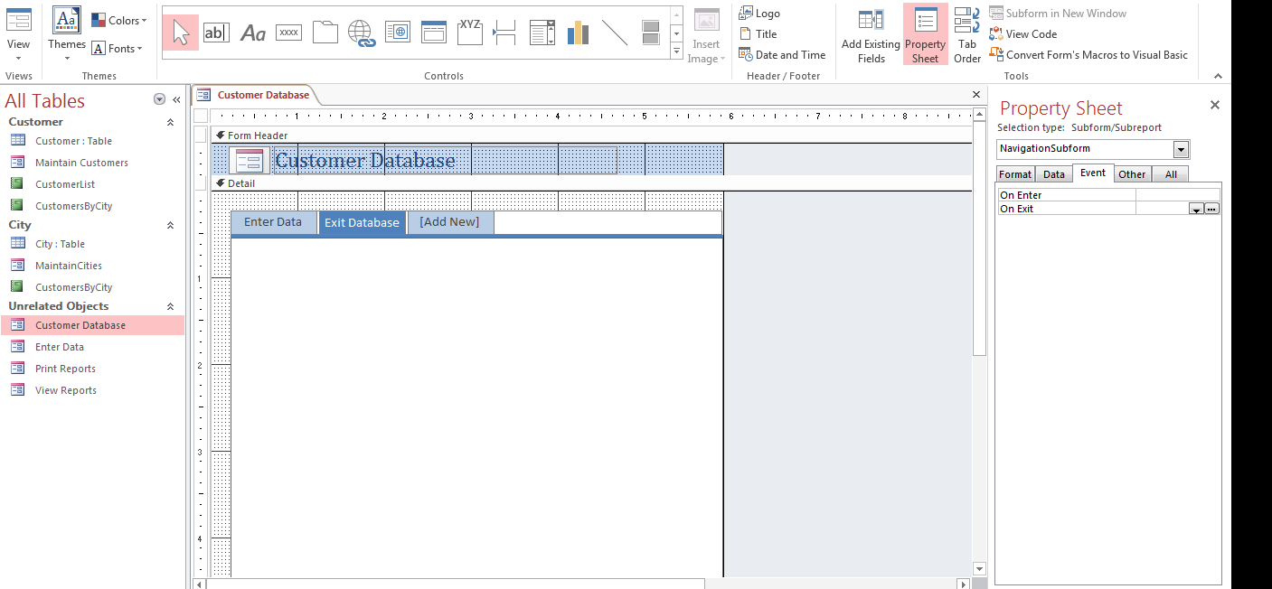

Step 2: Set the Options
Now you need to set up the Access environment so new users don’t see the objects in the navigation pane. Further, you want to set the customer database navigation form to show up automatically when the user starts the database application.
- Go to the file tab and press the options button at the bottom left.
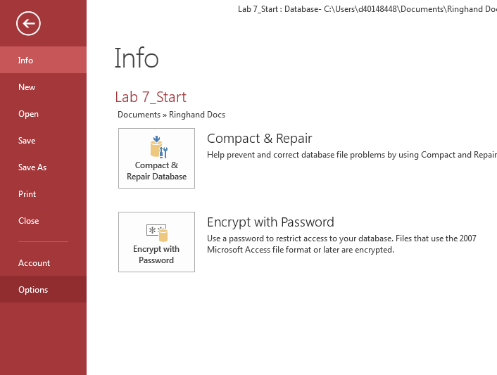

- You should get this screen.
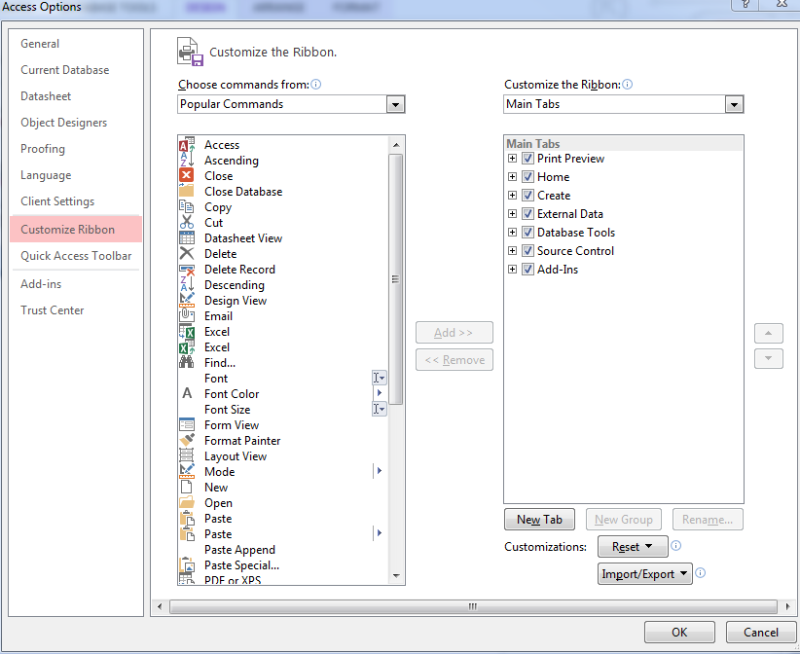
- Select the current database item in the left-most pane, and in that pane, (see next illustration) select the display form drop-down list. Then, select the customer database form and uncheck the display navigation pane checkbox.
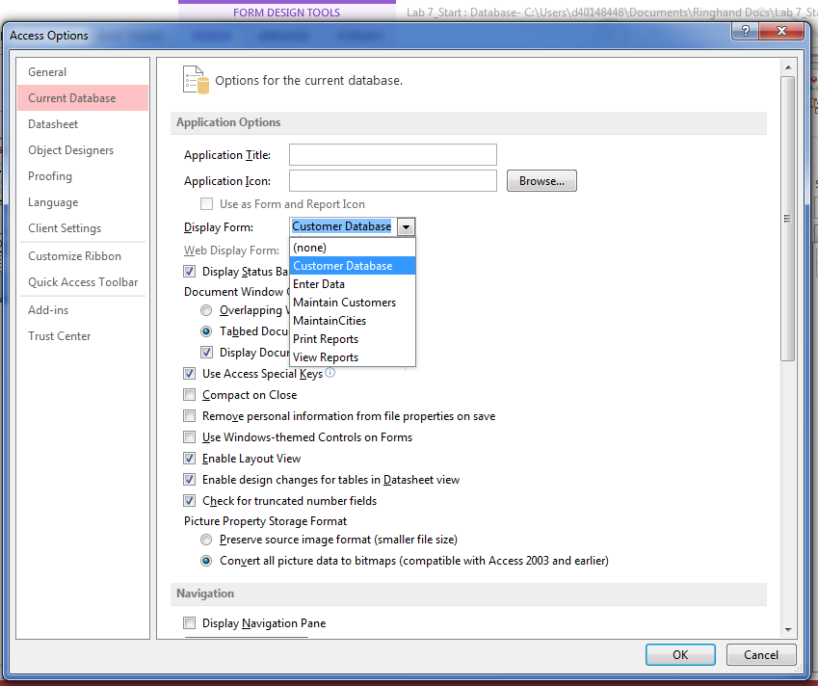
- Press the OK button to get this message.
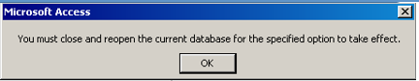
- Press OK, and then close and reopen your database. When it opens, the customer database navigations form should appear, and the navigation pane should be gone.
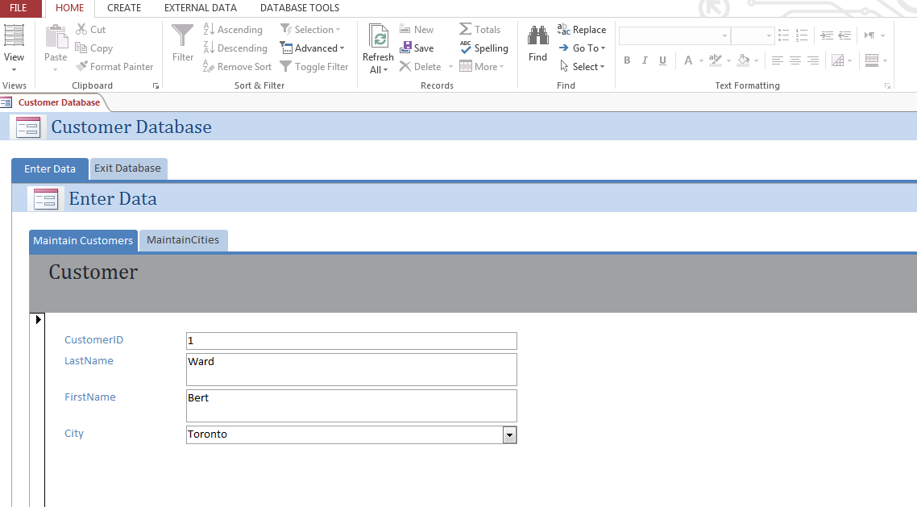

Step 3: Testing Your Navigation Forms
Test your navigation forms to make sure they work. If you have forgotten something or need something, open the form that needs changing in either layout or design view.

Step 4: Save and Submit
Save your file as: YourName_Lab7.accdb database. Submit your Lab 7 database to the Weekly LabAssignment.

END OF PART B

END OF LAB 7

