Part B: ABC Marketing Plan (Change to your name of business here)
Your Name
MKT500 Marketing Management
Strayer University
Dr. Your Professor
Date submitted
Introduction
Explain how you will use the feedback you received on Part A of your marketing plan to improve your plan. Do not just list the feedback.
Next, re-introduce your company you shared in Part A.
Lastly, review what you will share: branding strategy, primary and secondary target markets, positioning statement, and consumer behavior.

Branding Strategy
Write an introduction here (minimum of three sentences). Develop a branding strategy for your product that covers the brand name, logo, slogan, and at least one (1) brand extension. For each of these sections below, provide rationale. Each section should be a minimum of three sentences.

Brand Name
Text starts here, provide rationale (minimum of three sentences).

Logo
Text starts here (do not start with an image of your logo, describe first); provide rationale (minimum of three sentences). Relay what the logo means, for example, Nike’s swoosh logo. Example below:
Figure 1. Your company name logo and short descrption.

Slogan
Text starts here (do not start with your slogan, describe first); provide rationale (minimum of three sentences).

Brand Extension
Text starts here, provide rationale (minimum of three sentences).

Primary and Secondary Target Markets
Analyze the primary and secondary target markets for your company. Thoroughly include the demographic profile (for example, age, gender, ethnicity, et cetera), psychographic profile, professional profile, and geographic profile. Factors to consider in determining your target markets could be age, lifestyle values, attitudes, wants and needs, gender, number of kids, education income, stage in the household lifecycle, geographic location (urban versus rural, et cetera), or risk orientation. Make sure your target market is not too broad; be focused and concise, using multiple characteristics. Target market and segmentation choices are perfect topics for scholarly references to substantiate your position (search in library for peer-reviewed, journals).

Positioning Statement
Start with an introduction sentence or two. Then state what is your unique selling proposition (USP), who do you consider to be your competitors, and how does their positioning statement (as they are seen in the marketplace, what’s their USP) differ from yours. Include a perceptual map that shows your company’s position against its competitors. You may use Microsoft Word, PowerPoint, or other equivalent software to create your perceptual map. Figure 1 example is below:
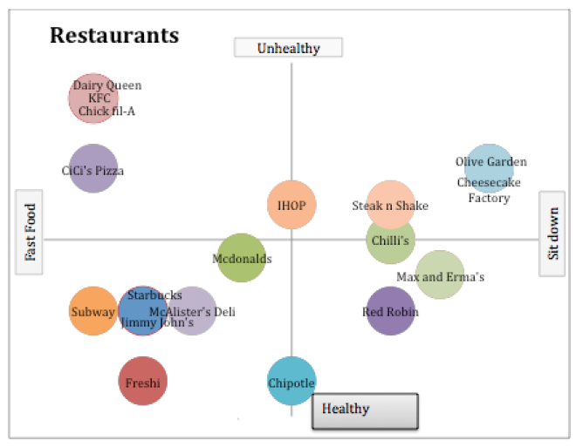
Figure 1. Perceptual map representing Your Company Name in relation to competitors XYZ company, ABC company, and AAA company.

From this map, create a statement that depicts your position. Prepare a positioning statement (that is, “For customers who want [segment], our brand is the best at [unique selling proposition—competitors and competitive advantage].”).
Under Armour example:
Under Armour’s mission statement is, “Under Armour’s mission is to make all athletes better through passion, design and the relentless pursuit of innovation.” A converted position statement might be: “For athletes who want to be the best, Under Armour is the best at making all athletes better through passion, design, and the pursuit of innovation.”

Note: See the textbook for an example of another perceptual map.

Consumer Behavior of Target Market
Examine the relevant consumer behavior for your target market (use segmentation and targeting rationale from your textbook). Explain the main reasons why the brand name, logo, slogan, brand extension, as well as the positioning statement are right for the identified target market. Objective is to examine the marketing science of customer behavior and products in the marketing exchange process and create dynamic strategies for competing. Remember your target market should consist of more than one characteristic (for example, age, lifestyle values, attitudes, wants and needs, gender, age, number of kids, education income, stage in the household lifecycle, geographic location (urban vs. rural, et cetera), or risk orientation). Good place to use references on consumer behavior from Journal of Marketing.

Conclusion
Summarize the plan to this point (minimum of three sentences) and you should not include any new thoughts (just summary).

Sources

Use three credible, relevant, and appropriate resources as marketing research to determine the feasibility of your product or service. To receive most points as exemplary, you must meet the required number of credible, relevant, and appropriate references.

These resources should be industry specific, relate to your chosen product or service, and be published in the last five years. A good way to incorporate is by using Journal of Marketing, as an example, for your theories and consumer behavior observations.

SWS Guidelines: (delete this from your paper)
This course requires the use of Strayer Writing Standards. For assistance and information, please refer to the Strayer Writing Standards link in the left-hand menu of your course and the Strayer Writing Center.

